Duncan I – King of Scotland 1034 – 1040

(Modern Gaelic: Donnchadh mac Crìonain)
(Medieval Gaelic: Donnchad mac Crínáin)
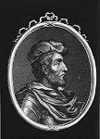
Duncan became King of Scotland upon the death of Malcolm II in 1034.

On November 24, 1034, King of Scotland Malcolm II died of natural causes. One month later, his grandson, Duncan MacCrinan, was elected King Duncan I of Scotland. He was a much weaker character than Malcolm and a terrible leader. For six uneasy years, Duncan ruled Scotland with a thirst for power, countermanded by his incompetence on the battlefield. In 1038, Ealdred, earl of Northumbria, attacked southern Scotland but the effort was repelled. Duncan's chiefs encouraged him to lead a counterattack. Duncan also wanted to invade the Orkney Islands to the north, held by Norway. Over the objections of all of his advisers, he chose to do both.

In 1040, Duncan I opened up two fronts. The attack on the Orkneys was led by his nephew, Moddan (perhaps the Earl of Caithness at that time). Duncan I led a force southward toward Durham in Northumbria. Both of Duncan’s armies were soon routed, and reformed only to be pursued by Thorfinn, mormaer of Orkney (1). MacBeth, mormaer of Moray, joined his cousin, Thorfinn, and together, they were victorious, killing Moddan.

Duncan I survived, but soon after he led an army north into Moray, MacBeth's domain, apparently on a punitive expedition against MacBeth. On August 14, 1040, MacBeth with Thorfinn defeated Duncan's army, killing Duncan in the process at Bothnagowan, now Pitgaveny, near Elgin. He is thought to have been buried at Elgin before later relocation to the Isle of Iona.

Later that month, MacBeth led his forces to Scone, the Scottish capital, and, at age 35, he was crowned King of Scotland.

MacBeth – King of Scotland 1040 – 1057

(Modern Gaelic: MacBheatha mac Fhionnlaigh) Macbeth MacFindlaech

(Medieval Gaelic: Mac Bethad mac Findláich)

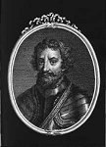 Duncan I’s cousin, MacBeth MacFindlaech, Mormaer of Moray, had a claim to the throne through his mother.

In crowning Duncan I, the system of succession established by Kenneth MacAlpin (reign 843 to 858 AD), had been violated, whereby the kingship alternated between two branches of the royal family. That means it was not Duncan’s turn! The rightful claimant was MacBeth, Duncan's first cousin. MacBeth, was equally a grandson of Malcolm II, and the rightful heir.

MacBeth-Early Life

MacBeth was born in Alba in central Scotland around 1005—the same year that his grandfather became King Malcolm II of Scotland. MacBeth’s father, Findlaech MacRuaridh, was mormaer of Moray. His mother, Doada (Donalda), was the second daughter of Malcolm II. Historians describe the young MacBeth as tall, fair haired and handsome, with a ruddy complexion.

At the age of 7, MacBeth was sent to a Christian monastery to be educated by monks—a requirement for all important chieftains' sons. In 1020, when MacBeth was age 15, his cousins, Malcolm (Mael Coluim) and Gille Coemgáin, killed his father (Findlay son of Ruaidri) (Findláech MacRuaidri) possibly for being too close to Malcolm II, king of Scotland. His cousins were the sons of his father’s brother, Mael Brigte.

Malcolm then became mormaer of Moray from 1020 to 1029, when he died. Malcolm’s brother and successor, Gille Coemgáin is recorded as Mormaer of Moray from 1029 until 1032.

MacBeth-Mormaer of Moray

After his tutelage, MacBeth reappeared around 1032 when his cousin, Gille Coemgáin, and 50 of his men were killed by order of King Malcolm II for his killing of MacBeth’s father, Findlaech. MacBeth was then elected mormaer of Moray, and soon married Gille Coemgáin's widow, Gruoch ingen Boite and adopted her son, Lulach. The marriage strengthened MacBeth’s claim to the throne, as Grouch was the daughter of Boite mac Cináeda, who was son of King Kenneth III (Cináed III).

MacBeth-King of Scotland

In December, 1034, the crowning of Duncan MacCrinan as King Duncan I of Scotland violated the system of succession established by Kenneth MacAlpin whereby the kingship alternated between two branches of the royal family. It was MacBeth’s turn!
Later sources suggest that MacBeth had a claim to the Scottish throne through his mother, but his Gaelic pedigree, on record only two generations after his death, traces his descent through his father Findlaech, and grandfather Ruaidri, from the house of Loarn, the Kings of Dál Riata.

As described above in the section about Duncan, Duncan I led an army north into Moray, MacBeth's domain, apparently on a punitive expedition against MacBeth. On August 14, 1040, Macbeth with Thorfinn defeated Duncan's army, killing Duncan in the process at Bothnagowan, now Pitgaveny, near Elgin. Later that month, Macbeth led his forces to Scone, the Scottish capital, and, at age 35, he was crowned King of Scotland.

Respected for his strong leadership qualities, MacBeth was a wise king who ruled successfully for 17 years. He lived in a fortified castle at Dunsinane (Dunsinnan) north of Perth. Life was peaceful and prosperous as MacBeth ruled with an even hand and encouraged the spread of Christianity. He enacted several good laws, among them one that enforced Celtic tradition requiring officers of the court to defend women and orphans anywhere in the kingdom. Another allowed daughters the same rights of inheritance as sons. MacBeth is considered to be one of the last Gaelic kings.

Duncan’s son Malcolm had fled to Northumbria after the defeat of his father but had never given up his claim to the throne. In 1045, a rebellion by those who had been Duncan I's supporters was soon suppressed. In 1046, Siward, Earl of Northumbria, unsuccessfully attempted to dethrone MacBeth in favor of Malcolm.

MacBeth’s rule was secure enough for him to go on a pilgrimage to Rome in 1050.
MacBeth and his wife, Gruoch, traveled to Rome for a papal jubilee, giving alms to the poor and donating to the Church. However, upon his return, MacBeth faced political turmoil brewing outside his realm. In 1052, Normans living in England fled the chaotic situation into Scotland. Celtic custom held that all travelers were welcome in MacBeth's court. However, this act of kindness didn't set too well with English lords.

Around the same time Duncan’s 21 year old son, Malcolm MacDuncan, was lobbying English lords that he was best-suited to serve as king of Scotland. In 1054 with the support of Earl Siward of Northumbria, Malcolm led an army north into Scotland against MacBeth. On July 27, 1054, MacBeth’s forces met the invaders at Dunsinane, close to the capital of Scone. By the end of the battle, 3,000 of MacBeth's forces had fallen. The invaders only lost 1,500, but the outcome was indecisive. MacBeth retrenched his army near Scone and Malcolm moved south to control Cumbria, the southernmost province of Scotland.

Consequently, in 1054, MacBeth was forced by Siward to yield part of southern Scotland to Malcolm.

MacBeth remained king, restoring Malcolm’s lands to him. Over the next three years, MacBeth and his army were under constant assault by Malcolm, but he was able to stave him off. By 1057, MacBeth had lost the support of two key allies, Pope Leo IX who died April 19, 1054, and the bishop of St. Andrew, Maelduin MacGille-Ordain who died in 1055; both of whom could have put pressure on England to not support Malcolm. MacBeth also lost his chief general, Thorfinn, ruler of the Orkneys, who had recently died.

MacBeth-Military Defeat and Death

On 15th August, 1057, at the Battle of Lumphanan in Aberdeenshire, MacBeth was finally defeated and killed by Malcolm’s men with assistance from the English; as MacBeth was trying to return to Moray.

His body was buried in the holy isle of Iona, where many other Scottish kings were buried. A few days after his death, his stepson and presumably son of Gruoch, Lulach, was elected King of Scotland. Lulach ruled for seven months before being killed by Malcolm's agents in 1058.

At that time, Lulach’s son, Mael Snechtai, became ‘King of Moray’, really mormaer of Moray, in 1058; and on April 25, 1058, Malcolm MacDuncan became King Malcolm III, of Scotland.

FAMILY TREE

This family tree, below, explains how Duncan, MacBeth, and Thorfinn were all cousins. Malcolm II and his wife Edith of Ossery had three daughters:

- Bethoc (Beatrix) (married Grimus Mortimer, Abbot Crinland), mother of Duncan I
- Donada (Donalda) (married Finleach), mother of MacBeth
- Anleta Thora (married Sigurd II Hlodversson) mother of Thorfinn, Jarl of Orkney

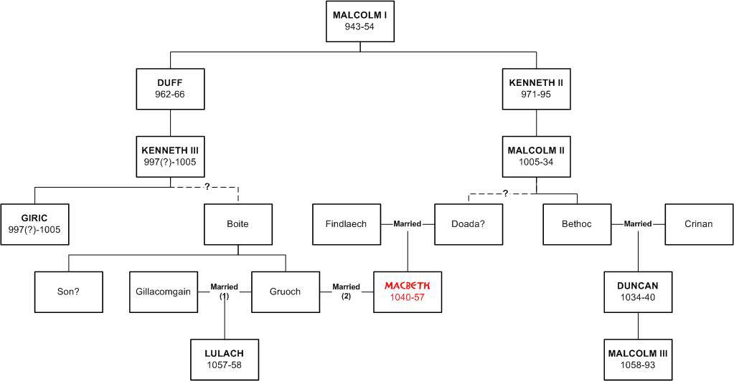

NOTES:
- Thorfinn the Mighty was a son of Sigurd and another grandson of King Malcolm II of Scotland. Along with Sigurd's other sons Thorfinn ruled Orkney during the first half of the 11th century and extended his authority over a small maritime empire stretching from Dublin to Shetland.

References: BIOGRAPHY of MACBETH: https://www.biography.com/people/macbeth-9390544

WIKI: https://en.wikipedia.org/wiki/Macbeth,_King_of_Scotland

