started June 7, 2020
DRAFT 10 – July 4, 2023

The Murrays Come to Manitoba

This is the story of George and Elizabeth Murray (nee Thom) in Manitoba. Most of the family activity was in the capital city, Winnipeg, but effort has been made to extend this work to include one daughter (Elizabeth) who would move to Souris, Manitoba, and another two daughters (Jessie and Robin) who would move to Saskatchewan. The entire Murray family consists of the father George Murray, the mother Elizabeth (nee Thom), and their 10 children. The oldest child was John. His mother was Anne Fraser, the girl next door. Next came Elizabeth whose mother was George’s first wife Elizabeth McRobbie. Elizabeth Thom was George’s second wife and the mother of George, James, Agnes, Jessie, Robertson (Robin), Alex(ander), Margaret, and Mary.

For simplicity we will refer to relationships as brother and sister, etc rather than half-brother and half-sister, etc.

In SCOTLAND:

The Murray family’s life in Glendaveny, Scotland, voyage across the ocean, and initial settlement in East Assiniboia, Canada, has been very well narrated in “The Murrays Come to Canada” by daughter Jessie Murray. The 1881 census for Glendaveny, Scotland lists the Murray family living in Glendaveny Cottage. At that time the family consisted of:
- George Murray, Jr, head of the family, married, 30 years old, occupied as a farm overseer, born in Rathen, Aberdeenshire
- Eliza Murray, wife, married, 25 years old, no occupation, born in Fraserburgh, Aberdeenshire
- John Murray, son, 8 years old, a scholar, born in Rathen, Aberdeenshire
- George Murray, son, 3 years old, no occupation, born in Rathen, Aberdeenshire
- James Murray, son, 1 year old, born in Rathen, Aberdeenshire

The members of this Murray family left their home in Glendaveny, Scotland, in 1889, 1890 and 1891, and arrived in East Assiniboia, Canada East. Assiniboia was in the district of Assiniboia which was part of the North West Territories, in those days. Assiniboia is now in the province of Saskatchewan, Canada. The Northwest Rebellion, led by Louis Riel in 1885, was instrumental in the creation of Saskatchewan as a province in 1905.

SCOTLAND to CANADA:

On August 22, 1889, George Murray boarded the ship “Vancouver” which departed Liverpool, England, then arrived in Montreal, Quebec, Canada on August 31, 1889. He was 39 years old. He came alone, leaving the family in Glendaveny, Scotland.

George found work on the railroad in Canada. He worked on building the rail line which had not yet reached Yorkton. Once established George sent for his family to join him. While George’s eldest daughter, Elizabeth Georgina Barbara Murray (born February 8, 1875) remained in Aberdeen with her widowed grandmother Barbara Murray (nee Robertson), the rest of the family boarded the ship “Pomeranian” which departed Glasgow on August 9, 1890 and arrived in Quebec City, Quebec, Canada, on August 20, 1890. The ship’s passenger list shows Saltcoats as the destination for the Murray family. Saltcoats is a town in present-day Saskatchewan. The family members listed as passengers were:

- Elizabeth, wife, age 33 years. This is Elizabeth (nee Thom), actually 35 years old.
- John, age 18 years. This is John Robertson Murray
- George, age 11 years. This is George who later became the tinsmith
- Agnes, age 9 years
- Jessie, age 6 years. Jessie later wrote “The Murrays Come to Canada”
- Robertson, age 4. She was a daughter, often called ‘Robin’
- Alex (age unclear on the passenger list). He was born November 1, 1888.

(Daughters Margaret and Mary were born later, in Canada.)

The trip from Quebec to Saltcoats was by train. The train stopped in Winnipeg, Manitoba, for passengers to clear immigration. There was a large building (immigration hall) where the immigrants had their paperwork done and stayed if waiting for a train to leave for elsewhere. Son, John stayed in Winnipeg (no address available) to work for Elisha Frederick (E.F.) Hutchings, a manufacturer of harnesses, etc. The mother, Elizabeth, and the remainder of the family continued by train to Saltcoats in early September, 1890. The father, George, met his family when the train arrived in Saltcoats. Life in Saltcoats and at the farm homestead are covered in “The Murrays Come to Canada”. Tragically George and Elizabeth’s son, Alex, died on September 7, 1890 after arriving at Saltcoats. He was 2 years old. So far, I am unable to find his grave, so find it possible he was buried on the homestead farm land. Earlier, George and Elizabeth had lost their son, James (born May 27, 1879 in Rathen Cottage, Rathen, Scotland), who died December 27, 1881, in Glendaveny, Scotland also 2 years old.

The first Winter in Canada (1890-1891) was spent in Saltcoats

IN CANADA

Most of the information for this work came from Henderson’s Winnipeg City Directory (Henderson), and the Canadian Censuses. When necessary for context, information from “The Murrays Come to Canada,” by Jessie Murray, is included in this text

In 1891, John Robertson Murray was employed as a packer for E.F. Hutchings (Elisha Frederick Hutchings), a business located at 519 Main Street, Winnipeg, at that time. John desired to become a harnessmaker which was a very viable trade in those days. He had some training before leaving Scotland.

The rest of the family appears on the Saskatchewan census of May 23, 1891 which would be in Saltcoats, before they moved to the farm. This census shows: George Murray 40, Farmer; wife Lizzie, 35; and daughters Agnes, 9; Jessie, 7; Robin, 5. Their son George was enumerated with the Kumph family. In 1891, son George, was living with William and Catherine Kumph, who owned the hotel in Saltcoats. He worked for them doing odd jobs like cutting wood and carrying water. He was 13 years old (born March 13, 1878) but enumerated as 14 years old on the census. The name of the hotel is not given in the census.

George, Elizabeth, and their children (George, Agnes, Jessie, Robertson) moved from the town of Saltcoats to the farm homestead in the Spring (Jessie thinks “about the first of June”) of 1891, after the census was taken. Their farm property consisted of ¼ section (160 acres) of land, located between the towns of Saltcoats and Rokeby on what was then a prairie trail and is now Provincial Highway #16 (Yellowhead Route). The legal description is South East quarter of Section 20 Township 24 Range 2 West of the 2nd meridian. The rail line, that father George was working on constructing, runs through the homestead. It is now a main line for the Canadian Pacific Railway. As mentioned, this area was called East Assiniboia, before Saskatchewan was a province. This piece of land is very accessible and I visited it in the Summer of 2020. It is still farmland.

Daughter Margaret (Maggie) (Nellie) was born on the farm homestead on June 26, 1891.

In Autumn of 1891, after a frost killed their crop, George and Elizabeth and family moved off the farm and to a house on the other side of Anderson Lake from Saltcoats. That Winter Agnes and Jessie walked across the frozen lake to school in Saltcoats.

Although grandmother Barbara Murray (father George’s mother) died November 21, 1890, daughter Elizabeth boarded the ship “Sarmation” almost a year later. It departed Glasgow on September 19, 1891, and arrived in Quebec City, Canada, on September 29, 1891, and Montreal on October 1, 1891. Her destination is listed as Winnipeg. She was 16 years old (born February 8, 1875) and her occupation was listed as a Domestic. At some point in time after arriving in Winnipeg she began work as a domestic for Elisha Frederick (E. F.) Hutchings, her brother John’s employer, living with that family at 49 Martha Street. She was still living there at the time of the 1901 census and probably stayed until she married Richard Roden, a Canadian Pacific Railway (CPR) employee, on June 19, 1901. Richard had come to Canada around 1880 (the 1921 census erroneously says 1882). He was born in England. In the 1881 census, a Richard Roden is living with his parents Joseph and Maria, and older sister Mary, in Thunder Bay. In Winnipeg’s 1891 census Richard Roden is a 21 year old lodger in the home of James and Jane Yates, with the occupation of CPR Hand. Richard Roden was not found in 1892 Henderson.

In the Spring of 1892, the railroad transferred George Murray to Rokeby, Assiniboia, to take over the station and a section of railroad; so he moved the family there, possibly to live in the train station or other accommodation provided by the railroad.

Meanwhile in Winnipeg, in 1892 John Robertson Murray lived (likely boarded) at 453 McWilliam Avenue which is now called Pacific Avenue. The house at 453 Pacific was built in 1882. This was the home of a James Yates, possibly the same James and Jane Yates home where Richard Roden lived in the 1891 census. This may explain how Elizabeth Murray met her future husband, Richard Roden. According to Henderson John was employed as a clerk at 519 Main Street, which was occupied by “E.F Hutchings, harness etc”.
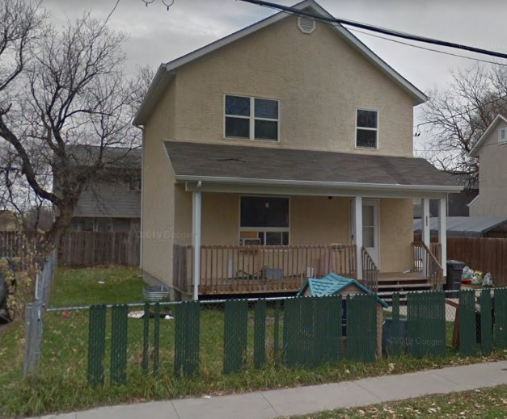
453 Pacific Avenue, today

In 1893, John lived at 180 James Avenue, a boarding house of Mrs. Thompson, a widow. In1893, John was still a clerk for E. F. Hutchings at their 519 Main Street location in Winnipeg.

While his parents and sisters remained in Rokeby, John found a job in Winnipeg for his brother, George, so George left East Assiniboia, in the Autumn of 1893. George was not found in 1893 Henderson, and could have missed the publication cut-off date.

With the two sons and a daughter already in Winnipeg, the rest of the family moved to Winnipeg early in 1894. The family in that move from East Assiniboia consisted of parents George and Elizabeth with daughters Agnes, Jessie, Robertson, and Margaret. Arriving in Winnipeg, they first stayed with a family named McInnis. Shortly thereafter, still in 1894, they moved into a block across the street from the police station, according to Jessie in “The Murrays Come to Canada”. They are found in Henderson in 1894 at 220 James Avenue, across the street from the police station which was at 221 James Avenue.

They stayed in this block “Maybe just for the Winter”, Jessie says in “The Murrays Come to Canada”. At this time, the father George is a labourer (possibly in a livery barn), and John is a clerk working for E.F. Hutchings at their 195 Market Street location.

Daughter Elizabeth is not listed in 1894 Henderson, which is consistent with her still living with E.F. Hutchings and family as a domestic.

In 1895 the Murray family has moved into 259 Princess Street, described by Jessie as the “little house on Princess Street” where “Johnnie and George had a room and Mother and we girls slept in two double beds in the front room.” [“The Murrays Come to Canada”]. “We girls” at this time were Agnes, Jessie, Robertson, and Margaret. Though not listed in 1895 Henderson, John likely still working for E. F. Hutchings. In 1895 son George moved to 72 Arthur Street to work for John Wallace who had a tin-shop at that location. The advertisement in Henderson reads, “John Wallace, Galvanized Iron and Cornice Manufacturers, 72 Arthur”. It was not unusual for business owners and employees to live in the same building as their business premises. George continued working for John Wallace until some time between 1897 and 1900. Again, there is no listing for daughter Elizabeth in 1895, which is consistent with her still living with the E.F. Hutchings family, as a domestic.

John Murray married Julia Simmons on November 26, 1895. Julia was born April 25, 1874, in Monmouth, Wales. She arrived in Winnipeg with her parents and 5 brothers on June 14, 1882. Julia grew up on Syndicate Street in Winnipeg, first at 160 Syndicate then moving next door to 164 Syndicate Street (shown in photo below). Earlier, in the 1891 census, Julia was listed as an apprentice dressmaker.

After their marriage John and Julia lived at 144 Syndicate Street, a few houses away from Julia’s family (last name Simmons) at 168 Syndicate.

[2021 Note: Due to address shifts, 144 Syndicate is now 140 Syndicate, a vacant lot; and 168 Syndicate is now 164 Syndicate]. Julia’s father built the first Simmons house at 160 Syndicate (present day address) in 1884. He built the second family house at 164 Syndicate (present day address) in 1895.

John and Julia’s first child, a daughter Gladys, was born September 27, 1896, about a week before her aunt Mary Murray was born. Gladys became Mom Campbell.
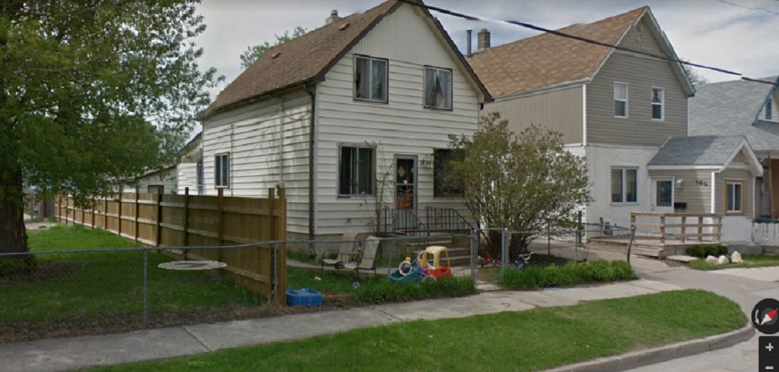
The two houses where Julia Simmons grew up: on the left is 160 (formerly 166) and on the right is 164 (formerly 168) Syndicate Street

The next move for George and Elizabeth Murray was to 324 Ross Avenue where they lived in 1896 with daughters Agnes, Jessie, Robertson, and Margaret. The father George was a labourer. Later, but still in 1896 George, Elizabeth and daughters moved to Pacific Avenue where their last child, daughter Mary Ur(e)y, was born on October 7, 1896. Son George was now a tinsmith, still at 72 Arthur Street. Son John was a shipper, presumably still for E. F. Hutchings. Daughter Elizabeth still not being listed in Henderson, is consistent with her living with the E.F. Hutchings family in 1896.

There is no digitized Henderson available for 1897 but the following year, 1898, was one of several moves. George and Elizabeth Murray, with their 5 daughters moved to 294 Ellen Street. Here are their daughters’ names with their ages (in brackets) in 1898: Agnes (17), Jessie (15), Robertson (12), Margaret (7), and Mary (2). Father George (48) is listed as a teamster in this year, which was a person who drove a team of horses, not uncommon in those days. Remembering that George grew up on a farm in Rathen he would be very familiar with horses. Son George (20), still a tinsmith, moved from 72 Arthur to join the family at 294 Ellen. His employer is not given in Henderson in 1898.

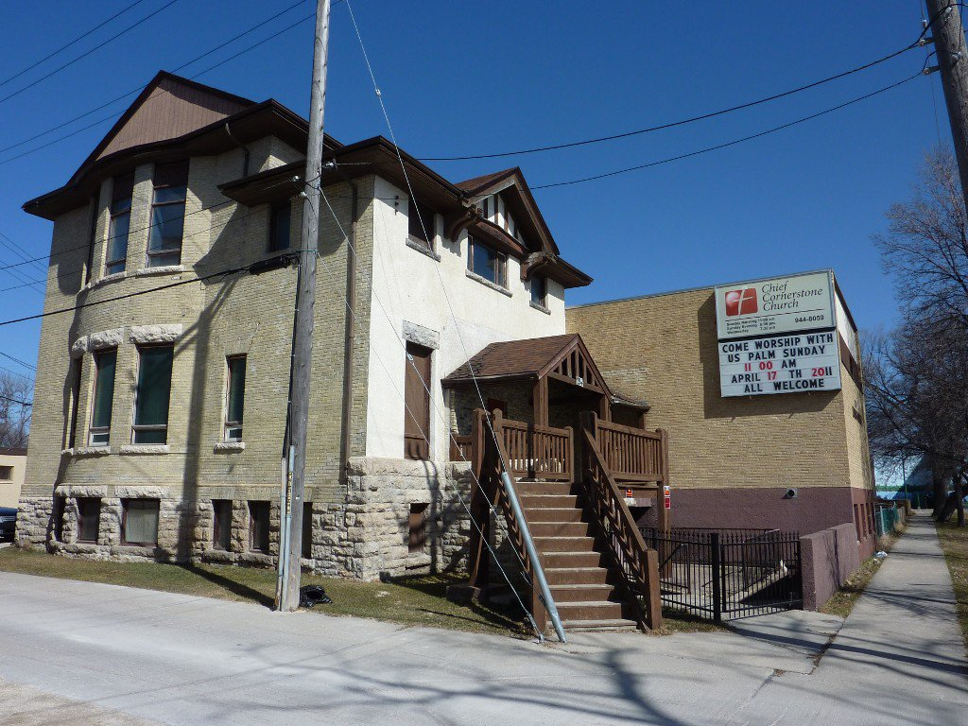

294 Ellen Street: Home of the Murray family in 1898
Year built is unknown

In 1898 there is still no Henderson listing for daughter Elizabeth (23). This is consistent with her living with the E.F. Hutchings family, as a domestic.

Son John (26) is now listed as a harnessmaker for the first time in Winnipeg! This is the job he has wanted since leaving Scotland, 7 years earlier. John and Julia moved into 166 Syndicate with their daughter Gladys. This is the “packing crate house” built by Julia’s father Thornton Simmons in 1884 at a location off North Main, and later skidded on the ice of the Red River to its permanent location on Syndicate Street. Julia’s parents, Thornton and Louisa Simmons, and their family had already moved into their new house next door at 168 Syndicate in 1895. [2020 Note: Due to address shifts, 166 Syndicate is now 160 Syndicate and 168 Syndicate is now 164 Syndicate]. More about the ‘packing crate house is featured in the book “Stories Houses Tell”, by Lillian Gibbons, published by Hyperion Press Limited.

1889 to 1910

As the century came to a close, in 1899, 1900 and 1901, George and Elizabeth Murray and family (with son George and their 5 daughters Agnes, Jessie, Robertson, Margaret, and Mary) were living at 294 Ellen Street. The father George was still a teamster in 1899, becoming a labourer in 1900 and 1901. Father George’s employers are not listed in these years. Son George’s employment is not listed in 1899 but he has become a tinner (tinsmith) for W.W. Cross in the two years of 1900 and 1901. This son, George, remained unmarried, living with his parents throughout their lives.

In the 1901 census for Winnipeg, the family of George and Elizabeth Murray consisted of (with birth dates and ages in brackets): father George- a dairyman (July 10, 1850 – 50); mother Elizabeth (November 6, 1856 – 44) [this is an error and the year should be 1855]; son George- a tinsmith (March 13, 1878 – 23), daughter Agnes H.- a stenographer (July 14, 1881 – 19), daughter Jessie A.- a dressmaker (October 8, 1883 – 17), daughter Robertson (May 7, 1886 – 14), daughter Maggie (June 26, 1891 – 9), daughter Mary U. (October 7, 1896 - 4). In Henderson, 1901 is the first year we see daughters Agnes and Jessie in the workplace. Agnes is listed as A.H. Murray- bookbinder, Stovel Company; and Jessie is listed as Jessie Murray- clerk (employer not given). The Stovel Company was a printing and publishing firm owned by three brothers John, August, and Chester Stovel. In 1901 this company was operating out of a (now) historic building, called the Stovel Block at 245 McDermot Avenue, occupying the north side of McDermot between Arthur and King Streets. Constructed in 1893, originally only 2 stories high, this building still stands. Now known as the Kays Building, it houses ‘Into the Music’. The Stovel Company, and its subsidiaries, would provide employment to Murray family members over many years to come, notably daughter Margaret (Maggie) and her husband Hugh Campbell Anderson.

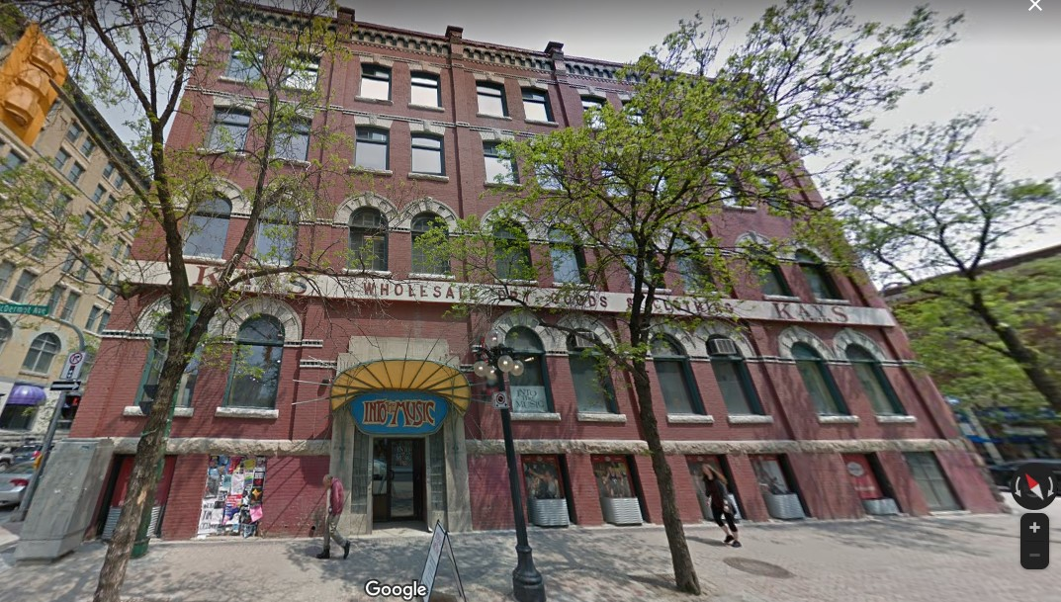

The Stovel Block, 245 McDermot Avenue

Son John continued his trade as a harnessmaker in 1899, but in 1900 and 1901 John was a shipper for the Great West Saddlery Company, the retail division of E. F. Hutchings the manufacturer. This may have been a disappointment for John as his desire was to be a harnessmaker, in the manufacturing end of the business. In 1899 up to and including 1901 John and Julia and their family remained living at 166 Syndicate [now 160 Syndicate, the packing crate house].

In the 1901 census for Winnipeg the family of John and Julia Murray consisted of (with birth dates and ages in brackets): father John- harnessmaker (April 2, 1872 – 28); mother Julia (April 25, 1874 – 26); daughter Gladys (September 27, 1896 - 4) and son George (August 26, 1898 – 2). The full name of Gladys was Gladys Elizabeth Louisia Murray. (Gladys thought her second-last name was supposed to be Louisa, like her grandmother. Gladys’s birth certificate has the “i” in it, and this was never changed.) The full name of son George was John George Thornton Murray; he was called Geordie. The religions given for John was Presbyterian and for Julia and her two children was Church of England. In this census the year of immigration to Canada for John Murray is given as 1887, which does not line up with other information about the family’s immigration. The year of immigration to Canada for Julia is given as 1882, which is consistent with other information. Also living with John, Julia and family were Julia’s brother Owen Simmons and a boarder named Walter Shea.

Elizabeth Murray, daughter of George and Elizabeth, is found living with the E.F. Hutchings family, in the 1901 census for Winnipeg, listed as Lizie Murray and employed as a domestic. Elizabeth’s year of birth (1874) and age (26) are given in this census, but not the birth month nor date. [this is an error because her birth record indicates she was born February 8, 1875]. In 1901 the E.F. Hutchings family were still living at 49 Martha.
From Ancestry.com (Source S.B.), Elizabeth Georgina Barbara Murray married Richard Roden on June 19, 1901.

In the 1901 census for Winnipeg, Richard Roden was living with his parents and this family consisted of (with birth dates ages in brackets): father Joseph- labourer, (August 14, 1843 – 57); mother Maria, (June 27, 1846 – 54); son Richard- labourer (August 12, 1870 - 30). All family members were born in England. In 1901 Henderson’s Directory, this family’s address is given as 587 Pacific Avenue in Winnipeg. This house is no longer standing. Also in the 1901 Henderson, Richard was now employed as a fireman for Canadian Pacific Railway (CPR), and his father Joseph was employed as a labourer (employer not stated).

In 1902 Richard Roden is found living at 294 Bushnell Street, Winnipeg employed by CPR as a fireman. Also living at 294 Bushnell during 1902 is Richard’s father Joseph, employed as a labourer (employer not stated). Elizabeth Georgina Barbara Murray must have moved into the Roden family home after marrying Richard. Elizabeth and Richard had their first child in Winnipeg, a daughter named Florance Lillian, on March 29, 1902. The house at 294 Bushnell is no longer standing, today.

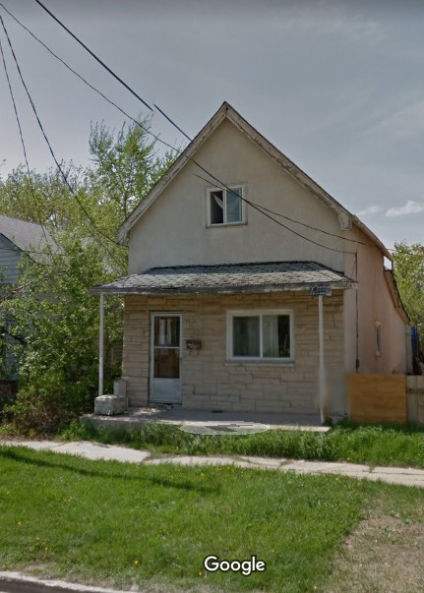
The year 1902 brought another move of residence, this time for daughters Agnes and Jessie who are now listed at 262 Nora Street; a house built in 1901 on a relatively new street in Winnipeg, at that time. This began a pattern where one or two family members would move, then the rest of the family followed the next year. In 1902 Agnes was a stenographer for Stovel. Agnes remained employed as a stenographer at Stovel (then at Nor’ West Farmer). until she married in 1906.

262 Nora Street, today

In 1902 Jessie was a dressmaker at Robinson & Company Ltd, a drygoods retailer. Originally called Robinson, Little and Company, founded at London, Ontario in 1875, this company moved its headquarters to Winnipeg in the early 20th century and began opening small department stores throughout western Canada. Was Jessie making dresses for the store to sell? The large Robinson, Little, and Company building was constructed between 1903 and 1904, and is situated at 54 Arthur Street, now home of Toad Hall Toys. The company operated over 180 “Robinson Stores” until forced into bankruptcy in 1985. Jessie remained employed at Robinson until at least 1909 as a dressmaker, then clerk, then tailoress.

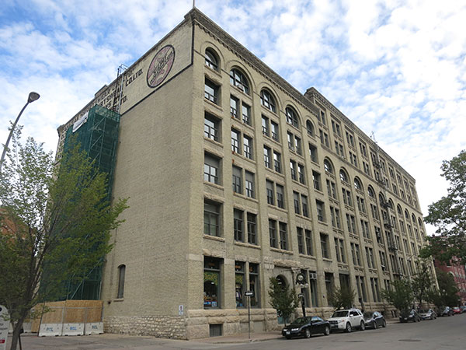

54 Arthur Street: Robinson, Little, and Company Building, today

The two buildings where Agnes and Jessie worked (245 McDermot and 54 Arthur) are about 100 meters (109 yards) apart from each other in downtown Winnipeg. Considering that in 1902 Agnes and Jessie lived together at 262 Nora Street which was about 2.5 kilometers (1 1/2 miles) from their workplaces, they likely walked to and from work together.

Although father George Murray is not listed in 1902, son George is listed as a tinsmith, working for W. A. Templeton (no home address given for George). William A. Templeton was a hardware merchant who also had a tin shop with various locations over the years George would continue working for W.A. Templeton until leaving that employ as foreman in 1931 or 1932. Likely address in 1902 for George, Elizabeth, son George, and daughters Robertson, Margaret, and Mary is still 294 Ellen.

Son John with Julia and their children moved from the ‘packing crate house’ at 166 Syndicate [now numbered 160 Syndicate] to down the street at 148 Syndicate [still 148 Syndicate, this house number did not change]. John and Julia’s third child, daughter Ruby Frances Louisa was born July 14, 1902, which may have prompted their move. Another possible reason for moving is that Julia’s brother, Thornton, married Maud Loader in 1902; and in 1903 they moved into the packing crate house vacated by John and Julia.

John left the harness and saddlery business in 1902 and became a coal and coal oil merchant and a driver. He will not return to harness making until he opens his own business, J. Murray & Co in 1908.
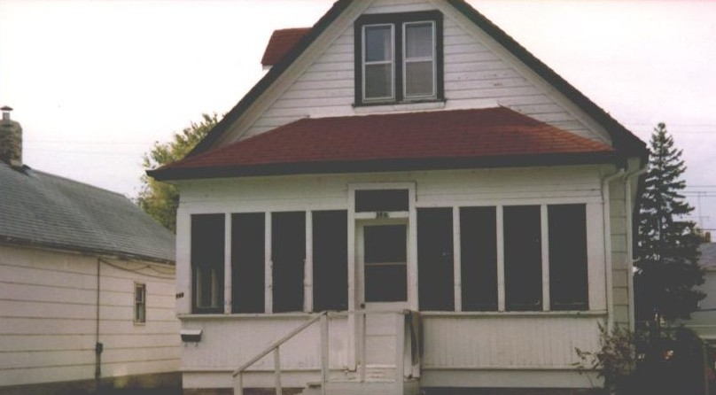

LEFT: 148 Syndicate: photo taken by Gladys Murray (year unknown)

BELOW: 148 Syndicate, today (the brown house in the middle)

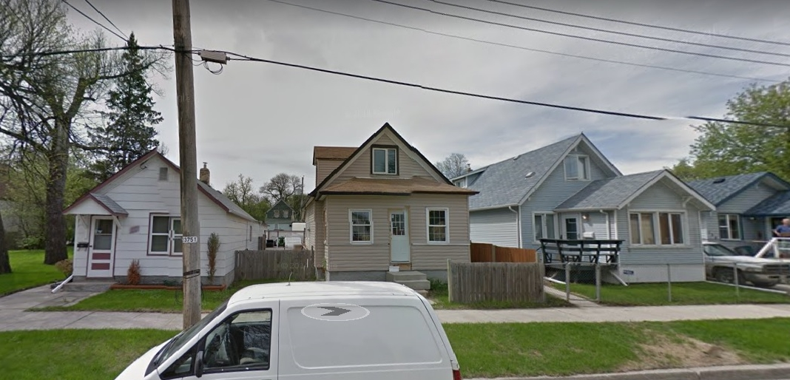
148 Syndicate, today

This is the year, 1903. For historical context, the Wright brothers made their famous flight on December 17th, 1903, at Kitty Hawk, North Carolina.
Still living at 262 Nora in 1903, Agnes and Jessie (with the same jobs as in 1902) were joined by their father George, now a milkman (milk delivery by horse drawn wagon), brother George (the tinsmith at W.A. Templeton) and their mother and sisters Robertson, Margaret, and Mary.

Son John was employed as a coal merchant in 1903. John, Julia, and children remained living at 148 Syndicate until 1914.

In 1903 Richard Roden is still listed at 294 Bushnell Street, Winnipeg, (presumably) with his wife Elizabeth (nee Murray) and daughter Florance. Richard is employed by CPR as a fireman. Also still living at 294 Bushnell is Richard’s father Joseph, employed as a labourer.

In 1904, Richard Roden, is still listed at 294 Bushnell Street, Winnipeg and still employed by CPR as a fireman. There is no Henderson record of Richard’s father Joseph Roden in 1904. On March 26, 1904, Elizabeth and Richard had their second child, a son, named Richard Hendry Roden.

In 1904 daughter Robertson (Robin) entered the workforce at Robinson & Co in the millinery department. In this year she was 18 years old. Her home was 259 Sherman with her older sister Jessie (who was still a dressmaker at Robinson). Sherman Street was very new in 1904, and this house was a new one. The rest of the family still lived at 262 Nora (but not for long!). These 2 addresses (259 Sherman and 262 Nora) back onto each other and are literally across the back lane from each other. Living back to back and with workplaces only 100 meters (109 yards) apart from each other, surely Agnes (still a steno at Stovel), Jessie, and now Robin would have walked back and forth to work together. Their father George was still a milk man (employer not named) and their brother George was still a tinsmith at W.A. Templeton.

In 1904, son John was employed as a coal oil merchant (employer not named), living with his wife and children at 148 Syndicate Street.

John was a driver for Imperial Oil in 1905. Most companies, including Imperial Oil, were still delivering their goods by horse drawn wagons in those days. John and Julia’s fourth and last child, daughter Hazel, was born June 11, 1905. They continued living at 148
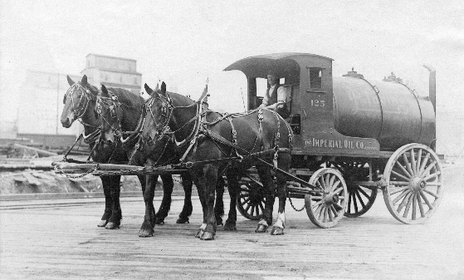
Syndicate.
The photo at right is an Imperial Oil tanker vehicle. This method of delivery continued into the 1920’s.
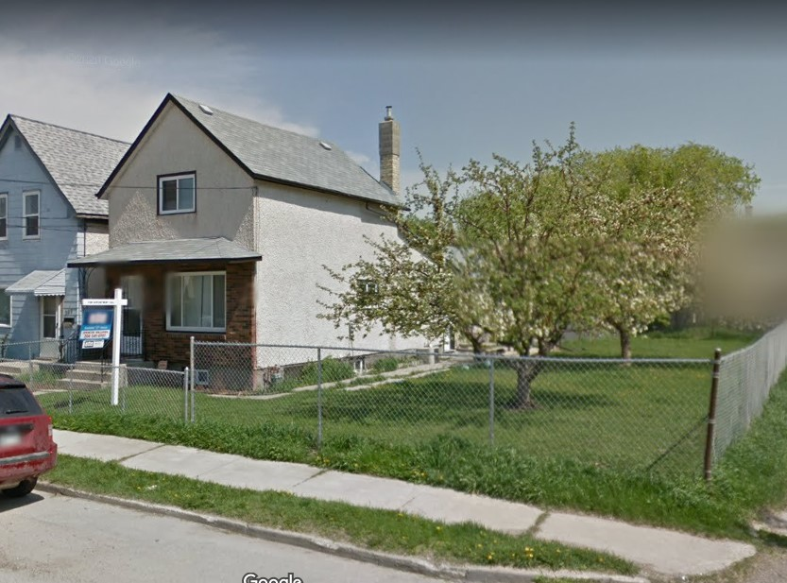

The same year, 1905, George, Elizabeth and family moved to 255 Sherman, a house which was built in 1903. So, at 255 Sherman were George and Elizabeth, daughters Agnes, Jessie, Robin, Margaret, Mary, and son George (the tinsmith working at W.A.Templeton)

255 Sherman, today

As for other job changes in 1905, father George is listed as a ‘dairyman’ which is likely the same occupation as the year before (milk man). Agnes is now working for Nor’ West Farmer, a publication for which the Stovel brothers (of Stovel Company) were president and directors. Probably both companies were in the same building. Jessie’s job remained the same, being a dressmaker at Robinson, and Robin is listed as a ‘clerk’ which might or might not have been a job change, but still at Robinson.

In this year of 1905, daughter Elizabeth and her husband Richard Roden have moved to 531 Flora in Winnipeg and Richard was promoted to train engineer still employed by CPR. This house at 531 Flora seems to be not standing, today.

The year 1905 is the first time we see John (Jack) Alvin Hudson in Winnipeg Henderson’s Directory. John (Jack) Alvin Hudson was born in Adjala Mono Mills, Ontario. He earlier appears in the Winnipeg census of 1891 when he was 8 years old, living with his parents (Robert and Ruth), his brothers (Daniel and William) and a lodger (James Duncan). Their address might have been 217 Market Street. John’s father died on November 2, 1895. In 1901 Henderson his mother was proprietor of Ideal Restaurant at 290 William. A restaurant still exists at this location. In 1901 John was living with his mother at room 23-124 Princess, a short walk (150 feet) from 290 William. The building at 124 Princess is no longer standing, today.

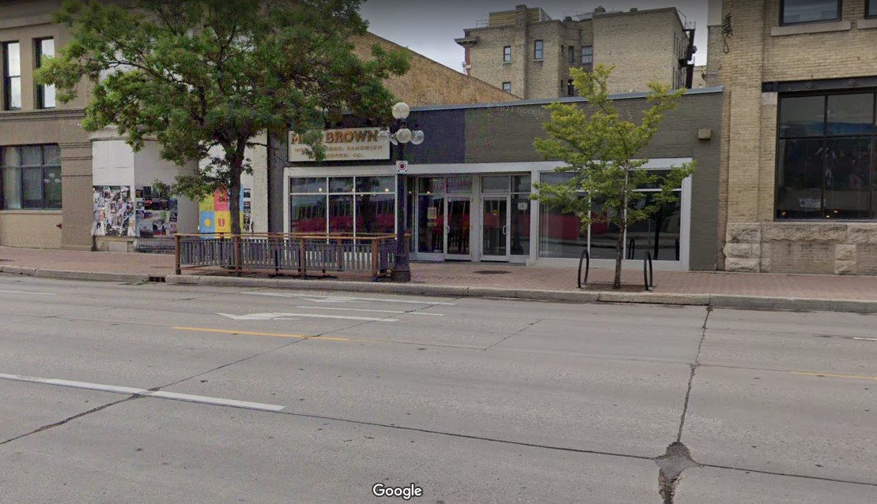
290 William, today

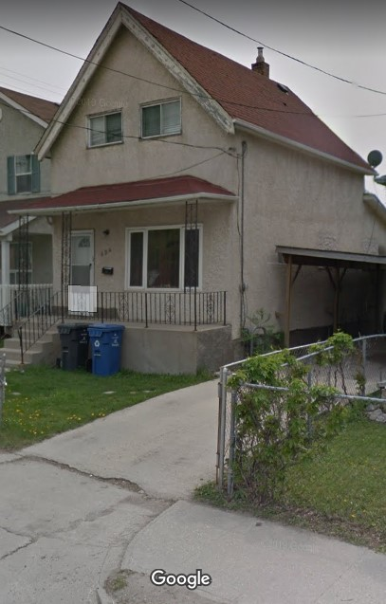
According to 1905 Henderson, John Hudson is rooming at 654 Wellington Avenue, a brand new home built in 1905 and owned by Josiah Jerrard, a printer. John is manager of Empire Cycle Company (a bicycle company) at 224 Logan. Also, this is the first year in Henderson we see Empire Cycle Company. If there is an owner of Empire Cycle other than John, that owner is not listed. John Alvin Hudson would marry Agnes Hendry Murray in 1906.

The building at 224 Logan is no longer standing, today.
654 Wellington Avenue, today

For historical context, on July 15, 1905, Eaton’s established its first major presence outside Toronto, on Portage Avenue in Winnipeg. The five-storey store, headed by founder Timothy Eaton’s son John Craig Eaton, made a stir with its elaborate lighting, sprinkler systems, and escalators that had not been seen in the city before. According to WIKI, “For many years, the Winnipeg Eaton's store was considered the most successful department store in the world….” In the same year, Eaton’s had their first Santa Clause parade in Toronto and Winnipeg, which would become an important annual event for Gladys and her family.
In 1905 Saskatchewan and Alberta joined Canadian Confederation as provinces prompting a census of Manitoba, Saskatchewan, and Alberta the following year.

The year 1906 was a census year for Manitoba, Saskatchewan, and Alberta. The population of Winnipeg was 90,153 people. In Henderson, George, Elizabeth and family are still all listed at 255 Sherman, except Jessie who has already moved to 659 Simcoe. This house does not exist today. On the census, taken July 5, 1906, George, Elizabeth, and family (son George, daughters Agnes, Jessie, Robertson (Robin). Margaret (Nellie), and Mary) are listed as moved to 659 Simcoe. The family will live at 659 Simcoe until 1920 or 1921. In 1906 all family members had the same occupations as the previous year, except Robin who is absent from Henderson in 1906.

Elizabeth and Richard Roden are still living at 531 Flora in Winnipeg. They were found in the 1906 Henderson, but they seem to have missed the census. In 1906, Elizabeth and Richard had their third child, a son, named Harold Murray Roden, born April 20, 1906.

John, Julia, and family are still living at 148 Syndicate. In the 1906 census for Syndicate Street, John has a horse, as do his father-in-law Thornton Simons and two of his brothers-in-law George and Frank Simmons. Did they keep their horses on Syndicate Street? I think they do.

On August 22, 1906 Agnes married John (Jack) Alvin Hudson, who was still a manager for Empire Cycle Company at 224 Logan in 1906. In the 1906 census John A. Hudson was a 23 year old lodger living at 162 Carlton, the home of Henry and Sarah Ward. This home no longer exists. Agnes was a steno at North West Farmer in 1906. Agnes is not listed in Henderson after 1906, and might not have been employed again.

In 1907 Agnes and John Hudson lived at 429 Redwood. This was a very new home built in 1905. The Henderson listing indicates they were home owners of that property. On June 23, 1907 they had a son Thom Murray Hudson who sadly passed away on June 29, 1907. In 1907 John was still manager for Empire Cycle Company at 224 Logan. The year 1907 is the first year a John Crabtree is listed in Winnipeg Henderson. This could be Harold John Crabtree or his father. This person is listed as a machinist or mechanic for Otis-Fensom Elevator Co, but the following year John Crabtree would start working for John Hudson. No other information is given for John Crabtree in 1907.

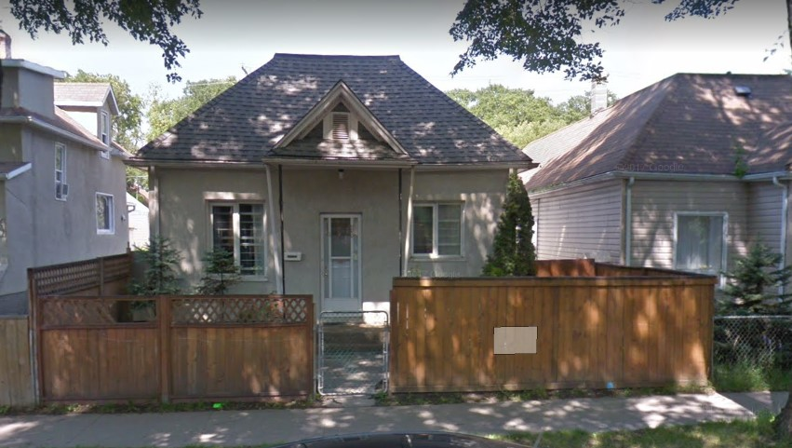

429 Redwood, today

In 1907 Agnes’s parents, her brother George, and her sisters (Jessie, Robin, Margaret, and Mary) continued living at 659 Simcoe. Father George Murray and son George Murray both have the same jobs, and at the same employers, as in 1906. Jessie is a clerk and Robin is a milliner, both at Robinson & Co. Ltd. John Robertson Murray, still living at 148 Syndicate, is listed as a coal oil dealer in 1907.

Elizabeth and Richard Roden are still living at 531 Flora but this (1907) would be their last year in Winnipeg. Richard is still a railroad engineer with CPR. They are not listed in Henderson’s Directory after 1907 so this is likely when they moved to Souris, Manitoba and raised their family of 6 children there. So, we now know that Elizabeth, the second oldest child and the daughter who stayed behind in Scotland with her ailing grandmother, was the first child to move away from Winnipeg. Souris is about 152 miles (244 kilometers) from Winnipeg.

The year 1908 was a really big one for John Robertson Murray, as it was then he started his own company! He was 36 years old. The first location was 103 Higgins and erroneously called “James Murray Saddlery” in Henderson, with “James” Murray living at 148 Syndicate. In a letter dated April 10, 1908, Julia’s father, Thornton, wrote to Julia’s daughter, Gladys, “You say your dad has moved shop. I hope he will do better where he has started.” Thornton must be referring to the move to 180 Princess Street. He did do much better! J. Murray and Co continued in business until 1932, a run of 24 years. However, change was coming because in this same year, Henry Ford launched the Model T car, which would eventually revolutionize family transportation.

Still all living at 659 Simcoe in 1908, George and Elizabeth Murray and their daughters have the same occupations as the previous year except Jessie has advanced to tailoress and Robin is listed an ‘employee’, both at Robinson.

In 1908 Agnes and John (Jack) Hudson still live at 429 Redwood, with John now being a manager for Consolidated Bicycle and Motor Co. with one of their locations at 224 Logan, the other location being 185 Notre Dame East. It looks like three companies (Empire Cycle, Crescent Bicycle and North End Cycle.) consolidated to create this one new company. The Henderson listing for Consolidated Bicycle and Motor Company gives C.G. Cruikshank (no relative to me) as the general manager. In 1908 and onward there is no listing in Henderson for either Empire Cycle, nor Crescent Bicycle, nor North End Cycle. The product line offered by Consolidated is not only bicycles, but includes motorcycles which were essentially bicycles with motors in those early days. Also employed at Consolidated Bicycle and Motor Co is John Crabtree, a machinist, rooming at 581 Balmoral.

The 1909 Henderson carried a bold print advertisement for “J. Murray & Co. Manufacturers of Light and Heavy Harnesses of all kinds, Dealers in Whips, Robes, Riding Saddles, Blankets, and Horse Clothing -180 Princess - Phone 8452”. This is the company of John Robertson Murray. J. Murray & Co was a manufacturer, occupying the southerly half of the ground floor of the McGregor Block which comprised of 180 and 182 Princess, both at street level, as well as (possibly 7 or 8) second storey rooms addressed 180 ½ Princess. The McGregor Block had been constructed in 1892, designed by architect George Browne (1852-1919). John, Julia, and family (Gladys, Geordie, Ruby, and Hazel) still lived at 148 Syndicate in 1909.
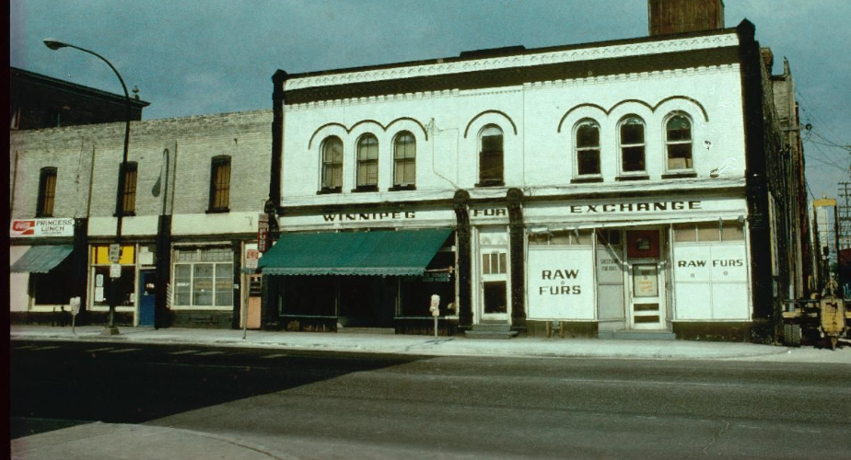
Princess Street from 172 to 182 Princess
In the photograph above, the white building is the McGregor Block. J. Murray & Co occupied the southerly half of the ground floor (where the green awning is).

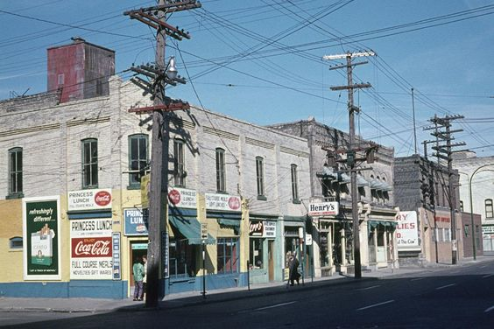
Princess Street from Elgin Avenue, looking North
Princess Lunch in the foreground then the McGregor Block, before Ross Ave

George, Elizabeth, and son George, daughters Jessie, Margaret, Mary are still living at 659 Simcoe in 1909. This is the last year we see Jessie in Henderson. Robin has moved to 255 Sherman, where the family had previously lived from 1905 to 1906. In 1909 father George and son George have the same occupations as the previous year. Margaret (listed as Nellie in Henderson) turned 18 this year and has now joined the workforce as a stenographer at Nor’ West Farmer. This is the same position and employer as her sister Agnes had before being married. Robin is a clerk at Robinson & Co.

In 1909 Agnes and John (Jack) Hudson moved to 537 Langside. That address is a vacant lot today. They had a son, Robert Murray Hudson, born on November 3, 1909. Of course ‘Murray’ was Agnes’s maiden name. John has the same employment as the previous year, which is a manager for Consolidated Bicycle and Motor Co. The Henderson listing for Consolidated Bicycle and Motor Co indicates three locations and three managers as follows: at 224 Logan is J.A. Hudson, manager; at 849 Main is C.L. Cruickshank manager; at 185 Notre Dame (East) is Joseph St Mars, manager. Agnes is still not listed in Henderson which indicates she likely was not employed in those days. John Crabtree is a mechanic, living at 283 Elgin and working for John Hudson at Consolidated Bicycle and Motor Co.
In 1910, we see Sam Cascisa, owner of S. Cascisa Restaurant at 172 Princess for the first time. This restaurant building, on the corner of Princess Street and Elgin Avenue, appears as Princess Lunch on the previous page photo. Prior to 1910, the restaurant location had been occupied by Restivo Bros. dealer in fruits, who had employed Marie Cascisa [Sam’s wife?]. Sam(uel) Cascisa had been a confectioner at 537 Ellice the year before, also living at 537 Ellice. The restaurant at 172 Princess became known as Elgin Café, employing Sam’s wife and children. Sam Cascisa would continue to own Elgin Café until 1939. Sam and John Murray would become friends and would often visit back and forth, on Princess Street. Over the years these two families informally crossed paths so often that it became a family joke to say, “Guess who I saw today?” with the answer being “Sam Cascisa!” or some such variation. Between Elgin and Ross Avenue, on the west side of Princess Street, were: 172- S. Cascisa Restaurant, 178-vacant, 180-J Murray & Co, 182-C A Dickerson wholesale produce, a back lane; and 186 (now 188)-the Carnefac Block. Of these buildings, the Carnefac Block is the only one which remains in 2021, and in 2016 it was designated as an historical building.

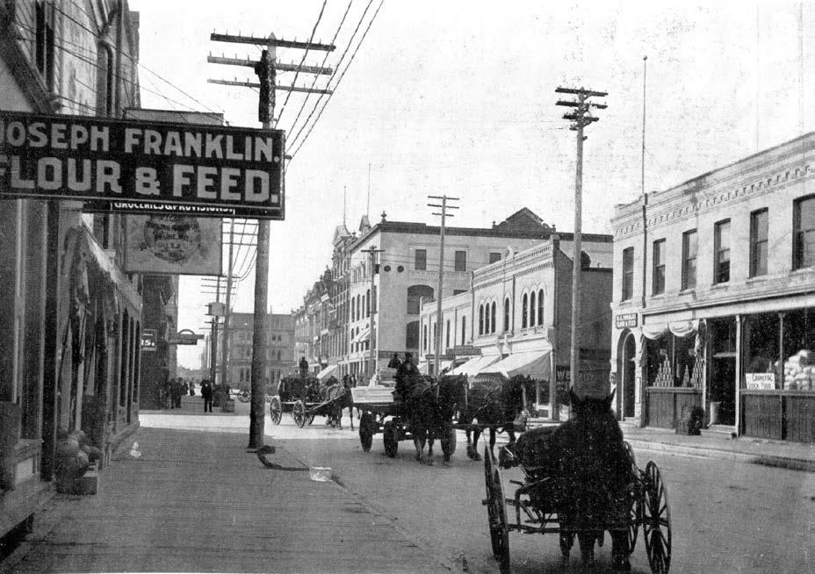
188
182
178
180
172

Princess Street looking South-circa 1903
Blue arrows indicate the addresses on Princess

Regarding residences and occupations in 1910, George, Elizabeth and family were still living at 659 Simcoe. Father George is now a coal oil dealer (employer not stated). Son George is still a tinsmith (employer not stated). Nellie (Margaret) and Jessie are not listed (possibly not employed) in 1910.

The Henderson page for Agnes and Jack Hudson did not get digitized for 1910. Consolidated Bicycle and Motor Company Ltd was listed for 1910, located at 185 Notre Dame, C.G Cruikshank (was spelled ‘Cruickshank’ in 1909) as manager. Also, Dominion Cycle Co was listed at 224 Logan, with Crabtree and Hudson, proprietors. Listed under Crabtree in 1910 is the company “Crabtree (HJ) and Hudson (JA), bicycle dealers, 224 Logan.”

Robertson Murray (Robin) was not listed in 1910 Henderson. She married Arthur Ernest Pearce (known as Ernest) on November 30, 1910, the year she was 24 years old, according to Ancestry.com. Ernest was born in Ontario in May, 1884 (died 1970). Robin and Ernest first met when they lived with their respective parents on homesteads in East Assiniboia (Saskatchewan). Robin (born May 7, 1886) was 4 years old when the Murray family arrived in Saltcoats and 5 years old when they moved to the homestead. Robin was years 8 old when they moved from the homestead to Winnipeg. I do not know how they met up in adult years. John Pearce (taken to be Ernest’s father) homesteaded on SE 36-Township 25- Range 3-west of the 2nd meridian. This land is located north of Rokeby, Saskatchewan. Robin, then, became the second daughter (Elizabeth was the first) to move away from Winnipeg. (see Appendix, Note 1)

John, Julia and children are still living at 148 Syndicate in 1910.

1911 to 1915

The 1911 Henderson indicates that John still lived at 148 Syndicate Street. The census for Winnipeg confirms that John, Julia and children were living at 148 Syndicate Street. The birth dates given in this census for this family are erroneous. John’s occupation in the 1911 census is given as storekeeper, self-employed, which is consistent with owning J Murray and Co.

Elizabeth and Richard Roden could not be found anywhere in Manitoba in the 1911 census.

The 1911 census shows that George, Elizabeth and family were living at 659 Simcoe with the family (birth dates and ages in brackets) consisting of: father George- salesman (July, 1851-60) [census error, it should say 1850]; mother Elizabeth (November, 1856-54) [census error, it should say 1855 and age 55]; son George- tinsmith (March, 1878-33); daughter Margaret-stenographer (June, 1881-19); daughter Mary (October,1896-14). Jessie was not found in the 1911 Manitoba census. Her last appearance in Henderson was in 1909.This might be around the time she moved to Saskatchewan, and a Jessie Murray was found in the 1911 Regina census that could be her. Jessie would be the third daughter to leave Winnipeg. Jessie Murray was not found anywhere in the 1916 census of the prairie provinces nor in the Canadian 1921 census. Jessie was married on June 2, 1921. Jessie married William Stevenson (Born 1885 - Died 1937) clothing salesman from Shaunavon, Saskatchewan. Jessie died in 1965.

Henderson for 1911 confirms the family address as 659 Simcoe with father George as a coal oil dealer (employer not listed), son George as a tinsmith (employer not listed), daughter Margaret (Nellie) as a stenographer for Nor’ West Farmer, and Jessie not listed.

In 1911 Agnes and Jack (Hudson) have moved into 120 Bannerman Avenue, a home they would have for the rest of their lives (until 1961). According to Henderson, this house was brand new. It did not exist in Henderson before 1911; and the street was not yet fully developed when 120 Bannerman was built in 1911. For example, there were 4 vacant lots to their west before the intersection of Emslie Street. From Google maps, this house remains in good appearance today (2021), in what appears to be a well-kept neighbourhood. In the 1911 Henderson, Jack Hudson is now a proprietor of Dominion Cycle Co., 224 Logan. The other proprietor was H. John Crabtree who lived at 154 Ellen, according to Henderson. No one with the last name of Crabtree is listed in the digitized Manitoba census for 1911.In the 1911 census this Hudson family consists of (with birth dates and ages in brackets): -father John Alvin- merchant, bicycle shop, employer, self-employed, Anglican (August, 1882-28), mother Agnes, Presbyterian (July, 1881-29), son Robert, Presbyterian (November 1909-1). Son Robert is Robert Murray Hudson who would become a doctor and the father of [confidential].
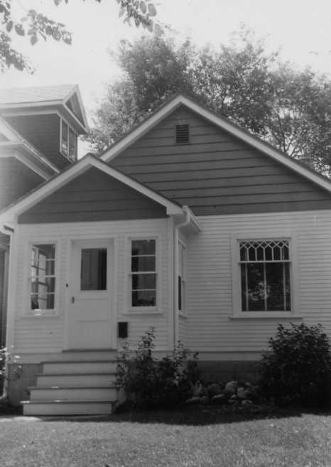

120 Bannerman Avenue, year unknown

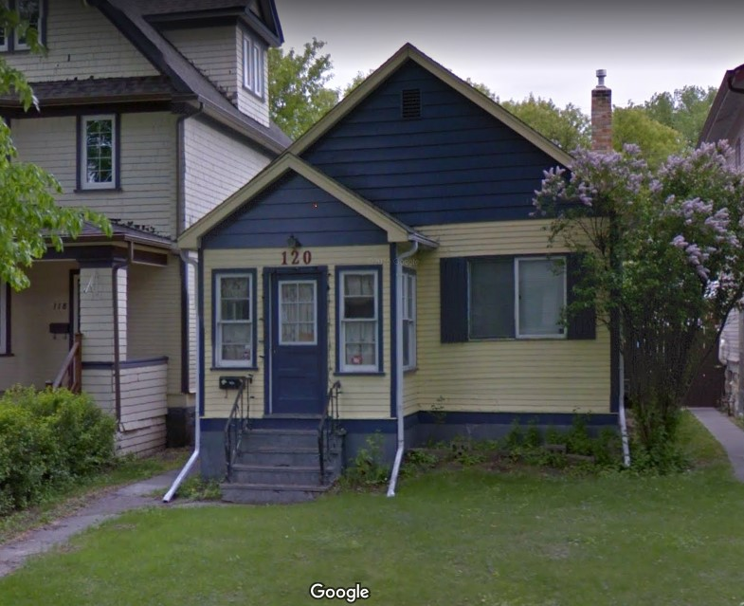

120 Bannerman Avenue, today

In the 1911 Census, Robin and Ernest Pearce are living on a farm on Township 25-Range 3-west of 2nd meridian. As mentioned, the original homestead land for John Pearce was SE Section 36-Township 25- Range 3 west of 2nd meridian. The land occupied by Robin and Ernest in 1911 would have included the original homestead property in Saskatchewan. In the 1911 census the family consists of (with birth dates and ages in brackets): husband Arthur E. (May, 1884-26), wife Robinson [census error, it should say Robertson] (May, 1884-26), Andrew ‘”McCrindle”- farm labourer (September, 1884-25), Harry Reid- farm labourer (March 1893-18), Hilda “Crimmel”- domestic servant (April, 1871-40).

In Henderson, 1911 is the first year we see David Magee in Winnipeg. David was 21 years old. He was born June 3, 1890 in the village of Kemptville, township of Oxford, county of Grenville, Ontario. He was raised in Cardinal, Ontario. In 1911 David Magee was a clerk working for AR Christie and living at 374 Home Street. The house at 374 Home Street was built in 1909. The prime resident at this address is listed as John E Magee, a butcher, which is likely John Magee, David’s older brother.

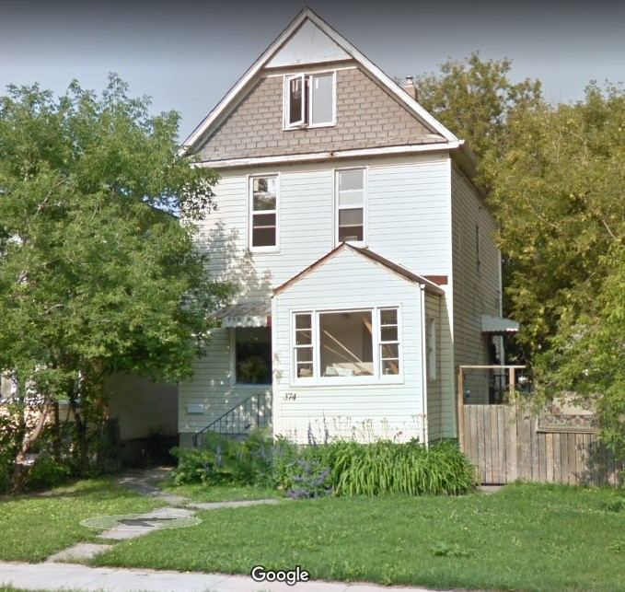

374 Home Street, today

For historical context, the Fort Garry Hotel in Winnipeg was built between 1911 and 1913 by the Grand Trunk Pacific Railway. This hotel is located one block from the railway's Union Station, and was the tallest structure in the city when it was completed. Like other Canadian railway hotels, it was constructed in the "château style" (also termed the "neo-château" or "châteauesque" style)

George, Elizabeth and family (son George, daughters Margaret and Mary) were still living at 659 Simcoe in 1912. Father George is a coal oil salesman (employer not given). Son George is still a tinsmith (employer not given). Margaret (Nellie) is still a steno, now employed at Stovel Co. where her sister Agnes started working in 1901.
Jessie was not found in 1912 Henderson.

Agnes and John Hudson were still living at 120 Bannerman Avenue in 1912. John Hudson and John Crabtree continued to be proprietors of Dominion Cycle Co. which has now expanded to 224-226 Logan. John Crabtree as living with his family members at 60 Polson in 1912.

John Robertson Murray and family were still living at 148 Syndicate, in 1912, John had a 1/3 page picture advertisement in Henderson’s Directory for J. Murray & Co.

In 1912, for the first time we see John and Julia Murray’s daughter, Gladys, in the workforce. She was 16 years old in 1912 and living with her parents and siblings at 148 Syndicate. Her job was a steno for Clark Brothers & Company, located at 143 Portage Avenue East. Clark Brothers was previously the firm of Love, McAllister & Company, wholesale stationers and paper dealers which Douglas Alexander Clark bought in 1898.

In 1912 David Magee (listed as D. Magee), was a travelling salesman, still living at 374 Home Street. The prime resident at 374 Home Street is again listed as John E. Magee who first appears in Winnipeg in 1908 (likely David’s older brother John Magee).

The Lightfoot family first appears with certainty in 1912 Winnipeg Henderson. Only one person appears and that is Jemima Lightfoot, with a job as ‘folder’ at Bulman Bros. This company was a lithographer and printer located on the south west corner of McDermot Avenue and Frances Street, which is now a parking lot. In 1912, Jemima Lightfoot was living at 5 McDermot Place. This family will become intermarried with the Murray family 2 generations hence. The building at 5 McDermot Place has been removed.

The following year, March 1913, Clark Brothers opened their new, 5 storey brick building at 48-50 Charlotte Street. Due to changes of street names and of address numbers, Charlotte Street became Hargrave Street and 48-50 became 448 Hargrave Street. This building, constructed in 1912 is still called Clark Brothers Warehouse as documented by the Historical Buildings & Resources Committee, City of Winnipeg. Gladys Murray likely worked on the second storey facing the street, where the general offices were. Gladys took the street car to work and met David Magee who had become a street car conductor for Winnipeg Street Railway in 1913. David still lived at 374 Home Street. The prime resident of this address is now listed as Mrs. Julia Jones. On December 22, 1913, Gladys married David Magee and moved to Cardinal Ontario. David was 23 years old and Gladys was 17.

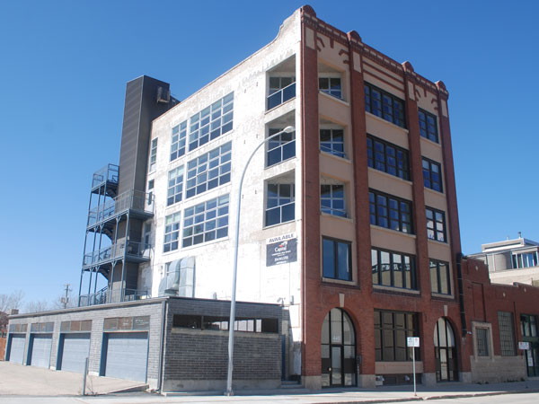

Clark Brothers Warehouse, 448 Hargrave Street
(the garage at the side built in 2012, and the tower at the back are later additions)

In 1913, John, Julia and children (Gladys, Geordie, Ruby, and Hazel) moved from 148 Syndicate into the same home they vacated in 1902; that is 160 Syndicate (the ‘packing crate house’ built by Julia’s father in 1884). Gladys’s Notice of Marriage in December, 1913 gives 160 Syndicate as her address. Henderson picks up this move in 1914. In Henderson, John is listed in bold print: “of J. Murray & Co” and their home phone number is given (St John 1799). J Murray & Co has a ¼ page advertisement in 1913 Henderson.

The Lightfoot family in 1913 Henderson consists of Jemima, Chas, and their two sons James and Chas G. (junior), all living at 5 McDermot Place. Chas G. Lightfoot would (on May 12, 1918) have a son named Arthur, who would marry Gladys’s daughter Verna (born on July 3, 1916).

George and Elizabeth Murray and family were still living at 659 Simcoe, in 1913. Father George was employed as a “traveller” which is a travelling salesman. Son George was still a tinsmith. Employers were not listed for either of the Georges.

Margaret (Nellie) was not found in 1913 Henderson.

Agnes and Jack Hudson were still living at 120 Bannerman in 1913 and Jack was still co-proprietor of Dominion Cycle Co., with J. Crabtree, located at 224-226 Logan Avenue. John Crabtree was still living with a family member at 60 Polson in 1913.

In 1914 George, Elizabeth and their family were still living at 659 Simcoe. The father George had no occupation listed. The son George was listed as a tinsmith (no employer given). Daughter Margaret is a steno, and has returned to Nor’-West Farmer. The daughters of George and Elizabeth not listed in 1914 Winnipeg Henderson are Elizabeth (in Souris), Jessie, Robin (in Saskatchewan), and Mary (not yet working).

Agnes and Jack Hudson were still living at 120 Bannerman in 1914. Their daughter, Elizabeth Ruth Hudson was born on February 12, 1914. Jack was now sole proprietor of Dominion Cycle Co. with H.J. Crabtree as manager (not proprietor). Dominion Cycle was located at 224-226 Logan Avenue plus a new location at 587 Portage Avenue, in Winnipeg. John Crabtree was still living with family members at 60 Polson.

In 1914 John and Julia, with their children Geordie, Ruby, and Hazel, are listed as living at 160 Syndicate. In this year we find Geordie, at 16 years old, in the workforce for the first time. He is employed as a clerk for Adams Brothers Harness Manufacturing. Adams Brothers, a Toronto, Ontario company, came to Winnipeg in 1911 and located at 154 Market Street. Oddly, Adams Brothers looks like a competitor to J Murray & Co. The same year Geordie’s father, John, had a ¼ page advertisement in Henderson for J. Murray & Co harness manufacturers. John and Julia’s daughter, Gladys, was still in Cardinal, Ontario, with her husband David Magee. Gladys had their first child, daughter Helena Isabelle on August 8, 1914 (that’s my Mom).

In the following year, 1915, John Murray’s son Geordie switched jobs to become a plumber’s helper (employer not given). He was still living with his parents (John and Julia) and his sisters (Ruby and Hazel) at 160 Syndicate. John’s company, J. Murray & Co had a ¼ age picture advertisement in Henderson including the words “Manufacturers of Every Description of Harness”.

John’s parents, George and Elizabeth were still living at 659 Simcoe with their son George (the tinsmith, employer not given), and daughters Margaret (Nellie) and Mary, in 1915. Father George’s occupation is salesman (employer not given). Nellie is still a stenographer at Nor’ West Farmer. Mary, now 19 years old, makes her first appearance in the workforce as a stenographer at Royal Trust Company. Royal Trust operated out of the Bank of Montreal Building, a well-known magnificent edifice which still stands at the intersection of Portage Avenue and Main Street. The Bank of Montreal Building was completed in 1913.
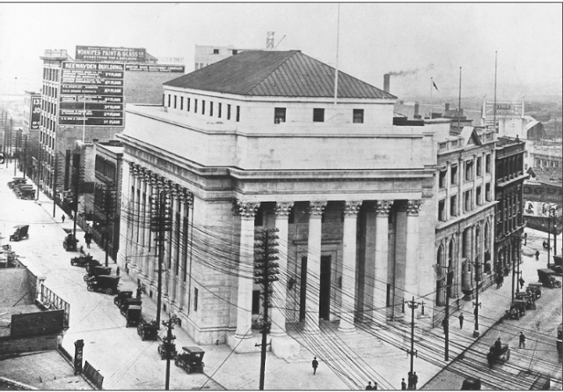

Bank of Montreal Building circa 1913

Agnes and Jack Hudson were still living at 120 Bannerman in 1915. Jack is a co-proprietor with John Crabtree (who is again a proprietor) of Dominion Cycle with locations at 224-226 Logan Avenue and 587 Portage Avenue. About this year, John and Agnes got on a motorcycle with a sidecar and took their two children (Robert and Elizabeth) to visit Anges’s sister Elizabeth Roden is Souris. This was a big trip and more so by motorcycle. As for John Crabtree, he was living with family members at 104 Broadway Court in 1915.

1916 to 1921

Due to the rapid expansion of the Northwest Provinces (Manitoba, Saskatchewan and Alberta) the Canadian Government conducted a special census with data as of June 1, 1916. The Northwest provinces are referred to as the prairie provinces today, being Manitoba, Saskatchewan, and Alberta.

In the 1916 census, as sometimes happens, there are errors that are very obvious to family members (like us). The family of George and Elizabeth in this census consists of (ages in brackets): father George- salesman (65), mother Elizabeth (59) [error: should be 60], son Muray [too funny, should be George]- tinsmith (38), daughter Margaret- stenographer (24), daughter Mary Ury (19). Also in error is the birth place of Margaret which was North West Territories (now Saskatchewan) not Manitoba as stated in the census. The year of immigration for those not born in Canada is stated as 1890 which is not correct for the father George who arrived in 1889. Finally, in this census the last name is spelled “Muray” instead of “Murray”. All are living at 659 Simcoe. All are Presbyterian. The 1916 Henderson confirms that George, Elizabeth and family are still at 659 Simcoe, but the father George is a market gardener (employer not given), their son George is a tinsmith (same as census); and daughters Margaret (Nellie) and Mary are both stenos; Margaret with Nor-West Farmer and Mary with Royal Trust Co.

The 1916 census lists John, Julia and family consisting of (with ages in brackets): father John- harness maker (43), mother Julia (42), son George (Geordie) - occupation not listed (17), daughter Ruby (13), daughter Hazel (10). Stated family religion is Presbyterian. (Henderson gives Geordie’s occupation as labourer.) This 1916 census shows John, Julia, and family have moved into 128 Syndicate Street, a house built in 1905. Gladys referred to 128 Syndicate as “the big house on the corner”, and it was likely the biggest house on the block at the time and even now it is. It must have been a big step up, to move from ‘the packing crate house’ to the big house on the corner. Gladys said she never did live in this house because by this time she was already “away” (married and living in Cardinal, Ontario, with her husband David Magee.) Gladys had her second child, daughter Verna, on July 3, 1916. John continued to run a ¼ page advertisement in Henderson for J. Murray & Co at 180 Princess Street.

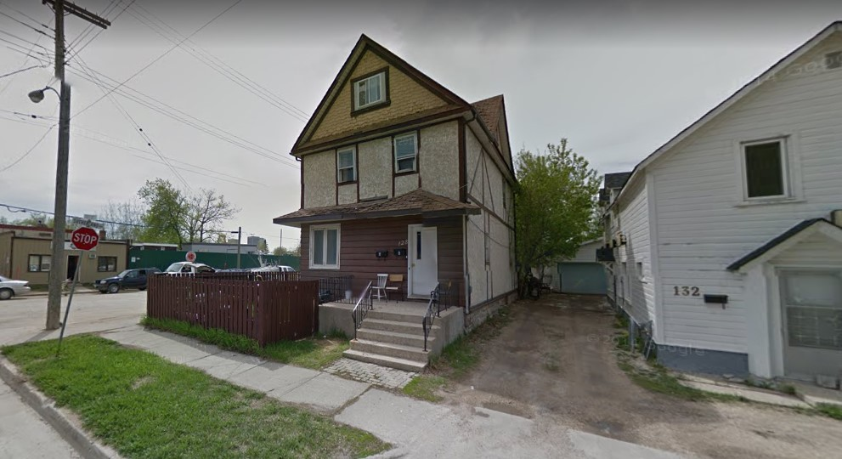
128 Syndicate Street, today
In 1916, living upstairs of John Murray’s shop, in suite 2-180 ½ Princess Street, was John Lightfoot, seemingly the brother or son of Chas (senior) Lightfoot. With John was Mrs. A. Lightfoot, an usher at Pantages Theatre. The grandson of Chas (senior) Lightfoot, Arthur Leslie Lightfoot, would be born two years later, on May 12, 1918; and would grow up to marry Gladys Murray’s daughter, Verna.

From the 1916 census, Elizabeth and Richard Roden are still living in the town of Souris Manitoba. Richard is still a train engineer with CPR and Elizabeth is not employed. By this time, they have 6 children, and the family consists of (with ages in brackets): father Richard (44), mother Elizabeth (41), daughter Florence L. (age 14 years) son Richard H. (age 12 years), son Harold M (10), daughter Jean E. (8), son Earl R. (6), son Albert E. (4). The stated religion for all family members is Presbyterian. There is not a Henderson for Souris so the next time we will see this family is in the 1921 census.

The 1916 census has several errors that must simply be ignored as wrong, but here is how it lists the Hudson family members (ages in brackets): John- employed in an auto shop [this is supposed to be a bicycle shop] (30), Helen [this is supposed to be Agnes] (28), son Robert (5), daughter Betty (2). Betty is Elizabeth Ruth Hudson who would become the author of “A Canadian Mosaic” which provides information about the Murray family. Both the census and Henderson confirm their address is still 120 Bannerman. The location of Dominion Cycle is 224-226 Logan without the 587 Portage Avenue location. John Hudson and H.J. Crabtree are both listed with Dominion Cycle in 1916 Henderson. John Crabtree is living with family members at 104 Broadway Court.

In the 1916 census Ernest and Robertson Pearce are living in the MacKenzie district of Saskatchewan in Township 25, Range 3 west of the 2nd meridian, which is consistent with the 1911 census. The family consisted of (with ages in brackets): father Earnest Pearce [should be Ernest]- farmer born in Ontario (32), mother Robinson Pearce [should be Robertson] born in Scotland (31), daughter Margaret Pearce, born in Saskatchewan (4), and Andrew Stephen- helper labourer born in Galacia (22), Paul Prystat- helper labourer born in Galacia (21), Tillia Itley- servant born in Russia (18).

There is no digitized version on-line of Winnipeg Henderson’s Directory for 1917. By way of historical context, the first Ford Truck was produced in 1917. This mechanization began to change the future, away from horse drawn vehicles and the need for harnesses, whips, saddles, and the other goods manufactured by J. Murray & Co.

In 1918 George and Elizabeth Murray continued living at 659 Simcoe with son George, and daughters Margaret (Nellie) and Mary. Father George was doing oil delivery (employer not stated) and his son, George was still a tinsmith (employer not stated).
Mary continued in 1918 with the same job since she first appeared in 1915, which was steno at Royal Trust Co.
Margaret (Nellie) was still a steno in 1918 but now with Stovel Co. Stovel was the publisher of Nor’ West Farmer who had employed Margaret since her entry into the workforce in 1909 up to this time. The Stovel Company had a new building constructed in about 1918, after a fire gutted their building at 245 McDermot in mid-1916. This new building at 365 Bannatyne, where Margaret worked in 1918, is still standing and is a municipally designated historic site. It is called the Stovel Printing Building and takes up the whole block on Bannatyne Avenue between Dagmar and Ellen Streets.
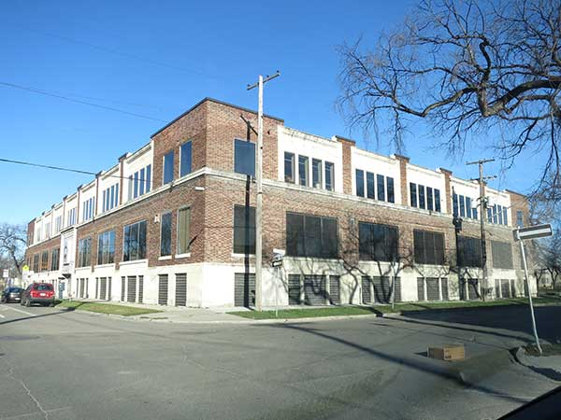

Stovel Printing Building, today

Agnes and Jack (Hudson) were still living at 120 Bannerman, in 1918, with a new son, William Bannerman Hudson, born January 2, 1918. William would be their fourth and last child. Jack is listed as a manager, not a proprietor, at Dominion Cycle, which is still located at 224-226 Logan. Harold John Crabtree is listed as a proprietor of Dominion Cycle and is also in active military service. This was in World War I (1914-1918). In 1918, at Harold John Crabtree residence of 271 Jefferson, West Kildonan, Winnipeg, is also residing Mary Crabtree, a widow of John. As we find Harold John Crabtree alive in 1921, this Mary could be his mother, with his father’s name also being John. [to be determined]
John and Julia, in 1918, were still at the big house on the corner, 128 Syndicate with their son Geordie who had changed jobs again; this time to a clerk for the City Fire Department. In 1918 John and Julia’s daughter, Ruby, entered the workforce for the first time. She was 16 years old in 1918. Ruby is employed by her father’s Company, J. Murray & Co as a bookkeeper. Their daughter, Gladys, was still in Cardinal, Ontario, with her husband David Magee. Gladys had their third and last child, daughter Vivian Rhonda, on July 18, 1918.

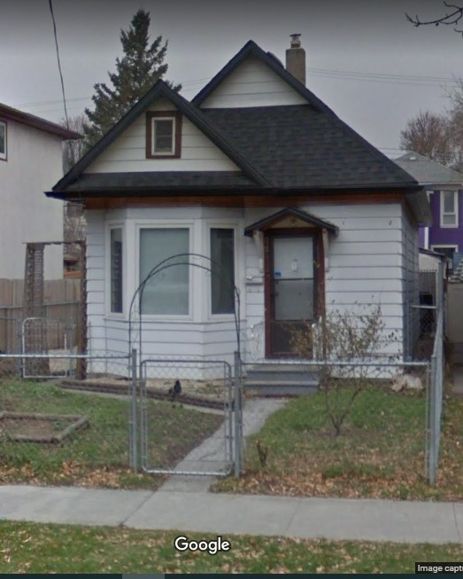
In the year 1918, Chas (senior) Lightfoot and family have moved from 1 McDermot Place to 89 ½ Gertie. Chas G. Lightfoot (junior) has moved from 1 McDermot Place to 626 Burnell Street, where he would live until his death around 1956-1957.

This family at 626 Burnell consisted of Chas G. (junior), his wife Charlotte, and their two sons John and Arthur. Arthur was born May 12, 1918. The home at 626 Burnell, built in 1909, is a very modest, 650 square foot, 1 ½ storey building. Chas G. Lightfoot was occupied as a pressman in 1918, an occupation he would retain up to and including 1956 or 1957. 626 Burnell, today

The year of 1919 saw the Winnipeg General Strike from May 15 to June 25. This year also saw a big change to J. Murray & Co. John Murray started a second department of the company called the Auto Top Department, adapting to the changing times from horse drawn vehicles to automobiles. All made of leather and similar to those used on wagons, early cars had roofs (tops) side curtains, and seat covers. Early trucks had leather box covers. The Auto Top Department catered to those specialties. It was located at 280 James Avenue, just one block from 180 Princess Street where the harness manufacturing remained. The 1/4 page advertisement in 1919 Henderson’s Directory announces the new department. This year, 1919, was the last year John, Julia, and family would live in the “big house on the corner”, 128 Syndicate. John’s son Geordie was a clerk for the Central Fire Hall (possibly the same job as the year before).
Also, this was the last year that John’s father, George, and family lived at 659 Simcoe. The father George was an oil dealer in 1919 (possibly the same as doing oil delivery the year before), and the son George was still a tinsmith at W.A. Templeton. Margaret (Nellie) was back at Nor’ West Farmer but now promoted to editor. In 1919 Mary continued with the same job since 1915 which was steno at Royal Trust Co.

Agnes and John (Jack) were still living at 120 Bannerman in 1919. Jack is manager at Dominion Cycle Co. at 224-226 Logan. Interestingly, Jack is not listed as proprietor, but as manager. Also, no one else is listed with Dominion Cycle, only Jack, listed as J.A. Hudson.
There is no mention of the family name Crabtree at all in Winnipeg’s Henderson in 1919. It is supposed that John Crabtree was away from Winnipeg in World War 1.

In 1920 John, Julia, and family (presumably consisting of son Geordie, and daughters Ruby and Hazel) moved from 128 Syndicate to 417 William Avenue, where they remained for only a short time. As mentioned, the home at 129 Syndicate was the biggest house on the block and it seem that John and Julia were the owners. The home at 417 William is ½ of a side-by-side duplex, and they presumably rented (did not own) that one. Neither Geordie, nor Ruby, nor Hazel are listed in Henderson this year so they might have been unemployed this year. In those days Julia’s brother James Simmons and his family were living one block away at 380 William Avenue in a suite in the Winnipeg (Carnegie) public library, where James Simmons was caretaker. This library building opened in October,1905. Neither John’s father nor brother, George, are listed in Henderson in 1920.

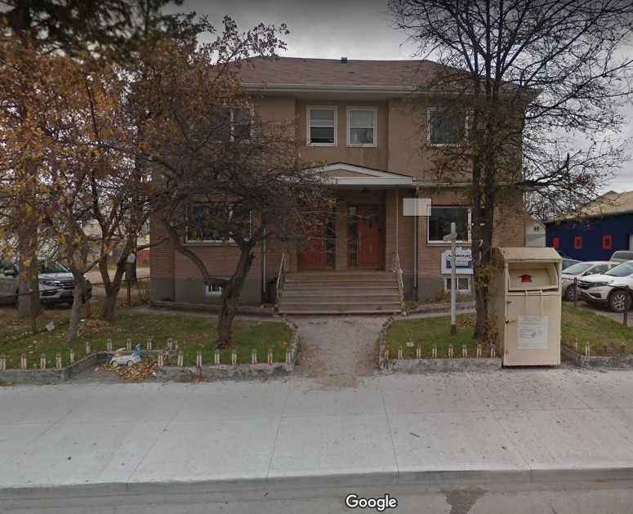

417 William Avenue, today
Year built could not be determined

In 1920, John’s sisters, Mary and Margaret (Nellie) have the same jobs as the previous year, but are now both living at 701 Banning Street, a 2 storey home first appearing in Henderson in 1914, as a new house (and still vacant in 1915). This home is in remarkably good exterior condition today (2021). It is most probable Mary and Margaret’s parents (George and Elizabeth Murray) and their brother, George (the tinsmith), also lived at 701 Banning in 1920; and these latter three people continued to do so for the rest of their days. This home is very likely where the father George wrote some of his poetry.

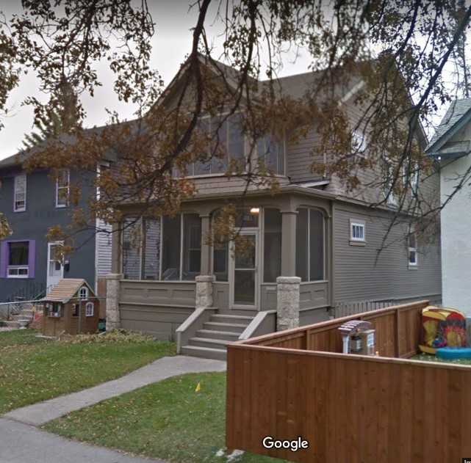

701 Banning Street, today
The side yard is where George and Elizabeth will be photographed by the Winnipeg newspaper in 1937, the year of their 60th wedding anniversary. 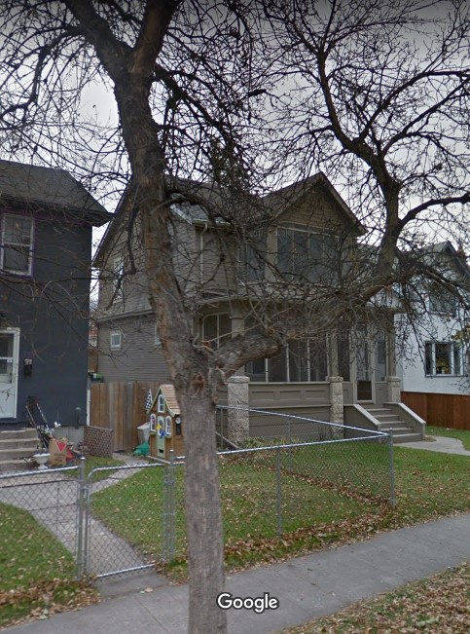

701 Banning Street, today
from the North West corner of the house

In 1920, George’s daughter, Agnes, and her husband John Hudson still lived at the same address (120 Bannerman); and John Hudson has the same job as the previous year. The listing for Dominion cycle says “John Hudson, mgr.” John Crabtree is not listed in 1920 Henderson.
In 1920, a census was taken in the United States of America. In that census, for Chicago, is the family of George and Isabelle Hendry. They had 4 sons in this census, one of whom was 22 year old Charlie. This Charles (Charlie) Hendry would marry Margaret Ury Murray on June 30, 1923

The year 1921 was a census year in Canada. The mother Elizabeth Murray, son George, daughters Margaret and Mary Ury were still living at 701 Banning as indicated in the census and in Henderson. The father George was not on this page of the census, but a George Murray matching his description was found on a farm, a few miles north of Winnipeg in what is today known as West St. Paul (The legal description of this land is Section 33-Township 12- Range 3-East of 1st meridian.) This George Murray was 71 years old, a farmer, immigrated to Canada in 1889, was born in Scotland, was married, and was Presbyterian. Is it that George went back to farming at this time? As for the rest of the family in the 1921 census (with ages in brackets), son George (42) was a tinsmith in a workshop, Margaret (29) is a [unclear] at North West Farmer, Mary Ury (23) was a [unclear] at a real estate office, and the mother Elizabeth (63) was not employed. Additional information from Henderson in 1921 is that son George was employed at Templeton’s, Margaret was an editoress, and Mary was a steno. The father, George Murray, was not found in 1921 Henderson which would be consistent with him living on a farm

Although 1921 was a census year, John, Julia and family were not found in the 1921 census. In Henderson, John is listed as manager of J Murray & Co, 180 Princess Street. There is a block advertisement in Henderson for J Murray & Company 180 Princess with the Auto Top Department at 280 James Avenue. The influence of the automobile and John’s business adaptation are apparent in this advertisement which offers “Saddles, Horse Goods, Wagon Covers, and Tarpaulins, Automobile Tires and Accessories.” On another page (page 198) in 1921 Henderson is a ¼ page advertisement which emphasizes the horse accessory items, with only few words about automotive supplies. Son Geordie is listed “of J. Murray & Co.” His job is not described. Hazel is a clerk at Robinson & Co., the same company where her two aunts, Jessie and Robertson, had worked; Jessie starting in 1902 and Robertson starting in 1904.

The 1921 Cardinal Ontario census, taken June 10, 1921, shows Gladys, David Magee, and their 3 daughters (listed as Isabel, age 6; Verna, age 4; and Vivian age 3) living in Cardinal. [This was a particularly difficult search because the last name is given as “Magie” in the search engine]. It must have been later that year Gladys and her daughters returned from Cardinal, Ontario to Winnipeg. Married to David Magee in 1913, Gladys was returning with her three daughters but without David. It is understood that David was an alcoholic and abusive, so Gladys’s father, John, went to Cardinal by train and brought them back to Winnipeg. Gladys does not appear in Henderson’s Winnipeg Directory until 1923.
In this year, 1921, John, Julia and family moved to suite #1-180 ½ Princess Street, which is one of the apartments over John’s business in the building called McGregor Block. This move accommodated the return of Gladys and her 3 daughters (Isabelle, Verna, and Vivian) from Cardinal, Ontario to Winnipeg. So, living on the second floor of this building in 1921 were: John and Julia, son Geordie, daughters Gladys, Ruby, and Hazel, and granddaughters Isabelle, Verna, and Vivian.

The McGregor Block

J Murray & Co occupied the half with the Green Awning
Entrance to the upstairs suites was through the centre door (under the word “FUR” in this photo.

Isabelle would later recount how as children she and her 2 sisters would play on the road of Elgin Avenue (left of the Princess Café in the photo above) with other children they called the ‘Elgin Gang’. Much less traffic then, than now!

The census for Souris, Manitoba in 1921, lists Richard and Elizabeth Roden and their children. Richard is a locomotive engineer for CPR. The year of immigration is given for Richard as 1882 (possibly an error, and could be 1890) and for Elizabeth as 1892 (this is an error and should be 1891). The children of Richard and Elizabeth in the 1921 census are (with ages in brackets): daughter Florence L. (10) [occupation unclear] at Union Bank; son Richard H. (17) clerk in a bank; son Harold M. (15) a student; daughter Elizabeth J. (13) a student; son Robertson E. (11); and son Albert E. (9). The stated religion for the family was Presbyterian. From family sources, Harold’s middle name was Murray and Robertson’s second name was Earle and he went by his second name. Albert’s second name was Edward.

Ancestry.com provides that Jessie Ann Murray married William Stevenson on June 2, 1921. William was a clothing salesman from Saskatchewan. I did not find either Jessie nor William in the 1916 census nor the 1921 census: neither in Manitoba nor in Saskatchewan.

In the 1921 census Agnes and John Hudson are listed with their family at 120 Bannerman Avenue in Winnipeg. At this time the family consists of (with ages in brackets): John A. (38) store [next word unclear] motorcycle; Agnes H. (39); son Robert M (11); daughter Elizabeth R. (7); son William B (3). This census indicates that Richard’s parents were both from England. From family sources, the second name of Robert was Murray, the second name of Elizabeth was Ruth, and of William was Bannerman. Son Robert would become a doctor. Daughter Elizabeth would write the book ‘A Canadian Mosaic’ which is rich with our family history. In the 1921 census, the year of immigration for Agnes was given as 1891 (should be 1890). In 1921 Henderson, John is listed as manager of Dominion Cycle. The Henderson listing for Dominion Cycle says John A. Hudson is manager and does not give any other name. Curiously, in 1921 Henderson under Crabtree, John Crabtree lists himself “of Dominion Cycle” which in Henderson usually implies ownership; and in the 1921 census his occupation is obscure but looks like merchant (or mechanic) and owner.

In Saskatchewan the 1921 census lists Robertson Pearce, the daughter of George and Elizabeth Murray, with her husband Ernest living on a farm in Saskatchewan on Section 28-Township 25-Range 3-west of 2nd meridian, which is in Wallace municipality in the district of Mackenzie. Ernest’s occupation is operator of his own farm. Robertson is not employed. The family in the 1921 census consists of (with ages in brackets): father Ernest (36); mother Robertson (35); daughters Margaret (9) and Evelyn (4). Both daughters were born in Saskatchewan. Ernest states his religion is Methodist, Robertson and their daughters are Presbyterian. Their land (28-25-3-W2) is relatively close to the homestead property settled by Ernest’s father, John Pearce, decades earlier.

----------------------------------------------

LOOKING FORWARD, FROM 1922 ONWARD.
George Murray, Elizabeth (nee Thom), and children:

By 1922, the family of George and Elizabeth Murray were living at 701 Banning Street in Winnipeg with their son, George (the tinsmith). George and Elizabeth would live at this address with their son for the rest of their days; Elizabeth passing away on September 12, 1938, and George passing away on April 23, 1939.

Son John Robertson Murray, my great grandfather, remained in Winnipeg, and can be followed in Henderson for the rest of his life.

Daughter Elizabeth Georgina Barbara (nee Murray) Roden is already living in Souris, Manitoba, before 1922. There are no digitized Henderson’s Directories for Souris. Later, in 1948, Elizabeth’s oldest son (named Richard Hendry Roden) moves to Winnipeg so we will follow him then in Henderson. Otherwise, we cannot follow this family further, except with data from personal collections.

George Murray, the tinsmith, lived with his parents, at 701 Banning Street in Winnipeg. He remained employed in the tinsmith business. He was living at this address when he passed away October 10, 1949.

Jessie Ann Murray last appeared in Henderson in 1912, but not after that.

In 1922, Agnes Hendry Murray is already married to John (Jack) Hudson, living at 120 Bannerman, and raising their 3 children. John and Agnes will remain living at 120 Bannerman for the rest of their days. We will follow John Hudson in Henderson until his retirement. Being relevant to John’s business, we will follow HJ Crabtree until he and John part company. RAY: Look at S.B’s Ancestry records for more on John and Agnes.

Robertson (Robin) Murray, by 1922, is already married to (Arthur) Ernest Pearce. They appear in the 1921 Saskatchewan census with 2 their daughters. As there is no Henderson or other directory for farms in Saskatchewan, we will not be able to follow them further, except with data from personal collections.

Both Margaret (Nellie) Helenor Murray and Mary Ur(e)y Murray are still living with their parents at 701 Banning in 1922.

Considering the reduced amount of new information found from 1922 and onward, the approach going forward will be to report primarily on changes only, rather than repetitiously reporting on a full year-by-year accounting of everyone.

1922 to 1926

In 1922, as in 1921, the father George Murray is missing from Henderson, possibly because he was still living and working on the farm. Son George has been promoted to foreman at Wm. A. Templeton’s tin shop, now located at #2-56 Princess Street. WA Templeton also had a hardware store at 380 Portage Avenue by this time.

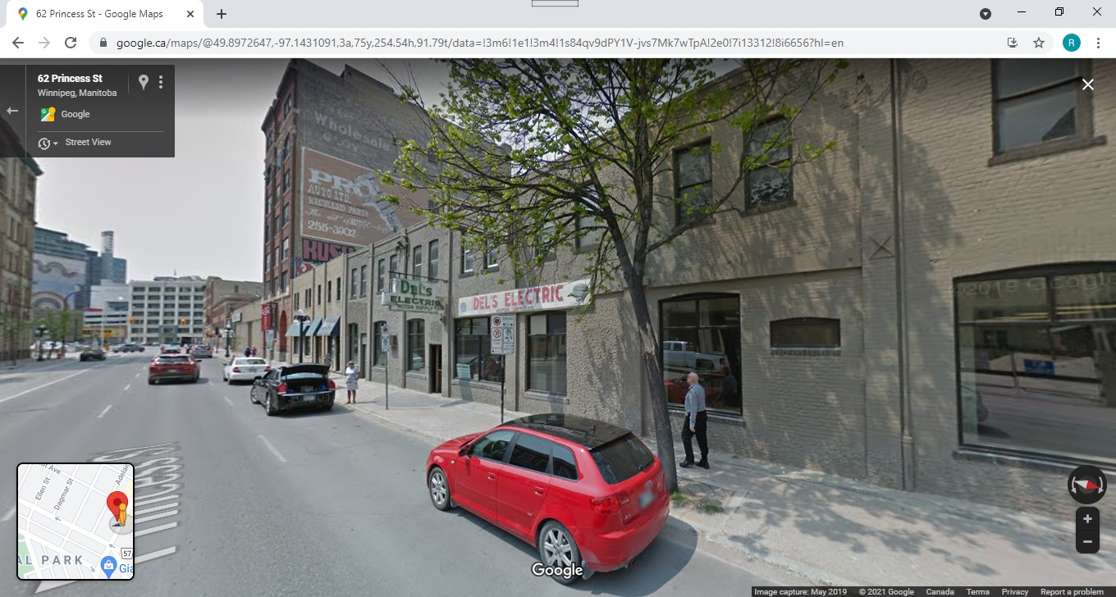
Templeton’s Tinshop at #2-56 Princess was located where the word “Electric” appears on the sign today. This location is only three and a half blocks from where J. Murray & Co was located at 180 Princess, at that time.

On August 26, 1922, Margaret Helenor Murray married Hugh Campbell Anderson. Hugh, who first appears in Henderson in 1911 as a clerk at Nor’ West Farmer and living at 268 Carlton Street, is now the office manager of Nor’ West Farmer, where Margaret is working in the Stovel (Printing) Building at 365 Bannatyne (pictured on page 35).
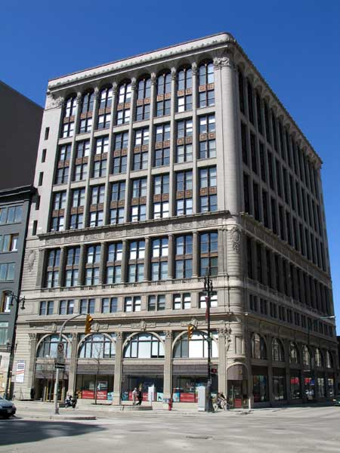

Mary’s employer in 1922 is now called Royal Agencies, likely the same company as Royal Trust Co., located on the 8th floor of the 11 storey Paris Building, at 259 Portage Avenue.

The Paris Building is a municipal designated historic site. Aside from incidental renovations, the building has mostly retained its original appearance.

The Paris Building, today

John Robertson Murray, his wife Julia, all 4 children, and all 3 granddaughters (Isabelle, Verna, and Vivian) are living in suite (or suites) at 180 ½ Princess in 1922. These 2nd storey suites in the McGregor Block are above John’s business, J Murray & Co. Family members employed in John’s business in 1922 are his son, Geordie who is listed as “with J. Murray & Co”, (again his job is not described); and all three of John’s daughters Gladys, Ruby and Hazel. Gladys is employed as a machine operator. Hazel who has left Robinson & Co. is now employed as a clerk. Ruby is employed as a bookkeeper. Gladys is listed as Mrs. G. McGee which is a wrong spelling for Magee but the first of many such misnomers, for which the reason can only be speculated at this time.
In 1922 Agnes’s husband, John A Hudson, is listed as “of Dominion Cycle”, which usually denotes ownership in Henderson. John Crabtree also lists himself a “of Dominion Cycle”. The company listing for Dominion Cycle does name both of them, with location 224-226 Logan.

According to Ancestry.com (reference S.B.) Jessie’s daughter Bess Stevenson was born between 1922 and 1930 in Saskatchewan. The 1926 census defines this closer.

In 1923 father George Murray is now listed with the rest of his family at 701 Banning Street with no occupation given. His son George is a tinsmith, not a foreman, at W.A. Templeton. Daughter Margaret (I also looked under Nellie) is missing from Henderson so might be unemployed. Margaret’s husband Hugh Anderson, is living at 5, 14 Alloway, but there is no Margaret Anderson at that address. Daughter Mary is still a steno at Royal Trust and living at 701 Banning until she married Charles Nicholson Hendry on June 30, 1923, in Winnipeg. According to her immigration record, Mary moved to Chicago in July, 1923, as a permanent move. This immigration record also states that Mary was 5’-9” tall, had brown hair and eyes, and had been to the USA in September of 1922. We only have recorded evidence of Mary again in the 1930 USA census. Mary, then, was the fourth and last daughter to move from Winnipeg. Daughters Agnes and Margaret did not move from Winnipeg. Neither did either of the two sons, John nor George, move from Winnipeg.

The family of John and Julia Murray, with their 4 children and 3 granddaughters, is still living in Suite 1-180 ½ Princess, in 1923. John’s son Geordie is a clerk at his father’s business J. Murray & Co. John’s daughter Gladys is listed as Mrs. George Murray, steno, at Clark Brothers, 48-50 Charlotte Street. This is the same company Gladys worked for in 1912 and 1913 before marrying David Magee and moving to Cardinal, Ontario. This company, under changes of ownership and management, remained Gladys’s employer until she retired in 1961. Daughters Ruby and Hazel are missing from Henderson in 1923 so might be unemployed. The granddaughters’ ages in 1923 are: Isabelle (9), Verna (7), and Vivian (5).

In 1923, Dominion Cycle is not listed at all in Henderson. Instead, Henderson lists “Crabtree & Hudson Ltd (successors to Dominion Cycle Co) 510-22 Portage”. Both John Hudson and John Crabtree list themselves as “of Crabtree & Hudson Ltd.”

Changes in 1924 are few. George and Elizabeth are, of course, still living at 701 Banning. George’s two daughters, Margaret and Mary, are both missing from Henderson in 1924. Margaret is likely not employed. Margaret had married Hugh Campbell Anderson in 1922 and her husband is still listed as office manager for Nor’ West Farmer, and shown living at 701 Banning in 1924. So, living in 701 Banning in 1924 are: parents George and Elizabeth, son George, daughter Margaret and son-in-law Hugh C. Anderson, and possibly daughter Mary.
John and Julia are still living at 180 ½ Princess, with their four children and their 3 granddaughters. Their daughter Gladys could not be found in Henderson in 1924. Their son Geordie is a clerk at J Murray & Co. Their daughter Hazel is listed, but no occupation is given for her. Their daughter Ruby is a bookkeeper for J Murray & Co. Geordie, Hazel, and Ruby

Again, in 1924, Dominion Cycle is not listed in Henderson and apparently never listed again. Instead, Henderson lists “Crabtree Hudson Ltd, HJ Crabtree and JA Hudson, auto supplies, 510 Portage.” Both John Hudson and John Crabtree list themselves as “of Crabtree & Hudson Ltd.”

Henderson in 1925 has few changes. George and Elizabeth Murray, and family, are still at 701 Banning. The father George is not listed in 1925 Henderson, and will not re-appear until 1928. Their son George is now promoted to a manager at Templeton’s Tin Shop. Their daughter Margaret’s husband, Hugh C. Anderson, is still listed as office manager for Nor’ West Farmer, living at 701 Banning in 1925.

In John and Julia Murray’s family, John lists himself as proprietor of J Murray & Co. in 1925 Henderson. Their son Geordie is still a clerk and their daughter Ruby is a steno, both at their father’s company. Daughters Gladys and Hazel are not listed in 1925 Henderson.

In 1925 Agnes and John Hudson are still living at 120 Bannerman. John Hudson’s company is listed as: ”Crabtree (H J) and Hudson (Jno A), auto accessories, 510-512 Portage Avenue”. Just as with J Murray & Co, the influence of the automobile has become apparent in this business. Both John Hudson and John Crabtree list themselves as “of Crabtree & Hudson”

November 18, 1926, saw the opening of the new Hudson’s Bay retail store at 450 Portage Avenue, in Winnipeg. For the Murrays this year was very similar to 1925. The Winnipeg addresses of interest are: 701 Banning, 180 (and 180 ½) Princess, and 120 Bannerman.

The year 1926 was a census year for the prairie provinces (not all of Canada) and is the last digitized census on the internet. Addresses are given on this census. Occupations are not given on the 1926 census. We can find occupations on Henderson.

In the census of 1926, George and Elizabeth Murray are confirmed as living at 701 Banning. Living with them is their son George; their daughter Margaret; Margaret’s husband Hugh Anderson; and Margaret and Hugh’s 2 month old baby son, Hugh junior. This would be Margaret and Hugh’s only child. He was born in Winnipeg, on March 17, 1926. His full name was Hugh John Anderson. In Henderson, son George is again listed as a tinsmith, not as a manager. Margaret is not listed in Henderson but her husband, Hugh C. Anderson, is now “asst adv mgr”, likely assistant advertising manager, for Nor’ West Farmer.

George’s oldest daughter, Elizabeth (nee Murray) Roden is in the 1926 census for the Town of Souris, Manitoba, living with her husband Richard and four of their six children, namely (with ages in brackets) Florance Lillian (24), Harold (20), Earl (16), and Albert (14).

John and Julia are in the 1926 census as living at 180 Princess Street. The census indicates that their son Geordie (George in the census), and daughters Ruby and Hazel are also living with them. Also, their daughter Gladys Murray, and granddaughters Isabel (should be Isabelle), Verna, and Vivian (all McGee, wrong spelling) are living with them at 180 Princess, as shown in the 1926 census.

John and Julia’s daughters, Gladys and Hazel, reappear in 1926 Henderson. Gladys is a clerk at Clark Bros at 48-50 Charlotte. Hazel is an employee at Reynolds Ltd., a printing company at 319 Elgin which was just around the corner from John’s business and their home, at 180 Princess. The three storey building at 319 Elgin was built in 1914 for the Scott Fruit Company, and is still standing today. Geordie Murray is not listed in 1926 Henderson. Ruby is still a steno at J Murray & Co. And Sam Cascisa is still at 172 Princess, now called the Elgin Café.

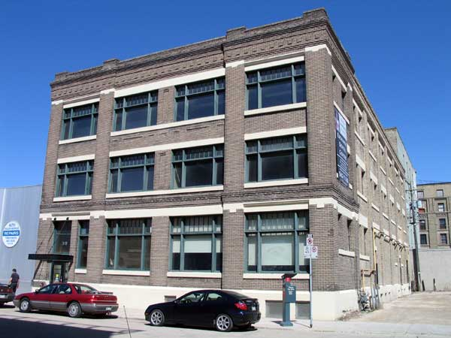
319 Elgin, today

In the 1926 census, daughter Agnes (nee Murray) Hudson and her husband John are listed at 120 Bannerman with their children Robert Murray (16 years old), Elizabeth Ruth (12 years old), and Wm Bannerman (8 years old) on the census.

In Henderson, John Hudson is listed as “John A Hudson of Crabtree & Hudson” in 1926. The company is listed as “Crabtree & Hudson, Ltd. (HJ Crabtree, JA Hudson), bicycles, 510-12 Portage. So, the emphasis is off automobiles and back to bicycles in 1926. John Crabtree lists himself as “H.J. Crabtree of Crabtree & Hudson Ltd.”

The 1926 census allows us to get back in touch with daughter Jessie (nee Murray) Stevenson (43 years old) who is living on 2nd Street East, in the town of Shaunavon, Saskatchewan with her husband William (44 years old) and their children Elizabeth (age 3) and William (age 3) both born in Saskatchewan. This means their children were twins, born in 1922 or 1923. Also living with this family is Thomas Stevenson (46 years old), a brother of the father William. Immigration information on this census provides that the brothers William and Thomas Stevenson were born in Ireland. William immigrated to Canada in 1911 and Thomas immigrated to Canada in 1909. Both parents of William and Thomas were born in Ireland. This 1926 census gives 1890 as the year of immigration for Jessie, as we already know.

George and Elizabeth’s daughter Robertson (Robin) was not found in the 1926 census in Saskatchewan nor in Manitoba. Neither were her husband nor any children found.

As mentioned, in the 1926 census Margaret and Hugh Campbell Anderson are living at 701 Banning with George, Elizabeth and their son George (the tinsmith), and their own son Hugh John Anderson.

CONTINUING FORWARD from HERE

The 1926 census is the last digitized census for Canada. Census records are useful for finding children of families, family member ages, and years of immigration. Henderson’s Directory is digitized to 1965 but only lists businesses and employed people, with a few exceptions. Apparently, there were no Henderson’s (or similar) Directories created for Souris in Manitoba, nor for farms in Saskatchewan.

Other useful records can include birth, marriage, and death records, including obituaries. The most recent of these records are often found in private collections, as the Canadian Government is bound to protect privacy of people who are still living, and has done so by placing limits on public accessibility for records newer than 100 years. Ancestry.com does have records submitted by members but these are not audited, so must be used carefully.

The year 1927 is one of very few changes for the Murray families.

In the family of George and Elizabeth, George is not listed in 1927 Henderson. Daughter Margaret is also not listed in 1927 Henderson (likely not employed) but her husband, Hugh C. Anderson, has been promoted to “adv mgr”, likely advertising manager, for Nor’ West Farmer, still living at 701 Banning, along with the rest of the family. This family at 701 Banning includes: parents George and Elizabeth, son George the tinsmith, daughter Margaret, son-in-law Hugh Anderson, and Hugh John Anderson, the 1 year old son of Margaret and Hugh.

John and Julia are still living “over the harness shop” as Gladys used to call it. Geordie has changed occupations and is working at Canada Messenger Service, although his job there is not given. In 1927 Hazel is missing and does not reappear until 1932.

In 1927 Agnes and John Hudson were raising their three children at 120 Bannerman. John’s company is listed as “Crabtree (HJ) and Hudson (JA), auto accessories, 510 Portage” So we see again the return to advertising auto accessories, whereas the previous year it was bicycles. John Crabtree lists himself as “H. John Crabtree of Crabtree & Hudson.”

In 1928 the father George Murray is listed again but with no occupation given. Born in 1850, he was 78 years old in 1928. George and Elizabeth Murray were still living at 701 Banning, with their son George, the tinsmith, daughter Margaret (not employed), son-in-law Hugh Campbell Anderson (still advertising manager of Nor-West Farmer), and 2 year old son of Margaret and Hugh, named Hugh John Anderson.

John and Julia’s son Geordie is now a salesman for his father’s company, J Murray & Co. For John, Julia, and family 1928 would be the last year they lived over the harness shop at 180 ½ Princess Street. This family at 180 ½ Princess included: parents John and Julia, son Geordie, daughters Gladys, Ruby, and possibly Hazel, granddaughters Isabelle (age 14), Verna (age 12), and Vivian (age 10). Gladys was not listed in 1928 Henderson.

The year 1928 had some big changes for Agnes and her husband, John Hudson. The company, Crabtree and Hudson, has disappeared from Henderson’s Directory and will never appear again. This is the end of business ownership for John Hudson, which may have begun as early as 1905. John Alvin Hudson is now employed as a salesman for Western Canada Motor Car Company, Ltd, dealer of Packard and Studebaker cars and Federal trucks. This company’s location was 263 Edmonton Street. John Crabtree is no longer affiliated with John Hudson. John Crabtree is now vice president of Matt Thompson. Ltd, bakers and confectionery at 163 Lipton and 1156 Ingersol Street, with Matt Thompson as proprietor. (Coincidently, Matt Thompson is also the employer of William J. Cruickshank, who began working there as a baker, two years earlier, in 1926. William J. Cruickshank was my father’s first cousin and is discussed in a separate essay.)

For parents George and Elizabeth Murray there was no change in 1929. Father George is again not listed, in 1929 Henderson.

In 1929, daughter Margaret and her husband Hugh Anderson (having married in 1922) moved with their 3 year old son, Hugh John Anderson, from the Murray family home at 701 Banning. They moved into a brand new, large, 1 ½ (almost two) storey house at 258 Ash Street. Ash Street is in the area of North River Heights in Winnipeg. Margaret and Hugh Anderson were the first occupants of this home. Hugh Anderson was still advertising manager for Nor’ West Farmer in 1929, located in the 365 Bannatyne
Building at 365 Bannatyne. This move was the first time Margaret was not living in her parents’ home. Margaret was the last daughter to leave home, but she did remain in Winnipeg. From this time forward, 701 Banning would be home to only three people, parents George and Elizabeth, and their son George (the tinsmith).

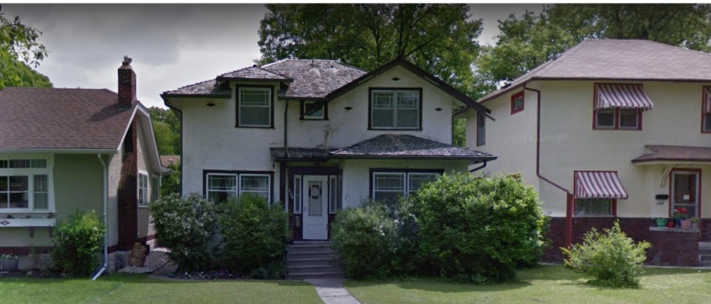
258 Ash Street, today

Another big change for the Murrays in 1929 was the move of John and Julia Murray and family from 180 Princess to 210 Horace Street, a two storey house in the Norwood area of Winnipeg built in 1908. From Henderson, it looks like John and Julia were the owners of this house. The family still consisted of John and Julia, daughter Gladys and her three daughters (Isabelle, Verna, and Vivian), son Geordie, and daughters Ruby and Hazel. Their son Geordie is still a salesman for J Murray & Co. Their daughter Gladys is a clerk for John Gibb Co., Wholesale and Manufacturing Stationers, 250-256 McDermot Avenue. It is thought this company was the new owner of Clark Bros (yet to be determined), although Clark Bros continued to operate at 48-50 Charlotte. The building at 250-256 McDermot was built in 1898 and is a designated historic site, today. Daughter Ruby continues as a book keeper for J Murray & Co., in 1929, the job she had when she first appeared in Henderson in 1922, and will keep until 1933.

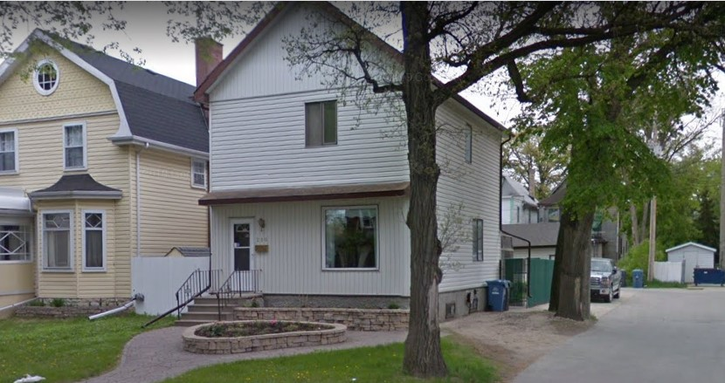
210 Horace, today. (The white house)
In this home where my Mom and Dad would meet around 1932

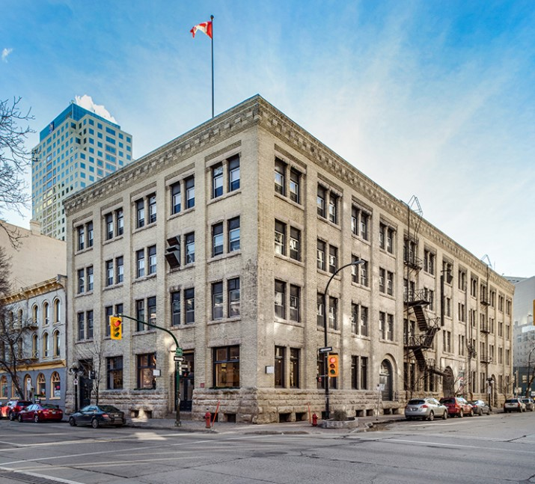
250-256 McDermot, today. Home of John Gibb Co in 1929.

John Hudson has changed jobs to be salesman at Sieberling Rubber Company in 1929. This was a company dealing in rubber tires. In 1929, Sieberling did not have an address in Henderson.

Near the end of the year, in October, 1929, the stock market crashed. From History.com, “The stock market crash of 1929 was not the sole cause of the Great Depression, but it did act to accelerate the global economic collapse of which it was also a symptom.”

The 1930’s

As the 1930’s begin, no one knows that this decade will be called “The Dirty Thirties” in the future. The stock market crash of 1929, and a severe drought across the Canadian and American prairies, created unprecedented hardships for Manitoba’s agriculturally based economy.

In 1930 George and Elizabeth are living with their son George at 701 Banning. The father George is not listed in Henderson (now 80 years old). The son George is listed as a tinsmith but no employer is listed, so he might have been laid off; but he will return to working at Templeton the following year.

John and Julia are living with their son, daughters, and three granddaughters at 210 Horace in 1930. The granddaughters’ ages in brackets in 1930 are: Isabelle (16), Verna (14), and Vivian (12). Daughter Hazel Murray is missing from Henderson in 1930. Geordie (32) is still a salesman for his father’s company J Murray & Co. There is a bold print advertisement in Henderson in 1930 which reads “Manufacturers of Harness, Auto Tops, Side Curtains, Seat Covers, Radiator Covers, Tents Awnings, Tarpaulins, Waggon Covers, and Everything in Canvas. Also Campers’ and Bush Supplies.” This was the first time we see J Murray & Co dealing in canvas goods, transitioning from a company that worked with leather. This decision made by John Robertson Murray would endure into the present day. By this time, automobiles had replaced horses for passenger vehicles and few horses were seen on Winnipeg streets, the exception being occasional freight wagons. The harness and tent and awning address was still 180 Princess Street and the Auto Top Department was still at 280 James Avenue. The page which could list daughter Ruby was not digitized. Gladys is still a clerk at John Gibb.

Agnes and John Hudson are still living at 120 Bannerman in 1930. John Hudson is listed in Henderson but with no occupation and no employer listed. It is possible he was unemployed at this time.

Margaret and Hugh Anderson are still living 258 Ash in 1930. Hugh is still advertising manager for nor’ West farmer.

According to the 1930 American census, on April 3, 1930 Mary was living in Chicago with her husband Charles and their 3-month-old son Charles (junior), who was born in Illinois. This census indicates that they owned their home valued at $7500.00, they had a radio set, and the home was not on a farm. This census also states that in 1930 Charles is 31 and Mary is 30 years old at their last birthdays, and that Charles was 24 and Mary was 23 years old when they were married. This 1930 census confirms that Charles was born in Scotland, as were his parents. [There could be a connection in Scotland with the Hendry family (because older sister Agnes’s middle name was Hendry. Also a Richard Roden’s middle name was Hendry, or Henry) but this has not yet been explored. RAY to do] The years of immigration to the United States is confirmed in this 1930 census as 1911 for Charles and 1923 for Mary. Charles is employed as a bricklayer at a brick company. To the question “Whether a veteran of U.S. military or naval forces.” Charles replied “Yes”. To the question of “What war or expedition”. Charles responded WW” for World War. This was in 1930 and the only World War anyone knew of had passed (we call it World War I, today).

The father George Murray returns to Henderson in 1931 with occupation listed as retired. He will be 81 years old this year. George and Elizabeth’s son George is now a foreman at Templeton’s Tin Shop, still located at 56 Princess (upstairs).

Son John, Julia and family are still living at 210 Horace in 1931. John has introduced a manager, William H. Batchelor to the Auto Top Department at 280 James Avenue. John retained the position of manager of the harness location at 180 Princess. This signals a big change for the company which will occur the next year in 1932. John and Julia’s son Geordie is a clerk but no employer is listed. Their daughter Ruby is a steno at her father’s company J Murray & Co while daughter Hazel is still missing from Henderson. Daughter Gladys continues to be employed as a clerk at John Gibb Co., wholesale and manufacturing stationers, at 250-256 McDermot Avenue. Gladys had only worked for her father’s company one year, in 1922, after returning from Cardinal, Ontario. In 1931, John’s friend Sam Cascisa is still operating his business called Elgin Café at 172 Princess Street, on the corner of Princess and Elgin.

John Hudson, the husband of Agnes, is listed in 1931 Henderson but again with no occupation nor employer. This is the second year in a row that John was listed this way, which seems to indicate he was unemployed in this period. John and Agnes would have had their three children as dependents in 1931. Robert Murray Hudson was 22 years old, and on his way to becoming a doctor. Daughter Elizabeth Ruth Hudson was 17 years old. Son William Bannerman Hudson was 13 years old. Throughout these difficult financial times John and Agnes retained their house (at 120 Bannerman) which was a great achievement in those days.
There were no changes for Margaret and Hugh Anderson from 1930 to 1931.

Still in the Great Depression in 1932, jobs were hard to find and difficult to keep. The father George Murray is again in Henderson, at 701 Banning, with occupation listed as retired. Living with them, George and Elizabeth’s son George is listed as tinsmith; but with no company listed he could be on lay-off from Templeton’s Tin Shop. Templeton’s Tin Shop is still listed in Henderson in 1932.

In 1932 John Robertson Murray is a manager at Garry Shoe Repair. Presumably his familiarity with leatherwork was relevant. This is the end of business ownership for John Robertson Murray, which began in 1908, when he was 36 years old. He is now 60 years old. New ownership of the company at 180 Princess is J.H. Whiley, proprietor of Murray Tent and Awning. This company name has endured to the present (2021) where it is operating at 653 Sargent Avenue, in Winnipeg. The Auto Top department continued as Murray Auto Top, 280 James Avenue, with William Batchelor as manager.

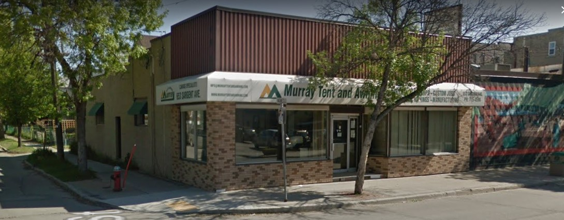
Murray Tent and Awning, today

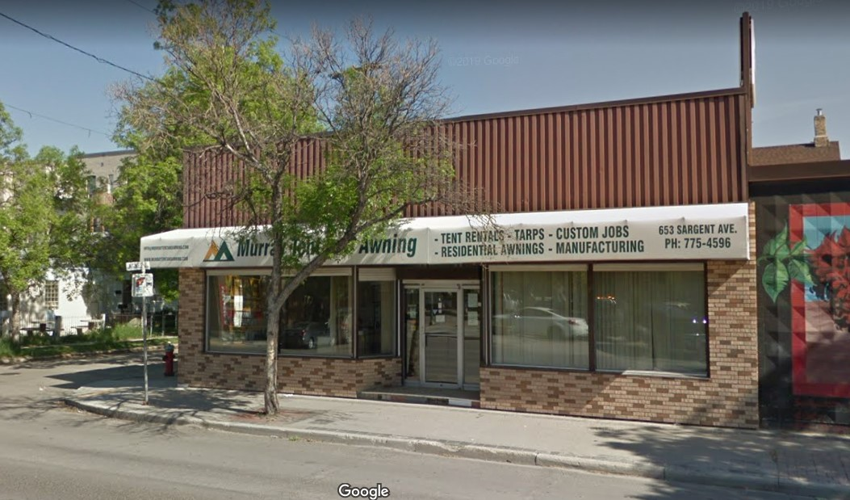
Murray Tent and Awning, today
at 653 Sargent Avenue
John’s son Geordie is listed as a clerk in 1932 Henderson, but no employer is given. John’s daughter Hazel returns to Henderson (after a long absence) listed as clerk, but no employer is given. John’s daughter Ruby is listed as a bookkeeper, but no employer is given.
In 1932, still living at 210 Horace with her parents, siblings, and her daughters, John’s daughter Gladys is in Henderson's Directory under her maiden name as Miss G. Murray, a clerk. In 1932 Gladys's employer changed to W.J. Gage & Co., wholesale stationery, 181 Bannatyne. This was a larger company from Toronto that bought-out John Gibb Company. (John Gibb stayed on as an employee of W.J. Gage).

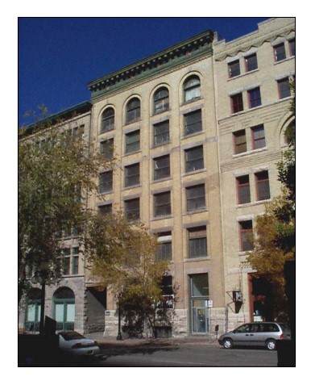

The building in the middle of this photograph, at 181 Bannatyne, is known as both the Kilgour Block and the Kelly Building. It is still standing today. This building was constructed in 1904.

W.J. Gage and Company occupied space in this building from the late 1910s to the 1960s. Gladys stayed with W.J. Gage & Co from 1932 until her retirement as a secretary in 1961, after turning 65 years old.
181 Bannatyne, in 1999

About this time father George Murray invited the Cruickshank family to his son John’s house at 210 Horace for a musical evening. A family story is that George Murray used to carry his fiddle across the field from his house at 701 Banning to the Cruickshank house at 1040 Garfield. In those days there was a lot of empty space (therefore, “across the field”) in the area we now call the West End of Winnipeg. Then George Murray and Georgina Cruickshank would play Scottish music together. Most of the Murrays and Cruickshanks played musical instruments such as piano and violin. One of the Cruickshank sons was Charles Norrie Cruickshank who took a liking to John’s granddaughter (Gladys’s daughter) Isabelle. Eventually Charles (aka Charlie) and Isabelle were married. These were my parents.

According to Henderson, in 1932 John Hudson is employed by Carter & McGee. This company is not listed in 1932 Henderson but there is a Carter McGeachy, insurance company, so there could be a mis-spelling. Robert Hudson, son of Agnes and John, appears in Henderson for the first time in 1932. Robert is an employee at Seifreds Service Garage, and living with his parents at 120 Bannerman. Robert is 23 years old in 1932. As a catch up on John’s old partner, John Crabtree, he left Matt Thompson as president in 1932 and became president of Honeysuckle Bakeries, a position he would hold until 1955. This change from Matt Thompson to Honeysuckle seems like a change in company name rather than a change of employer.

There were no changes for Margaret and Hugh Anderson from 1929 through to 1932.

In 1933 there are no changes in Henderson for father George Murray or his son George, seemingly neither one being employed.

Son John Murray is listed in 1933 Henderson as still living at 210 Horace, but with no occupation listed. The companies Murray Auto Top and Murray Tent & Awning continue under William Batchelor and J. Wiley as started in 1932. John and Julia’s son Geordie is not listed this year in Henderson. Their daughter Ruby has started working for Reliable Radio Stores as a bookkeeper, and their daughter Hazel is listed as a clerk but no employer is given for her. Their daughter Gladys, and her three daughters Isabelle (19), Verna (17) and Vivian (15) moved out of 210 Horace in 1932, and here is the story:

When the Depression hit, John’s granddaughter, Isabelle, like many others, had dropped out of school (in grade 9) to work and help support the family. She did housework and like many people in those days was trying to get a job at Eaton's. One day the phone rang and it was for Isabelle to go to work at Eaton’s. Julia (her grandmother) said she was already working but that she had a daughter Ruby who was available for work. When Gladys found out what had happened, she took her daughters and moved to 372 Edmonton. Isabelle eventually did get a job in 1935 working in the Mail Order Department of Eaton’s parceling up things to be sent out. In 1933 Gladys is going by her maiden name of Miss G. Murray. This is the first time Gladys and her daughters have not lived with John and Julia since returning from Cardinal to Winnipeg after the 1921 census. They will not return to living with John and Julia again.

No building was found with the current address of 372 Edmonton. However, at 368 Edmonton there is a building that could have been a rooming house in 1932. Addresses occasionally shifted in Winnipeg. RAY: This needs more investigation.
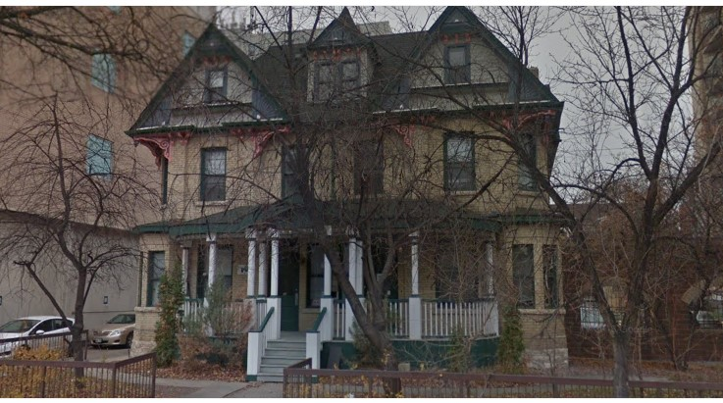
368 Edmonton, today

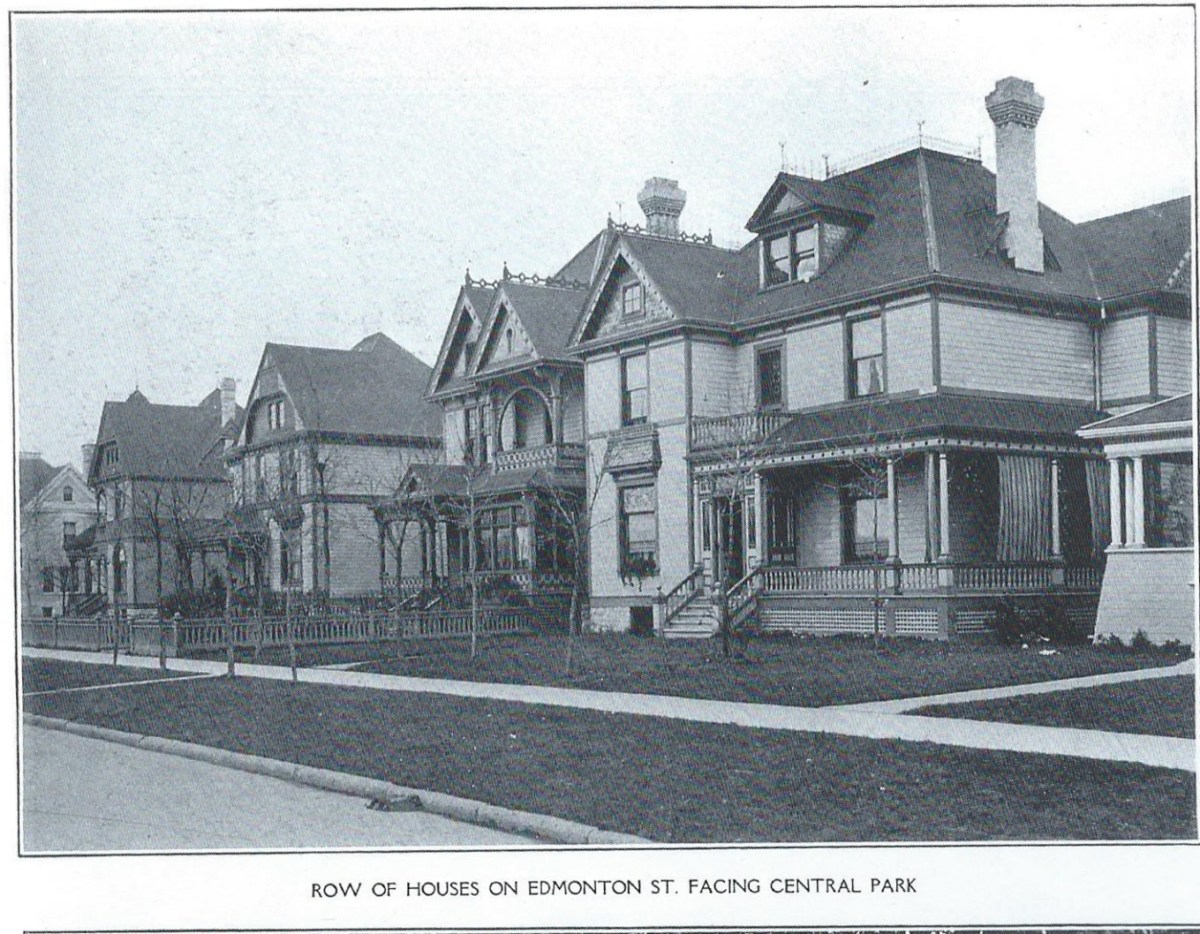

The black and white photo (above) was shown to Gladys and Vivian and they thought it was the second or third house they lived in. They lived upstairs.

Agnes’s husband John Hudson is listed as a salesman in 1933 but with no employer listed, he is possibly unemployed. Their son, Robert M. Hudson is listed living with his parents, but with no occupation and no employer given, Robert is possibly unemployed, also.

There is no change for Margaret & Hugh Anderson in from 1929 to 1933.

In 1934 Henderson, only one George Murray is listed at 701 Banning Street so it is unknown whether this refers to the father or the son. In any case, the George Murray listed at 701 Banning has no occupation given. It is likely that no one was employed in that home in 1934.

John is not listed in 1934 Henderson and neither is his son, Geordie. Ruby is listed as a steno and Hazel is listed as a clerk but no employer is given for either of these daughters. It is likely that no one was employed at 210 Horace in 1934. The two companies that John started are continuing just as in 1932 and 1933, with the change that William Batchelor has changed from manager to proprietor of Murray Auto Top.

John’s daughter Gladys is listed as Miss C Murray in 1934 Henderson, renting at 372 Edmonton. Her three daughters are still living with her. Gladys is employed as a steno at W.J. Gage.

A fortunate turn occurred for John Hudson in 1934 when he became a salesman for the Winnipeg Free Press newspaper, a job he would retain until 1948. In the 7 years since the company Crabtree and Hudson last appeared in Henderson, John Hudson has appeared to be unemployed only 3 times. When employed, John was a salesman, first for Western Motor Car, next Sieberling Rubber, then Carter McGeachy insurance, and now the Free Press newspaper. Clearly sales is a strong skill for John Alvin Hudson. Also in 1934 Robert Hudson, son of Agnes and John, is listed as a med(ical) student, living with his parents at 120 Bannerman.

There is still no change for Margaret & Hugh Anderson from 1929 to 1934. Margaret and Hugh are still living 258 Ash where they moved in 1929. Hugh is still advertising manager for Nor’ West Farmer.

With fewer people employed in 1935 there are fewer entries in Henderson. At 701 Banning the father George Murray is listed with occupation “retired”. The son George is listed with occupation “tinsmith” but no employer is given, so he could be on a long lay-off from Templeton’s Tin Shop. Again, it looks like no one is employed at this address.

John, Julia, and family continue to live at 210 Horace. John’s listed occupation is “retired”. He is 63 years old in 1935. John and Julia’s son Geordie is not listed, and neither are their daughters Ruby nor Hazel. It is likely that again no one was employed at 210 Horace in 1935.

John’s daughter Gladys continued to be employed in 1935, working as a steno at W.J. Gage. She is listed twice, once as Miss G. Murray (her maiden name) and once as Gladys Magee (her married name). Gladys and her three daughters are still renting at 372 Edmonton. In this year Gladys’s daughter, Isabelle Magee first appears in Henderson. She is an employee of Eaton’s. This is my Mom. If recollection serves, she was working in the mail order department and liked the job very much.

In 1935, Murray Auto Top continues with William Batchelor as proprietor, at 280 James Avenue, the same as 1934. Murray Tent and Awning is not listed in 1935 Henderson but will return the following year, at a new address.

No change was observed for Agnes and John Hudson in 1935, still living at 120 Bannerman. John continues as a salesman for the Winnipeg Free Press newspaper. It might be that he was selling advertising space in the newspaper which would make his job similar to that of his brother-in-law, Hugh Anderson. In 1935, Agnes and John’s son Robert Hudson is listed as Dr. R.M. Hudson, house doctor, Misericordia Hospital. Robert’s residence is given as 20 Sherbrook Street, which is the Misericordia Hospital address. This must have been a huge sense of pride for his grandparents, George and Elizabeth Murray. Robert Murray Hudson married Hilda Kearns (1907-1981) on December 21, 1935, in Ottawa, Ontario. They had three children. Sadly, their son Stanley, born in Ottawa on December, 21, 1937, did not live more than one day. Robert Hudson opened a medical practice in Quyon, Quebec. From his daughter, “The country was new, he did not know the lay of the land or the people, he had no car and plowing was not good. Dr Hudson hired Lally Lusk and his horse and sleigh to drive him on house calls.”

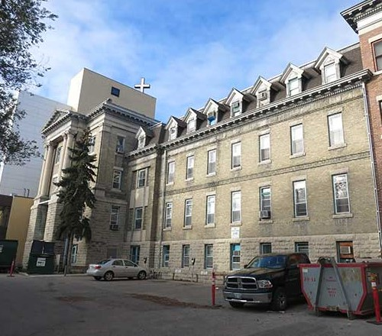
Misericordia Hospital-earliest part of the complex

One of George and Elizabeth Murray’s daughters, Jessie Ann Stevenson, was seemingly living in Saskatchewan in 1935. Jessie’s daughter Bess Stevenson died in 1935. Bess was born between 1922 and 1923.

In 1935 Hugh and Margaret Anderson are still living at 258 Ash Street, where they have lived since 1929. Hugh is still advertising manager for Nor’ West Farmer.

The year 1936 brought few changes in Henderson for addresses or occupations of the Murray families. There was no change from 1935 for George and Elizabeth Murray or their son, George at 710 Banning.

In 1936, John, Julia, and family moved from 210 Horace Street in the Norwood area of Winnipeg, to 15 Sutherland which is a very small house, just around the corner from where Julia’s parents were living on Syndicate Street. The house at 15 Sutherland was built around 1903, and possibly 800 square feet, or less. Although it is a small building, without Gladys and her 3 daughters, only John and Julia, Ruby, and Hazel lived there.

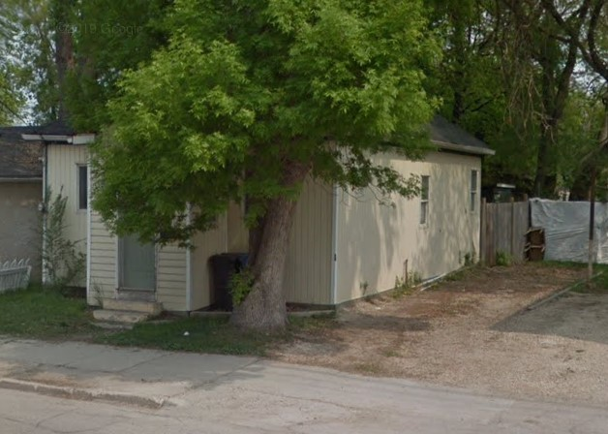
15 Sutherland, today

There was no change for John and Julia’s daughter, Gladys in 1936. In Henderson Gladys’s eldest daughter, Isabelle Magee was still an employee at Eaton’s. Isabelle would marry Charlie Cruickshank on May 9, 1936, after the publication of Henderson. Gladys’s second daughter, Verna made her first appearance in Henderson in 1936, but with no job or employer listed.

In 1936, Murray Auto Top continues with no change since 1934. Murray Tent and Awning is listed in 1936 Henderson but at the new address of 269 James Avenue, still with Joseph Whiley as proprietor. The building at 269 James Avenue was the McRae Block, which is no longer in existence.

No change was observed for Agnes and John Hudson in from 1934 and 1935 to 1936. Their son, Robert was not listed in 1936 Henderson.

Also, no change was observed for Margaret and Hugh Anderson in 1936. Hugh and Margaret Anderson have had the same address, 258 Ash Street, since 1929. Hugh is still advertising manager for Nor’ West Farmer, a job he took in 1927, but this will be his last year at that job.

Father George Murray is listed, but with no occupation in 1937. His son, George, is listed as tinsmith but with no employer listed. This would be the sixth year in a row (starting in 1932) that no one was working at 701 Banning Street.
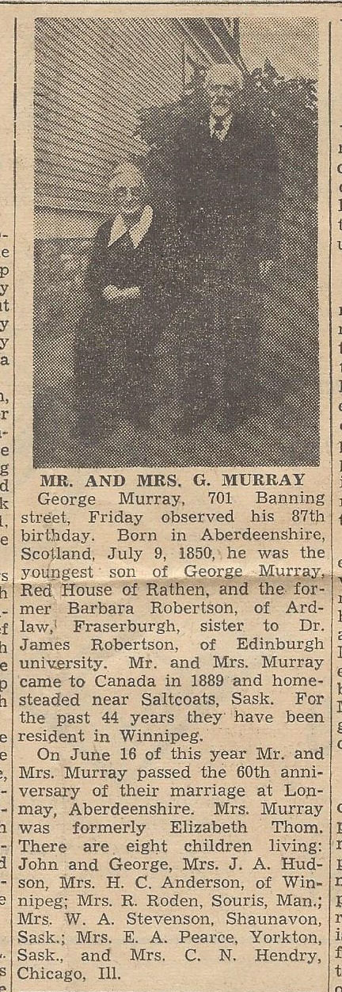

George and Elizabeth celebrated their 60th wedding anniversary on June 16, 1937, and one of the Winnipeg newspapers printed an article about them with a photograph outside of their home at 701 Banning Street.

George was 87 years old and Elizabeth was 82 in 1937.The newspaper article verifies that the sons John and George were living in Winnipeg, and the daughters were living these locations: Elizabeth in Souris; Agnes in Winnipeg; Jessie in Shaunavon, Saskatchewan; Robertson (Robin) in Yorkton, Saskatchewan; Margaret in Winnipeg; and Mary in Chicago.

Son John and family are living at 15 Sutherland where they moved into the previous year (1936). John Murray lists his occupation in 1937 as harnessmaker, with no employer given. There would be few job opportunities for a harnessmaker by this time as the automobile had firmly taken hold of passenger and freight transportation. John is 65 years old in 1937. Other family members at 15 Sutherland consisted of: mother Julia, son George (Geordie) as an employee at Shea’s Brewery, and daughters Ruby and Hazel, both with no occupation listed.

As for companies that John Murray started, Murray Auto Top continued in 1937 without change, since 1934. Murray Tent and Awning is listed with no changes from 1936 to 1937.

John’s daughter Gladys Magee has moved from 372 Edmonton to renting rooms at 627 Maryland Street in 1937 Henderson, although the actual move must have occurred in 1936. This house, 627 Maryland, was owned and occupied by John and Margie Tough. John Tough was a bookkeeper at Clark Bros where Gladys had been employed up to 1928. Gladys is listed as an employee at W.J. Gage. Living with Gladys are her two yet-unmarried daughters Verna Magee, an employee at W.J. Gage, and Vivian Magee, a steno with no employer listed.

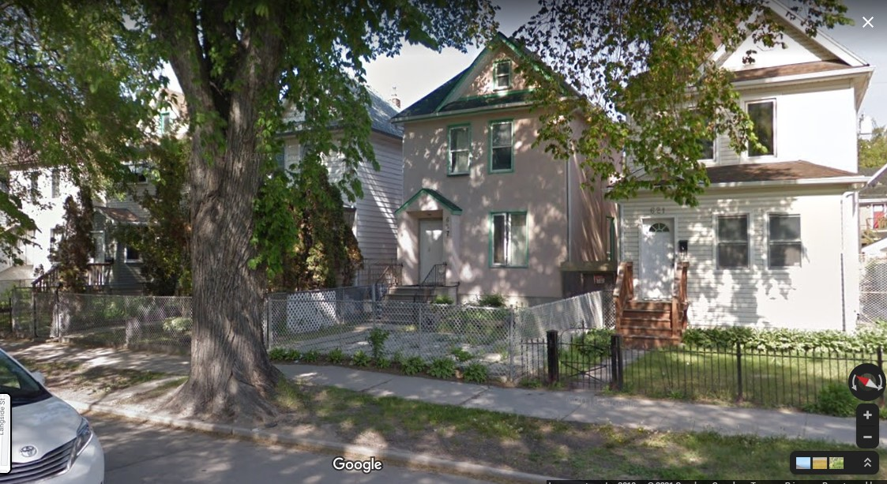

627 Maryland, today
The pink house is 627 Maryland
The house to the left is 629 Maryland (obscured by a tree)
Both of these houses were built in 1905

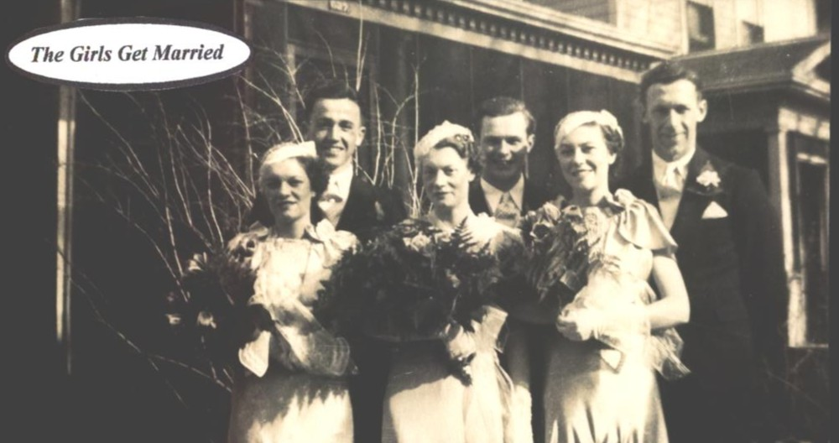
Isabelle’s Wedding Day
In Front of 627 Maryland, when it had a verandah
L to R: Front Row: Verna, Isabelle, Vivian
Back Row: Arthur Lightfoot, Charlie Cruickshank, Denny Konchak

Gladys’s eldest daughter Helena Isabelle (my Mom) was married to Charlie Cruickshank (my Dad) the previous year, on May 9, 1936. Isabelle is not listed in 1937 Henderson so seemingly she had left Eaton’s and was unemployed. During the Great Depression, when jobs were hard to find, women, once married, were discouraged from working in order to leave jobs available for the men. Isabelle did do casual labour, specifically housecleaning, in those days. Charlie’s job is listed as helper at Frank Nels (mis-spelled, should be Neuls). Isabelle and Charlie boarded at 629 Maryland in 1937, right next door to Gladys, Verna, and Vivian. The house, 629 Maryland was owned by Alex S. Walker, a carpenter, the father of Margie Tough.

No change was observed for Agnes and John Hudson from 1934 to 1937.

In 1937, Hugh Anderson has changed jobs from advertising manager for Nor’ West Farmer (a job he took in 1927) to employee at Stovel Company. The previous year, 1936, Nor’ West Farmer merged with The Country Guide to form “The Country Guide and Nor’ West farmer”. (In the 1940’s this publication simplified its name to be called The Country Guide.) Hugh’s new employer, Stovel, employed members of the Murray family dating back to when Margaret’s older sister, Agnes, first worked there as a stenographer in 1902, before she transferred to Nor’ West Farmer in 1905.
Father George Murray is listed as retired in 1938. His son, George, is listed as tinsmith but with no employer listed. This would be the seventh year in a row (starting in 1932) that no one was working at 701 Banning Street. Elizabeth (nee Thom) died on September 12, 1938. Elizabeth was born November 6, 1855. At 35 years old, she moved with her family from Scotland to Saskatchewan then to Winnipeg in the day when the rail lines were still being built. She raised her family which included a step-son and a step-daughter, and lost two 2-year-old sons; James who died in Scotland and Alex who died in Saskatchewan. Elizabeth is a woman to be remembered.

In 1938, son John Murray and family are still living at 15 Sutherland. John lists his occupation as salesman, with no employer given. Other family members at 15 Sutherland consisted of: mother Julia, and son George (Geordie) as an employee at Shea’s Brewery. John’s daughter Ruby Murray has moved out of her parents’ home for what appears to be the first time in her life. She is 36 years old in 1938. Ruby moved into 87 Donald Street, but with no occupation listed. Listed as occupant of 87 Donald Street is John W. Murray, which is mysterious. Could this be John R. Murray? Could it be someone we don’t know? Daughter Hazel was not found in 1938 Henderson.

In 1938, Murray Auto Top is listed with no changes since 1934. However, in this year the listed address for Murray Tent & Awning is 259 Templeton, which is the residence of J.H. Whiley the proprietor and manager. As we shall see, Murray Tent and Awning will be back at 269 James Avenue the next year, in 1939.

In 1938 John’s daughter Gladys moved to suite 17-729 Wellington Avenue, the Westhome Apartments, under the name of Mrs. G. Magee. Gladys’s two daughters Verna and Vivian are still listed at 627 Maryland but they followed Gladys the same year or the next. In 1938, Verna was a machine operator at W.J. Gage and Co, where her mother was working as a steno. Vivian was a saleslady at Woolworth’s department store, a job she liked very much and where she made life-long friends. Vivian will return to Woolworth’s, as a saleslady, in 1957.

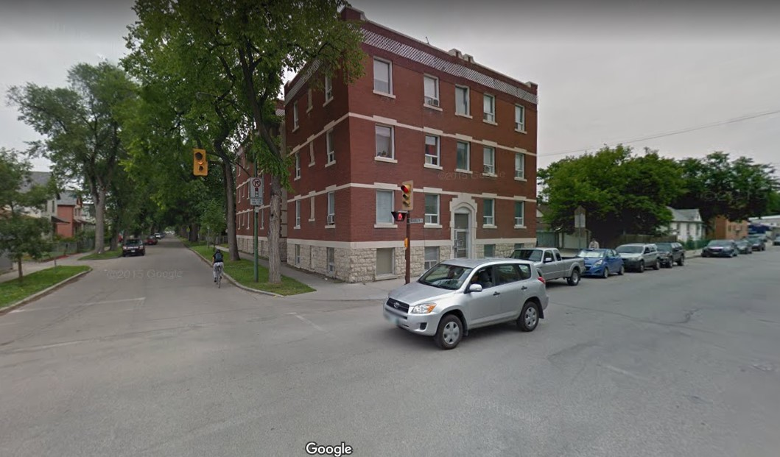
729 Wellington Avenue, today
Westhome Apartments
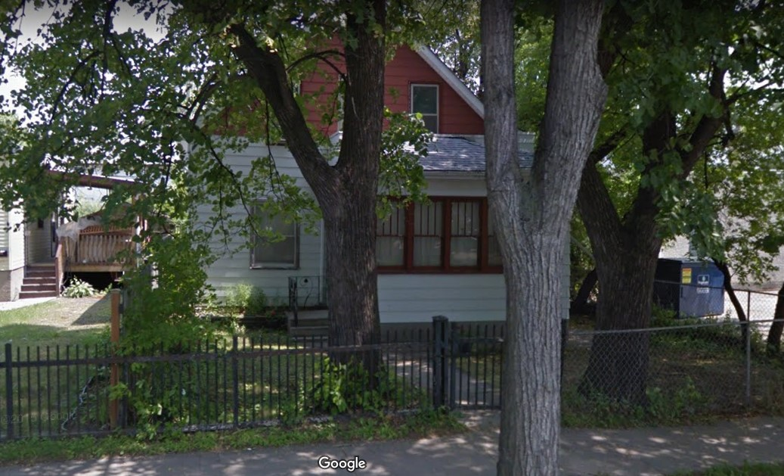
709 Lipton, today
Gladys’s daughter Isabelle and husband Charlie also moved in 1938. They moved into the upstairs of 709 Lipton Street, a house owned by Ernest Hotchin, built in 1910. Today, and presumably then, 709 Lipton is a 1 ½ storey house with not much room at all on the upper floor. It was very warm in the Summer. In 1938 Charlie was an employee at Neuls.

In 1938, William Bannerman Hudson, son of Agnes and John Hudson, married Connie Deller, who was born in Winnipeg. Agnes and John are still living at 120 Bannerman in 1938. John is still a salesman for the Winnipeg Free Press newspaper, a job he began in1934. Their son Robert is listed living at home again, at 120 Bannerman. Robert’s occupation is not given in 1938. This could be an error in Henderson??? We will not see Robert in Winnipeg Henderson again. {RAY: Check with S.B.}

In 1938, Margaret and Hugh Anderson are still living at 258 Ash Street. Hugh went from being an employee to being an editor at Stovels, having started with that employer the previous year, in 1937.

On April 30, 1939 the father, George Murray, passed away. So much could be said at this point about the man who was born July 9, 1850, on a small tenant farm called Redhouse, in Rathen, Scotland. He homestead farmed in Saskatchewan, before it was a province, using oxen to pull the plough. He finished raising his family in Winnipeg, Manitoba. Continuing to reside at 701 Banning Street was their son George (the tinsmith) who is listed in 1939 Henderson with no occupation given.

Son John Murray and family moved in 1939 from 15 Sutherland to 280 Eugenie. This house is no longer standing. John lists his occupation in 1939 as a harnessmaker, with no employer given. It is obvious to us now that the automobile has replaced the horse and wagon so harness making has become a thing of the past. Living with John and Julia at 280 Eugenie is son George (Geordie) as a labourer at Shea’s Brewery. Geordie’s address in Henderson is listed as 200 Eugenie, but it seems more likely he was living with his parents at 280, and the 200 is an error. John’s daughters, Ruby and Hazel were not found in 1939 Henderson.

In 1939, Murray Auto Top is listed with no changes since 1934. Murray Tent & Awning is again located in the McRae Block at 269 James Avenue, in 1939; still with J.H. Wiley as proprietor.

There were no changes in address nor occupation for Gladys nor any of her 3 daughters in 1939. Gladys was again listed twice in Henderson as Mrs. G. Magee and as Gladys Murray.

Gladys’s eldest daughter Isabelle had her first child, a daughter, on June 3, 1939. Isabelle’s husband, Charlie, has become a serviceman at Newell Spring (the same company as 1938 but spelled differently). Charlie and Isabelle were still living in the upstairs of the 1 ½ storey house at 709 Lipton Street, crowded and hot.

There were no changes for Agnes & John Hudson from 1934 to 1939 in Henderson. Their son William Bannerman Hudson appears for the first time in 1939 Henderson as a clerk working at Swift’s, and living with his parents at 120 Bannerman. ‘Swift’s’ could refer to the meat processing company or to a law firm, both of which are listed in 1939 Henderson.

Margaret and Hugh Campbell Anderson were still living at 258 Ash Street in 1939. Hugh changed jobs in 1939, from editor at Stovels to become the advertising manager for Canadian Finance (probably a magazine). Canadian Finance was located in the Stovel Building, also known as the Stovel Printing Building, at 365 Bannatyne. The Stovel Building also housed Nor’ West Farmer. As earlier mentioned, the Stovel Building was constructed about 1916, after fire destroyed the interior of their previous location, called the Stovel Block at 245 McDermot Avenue, which had been built in 1893. Both buildings, the Stovel (Printing) Building and the Stovel Block are now municipally designated historic sites.

The 1940’s

The 1940’s was a decade that begins a further decline in the number of Murray family people we are following in Winnipeg. George and Elizabeth have passed away. Sons John and George will not survive this decade. Daughter Elizabeth has long ago moved to Souris. Daughters Jessie and Robin have long ago moved to Saskatchewan. Daughter Margaret will move from Winnipeg in 1941 or 1942 but return in 1943. Daughter Mary has long ago moved to Chicago.

Of course, there are grandchildren, great grandchildren, and great-great grandchildren but that list becomes too extensive to provide in detail. Sufficient to say that in 2021, as this is being written, there are great-great-great-great grandchildren that I know of, all descended from George Murray, born in 1850 on a little farm in Rathen, Scotland.

This first half of the 1940’s was dominated by World War II. The war affected the residences and occupations of many people in Winnipeg.

In 1940 George (the tinsmith) Murray is still living at 701 Banning. With no occupation listed, he is likely unemployed. George was 62 years old in 1940 and, for what might be the first time in his life, living alone.

There are no changes from 1939 to 1940 for John Robertson Murray and family. Murray Auto Top is listed with no changes from 1934 to 1940. Murray Tent and Awning is not listed in 1940.
There was no change in address nor occupation for Gladys in 1940. She is again listed twice in 1940, this time as Mrs. G. Magee and as Miss G. Murray. Glady’s daughters Verna and Vivian were still living with their mother, having the same jobs and employers in 1940, as in 1938 and 1939. Vivian was married to William Daniel Konchak (known as Denny) on September 21, 1940. Denny’s parents’ home and family home was at 823 Alverstone Street. Vivian and Denny moved into that family home when married. In 1940 Henderson, Denny’s occupation was given as constable at the City of Winnipeg. Denny first appeared in this job in the 1938 Henderson. Except for his time in the airforce, Denny would remain employed as a policeman of Winnipeg City Police Department until his retirement, on July 28, 1968. Denny’s father, William Konchak is listed as the home owner of 823 Alverstone and employed as a switchman for CPR in 1940.

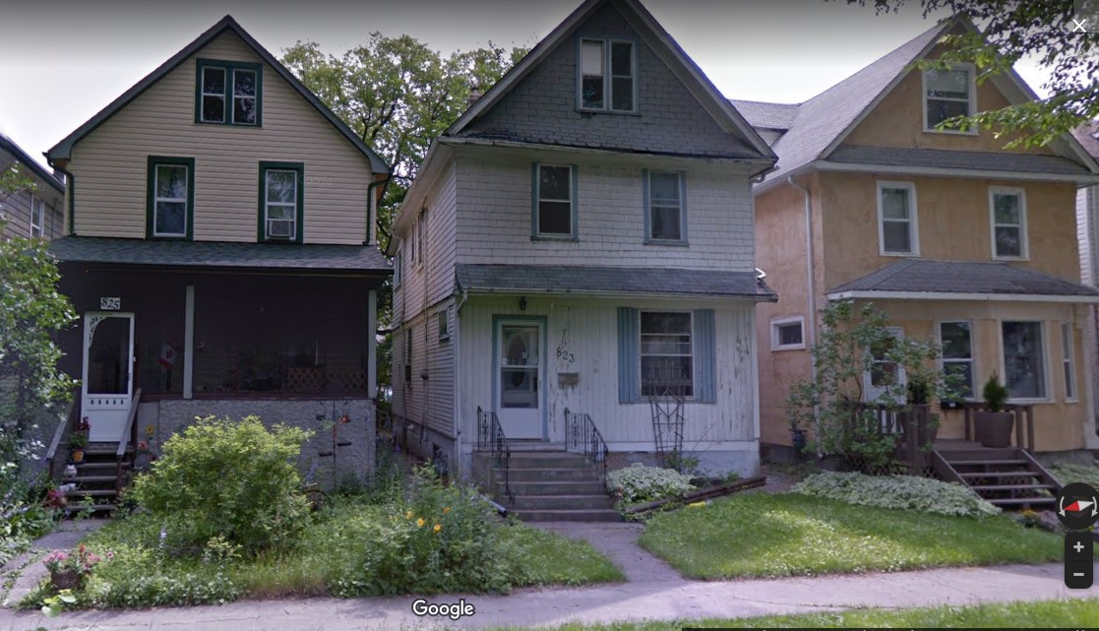
823 Alverstone, in 2015
This Konchak family home was built in 1912
In 1940, 823 Alverstone had a front porch and was in good repair
It is under renovation now (in 2021)

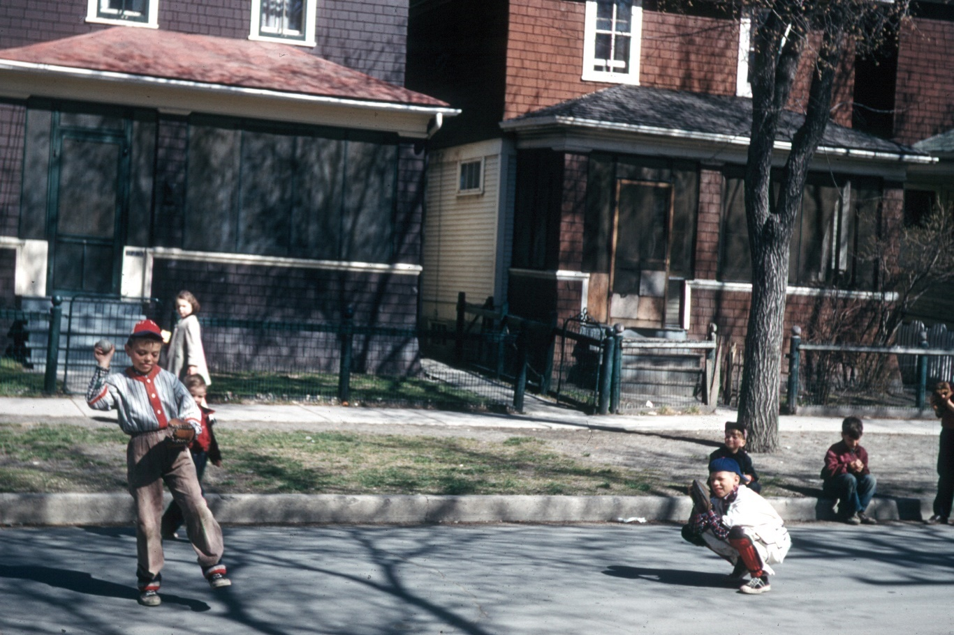
823 Alverstone, around mid-1950’s

Gladys’s eldest daughter Isabelle, with husband Charlie and daughter were still living in the upstairs of the 1 ½ storey house at 709 Lipton Street. Charlie is now listed as an employee, not a serviceman, at Fred Neuls (the same company as 1938 and 1939).

The 1940 voters' list for Shaunavon, Saskatchewan, has a Jessie Stevenson, widow; a James Stevenson; and a Mrs. James Stevenson. Could these be related to Jessie (nee Murray)?

In 1940, Henderson again lists William Bannerman Hudson, son of Agnes & John Hudson as a clerk working at Swift’s (then a salesman of the Swift-Canadian Co. Ltd) but now living at 435 Dubuc, a 650 square foot starter home built in 1917. On December 12, 1940, William was killed by a drunk driver of a coal truck, Emil Urach, at the intersection of Dubuc and Youville Road. He was 22 years old. He had been married only 2 years. William’s father John Hudson is still a salesman at the Free Press newspaper, a job he started in 1934. John and Agnes Hudson continue to live at 120 Bannerman in 1940.

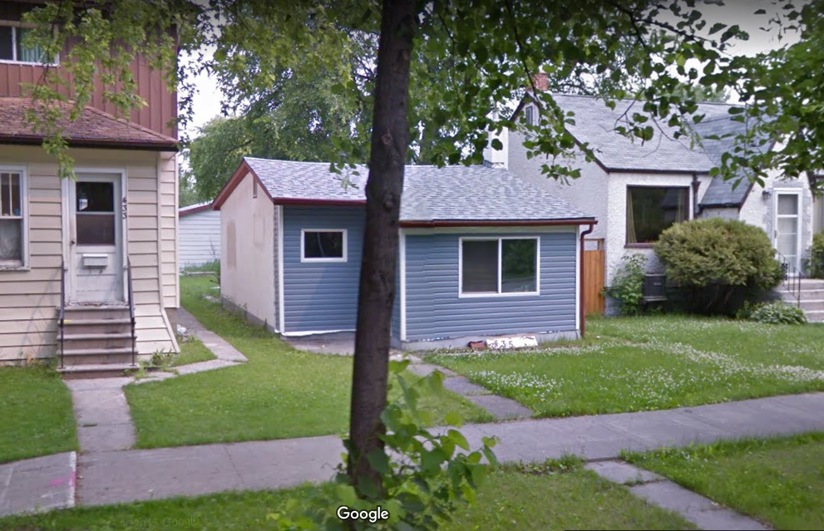
435 Dubuc, today

Margaret and Hugh Anderson were still living at 258 Ash Street in 1940. There is no occupation listed for Hugh so he might be unemployed at this time. Canadian Finance, Hugh’s employer in 1939, was not listed in 1940 Henderson so it might be out of business.

In 1941 George Murray (the tinsmith) appears at 701 Banning Street, with no occupation listed.

George’s brother, John, is still living at 280 Eugenie and listed as a harness maker, with no employer given. John’s son, Geordie is still living at 280 Eugenie, too, and still employed as a labourer at Shea’s Brewery. John’s daughters Ruby and Hazel were not found in 1941 Henderson.

As for the companies started by John, in 1941 Murray Auto Top Co remains as it has been since 1934: at 280 James Avenue, with Wm. H. Batchelor as proprietor. Murray Tent & Awning is not listed in 1941 Henderson.

John’s daughter Gladys is not listed as ‘Gladys’ in 1941 Henderson, but a Violet Magee does appear living at their home at 17-729 Wellington, working as an employee at Kresges department store. This is an odd entry as there is no family member named Violet and I am not aware of any family member working at Kresges. This “Violet” should not be a misspelling for Gladys’s daughter Vivian, who was married the previous year, on September 21, 1940, so is now Vivian Konchak. Vivian Konchak is not listed in 1941 Henderson so was likely not working. Vivian’s husband Denny is listed at 823 Alverstone, the family home.

Neither is “Violet” Gladys’s daughter Verna, who is still living at 17-729 Wellington and is still an operator at W.J. Gage, in 1941 Henderson. This is the last time Verna will appear in Henderson as she was married to Arthur Leslie Lightfoot in March of 1941. In this year Arthur’s father and brother are listed as living at 626 Burnell. Arthur’s father’s name was Chas and he was a brakeman (employer not listed). Arthur’s older brother’s name was John and he was a salesman at Bond and Ronald, a chocolate/candy company. John was not found in 1941 Henderson. Arthur’s mother, Charlotte, was likely not working at that time, as she was not listed in 1941 Henderson.

An important move happened for Glady’s daughter Isabelle in 1941 when she, her husband Charlie, and their daughter moved out of the 1 ½ storey house at 709 Lipton and into 430 Beverley Street, owned by Mrs. Ada Hagland, and built in 1908. This house is today, and likely was then, a full 2 storey house so living on the second storey would have been much more spacious than the top storey of the 1 ½ storey home at 709 Lipton Street. Their daughter was 2 years old in 1941. Unfortunately, Ada Hagland complained about the amount of water Isabelle was using to wash diapers, causing Isabelle and Charlie to seek other housing options. Charlie remained an employee at Fred Neuls.

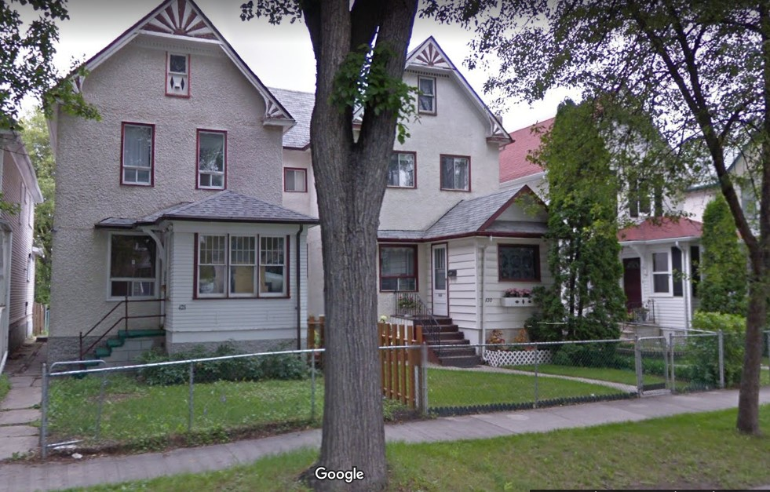
430 Beverley, today

There were no changes in Henderson for Agnes & John Hudson from 1934 to 1941. Listed in Henderson for the first time is Elizabeth Hudson, daughter of Agnes and John. She appears with no occupation and no employer, living at 120 Bannerman with her parents. Also erroneously listed is Agnes and John’s son William, occupied as a clerk at Swift’s and living at 435 Dubuc. William had passed away on December 12, 1940.

Likewise, there were no changes for Margaret and Hugh Anderson in 1941 Henderson. They were still living at 258 Ash and Hugh was seemingly unemployed as no job nor employer was listed.

In 1942 George Murray (the tinsmith) is again listed at 701 Banning, with no employer. This has been his status since 1932, essentially all the way through the Depression. It is not possible to say if he was doing casual work during these years or where his income came from but he did retain the house at 701 Banning which appears to be owned by him, not a rental.

John Murray is listed as retired in 1942, still living at 280 Eugenie. Living with John are his wife Julia and their son Geordie who is still employed as a labourer at Shea’s. John’s daughters Ruby and Hazel are not found in Henderson in this period. Hazel could be going by one of her married names (Anderson or Sealey). Ruby might still be living with her parents and unemployed.

There is no change for Murray Auto Top from 1934 to 1942 but Murray Tent & Awning has returned to Henderson after not being listed in 1940 and 1941. Murray Tent & Awning has come under new ownership of Mrs. Ahlbaum, proprietor, in 1942. The location for Murray Tent & Awning is unclear but looks like 269 James Avenue, which was its previous location since 1936 (except in 1938).

John’s daughter Gladys appears only once in 1942 Henderson and that is as Miss G. Murray, clerk, at Gage & Co. Her address is 1156 Downing Street which is the brand new 750 square foot home of her daughter Isabelle and husband Charlie with their daughter, now 3 years old. This house was built by Charlie’s father who was Frank Cruickshank, and Charlie and his 2 brothers Hugh and Alex. As Frank was in the house building business, he made the purchase of a house affordable for Charlie and Isabelle. The house at 1156 Downing has changed very little in exterior appearance since it was built in 1941 or 1942. In those days the street was so new that there were no houses next door, on either side. This would be the Cruickshank family home until 1962. Charlie is still an employee at Fred Neul’s in 1942.

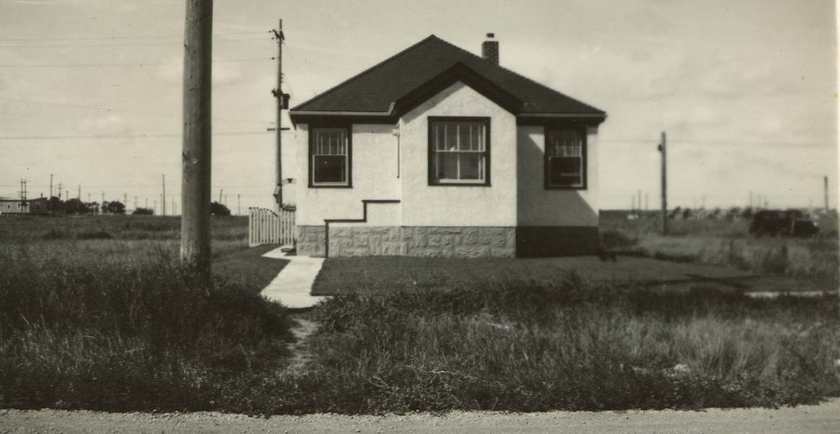 1156 Downing, new in 1941-1942

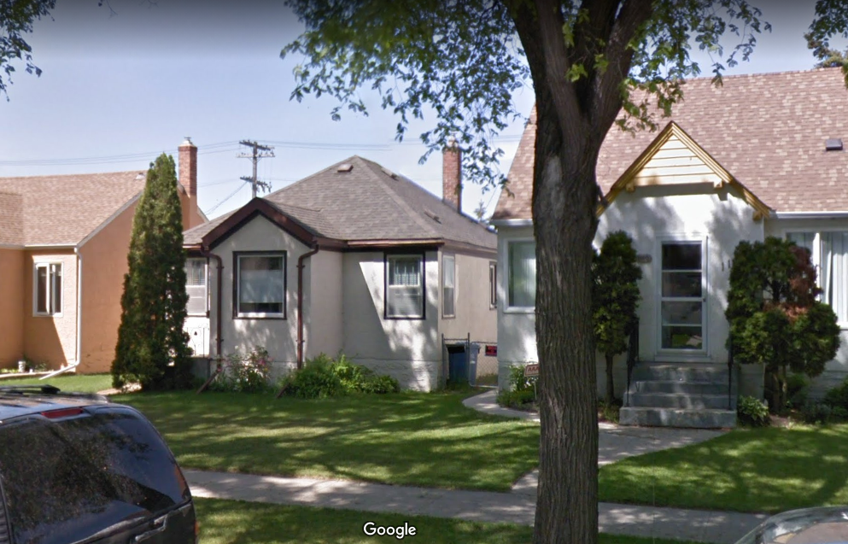
1156 Downing, today

Verna and Arthur Lightfoot are not listed in 1942 Henderson. Vivian and Denny Konchak are listed at 823 Alverstone.

In 1942, Agnes and John Hudson are still living at 120 Bannerman, their home since 1911. John is still a salesman at the Winnipeg Free Press newspaper, the job he took in 1934.

Margaret and Hugh Anderson do not appear in 1942 Winnipeg Henderson’s Directory. As Henderson focused on employed individuals, it is probable that Hugh moved from Winnipeg at this time, a period in which he might have been in officer training. This was during World War II. Margaret and their son, Hugh John Anderson, likely remained at 258 Ash Street as this is their address in the following year, 1943.

In 1943, George Murray (the tinsmith) has indication of employment for the first time since 1932. He is employed at 45 Arthur Street, which is the address of Reliance Heating Ltd. It seems like that building no longer exists. George’s former employer, WA Templeton’s Tin Shop, has disappeared from Henderson by 1943, so the company likely did not survive the Depression. George Murray continues to reside at 701 Banning Street which will be his home for the rest of his life.

In 1943, John Murray remains retired, living at 280 Eugenie. John’s daughter Ruby is living with her parents at 280 Eugenie. She now indicates employment for the first time since 1938, being employed, as an assistant for Dr. J.R. Davidson.

The changes for Murray Auto Top and Murray Tent & Awning are that Wm. H. Batchelor and Mrs. G. Ahlbaum are no longer proprietors but are now both managers. It is unknown who the owners of these companies were at this time.

John’s daughter Gladys, listed as Gladys Murray, has moved into apartment 8-543 Bannatyne, in 1943. Gladys will live at this address until 1961, with only a short time away from 1945 to 1947. This building appears on the left in the following photo. Interestingly, this building is exactly the same one that guitarist Kurt Winter lived in, years later, and comprised the photograph on Guess Who's album "So Long Bannatyne". Gladys is still employed by WJ Gage & Co. Ltd. In 1943.

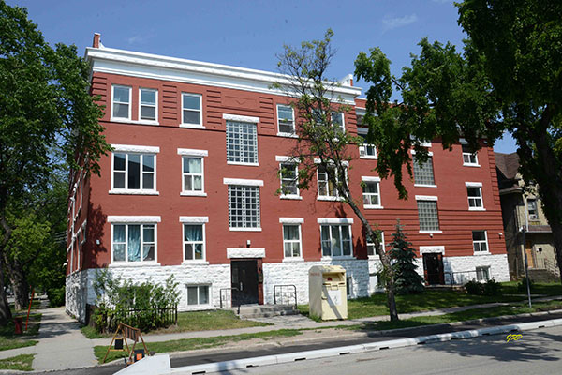
543 Bannatyne, the Bannatyne Apartments, today

Gladys’s daughter Isabelle is still living at 1156 Downing Street with husband Charlie Cruickshank and daughter in 1943. Charlie is now a salesman at F. Neuls. He will continue in sales for the rest of his life.

Arthur and Verna Lightfoot are not listed in 1943 in Henderson. This is because Arthur and Verna were living in Toronto, Ontario, where Arthur was serving in the Canadian military (Airforce).
Vivian and Denny Konchak are listed in 1943 Henderson as living in the Konchak family home at 823 Alverstone. Denny’s father, William is also listed at this address with occupation of retired. Denny’s occupation is given as constable at the City of Winnipeg, but he entered military service just after their first child, a daughter, was born on February 17, 1943. Vivian and Denny’s daughter was delivered by Dr. J.R. Davidson, who would later be Ruby Murray’s employer (starting in 1945). In this year, when their daughter was 6 ½ months old, Vivian took the train to St. Thomas, Ontario, to be with Denny who was stationed there in the military service. When their daughter was 9 months old, Vivian, Denny, and their daughter returned to Winnipeg. They lived for a few months with the Cruickshank family at 1156 Downing Street. Then they moved to 830 Alverstone and lived upstairs of the Carmichael house

There was no change in Henderson from 1934 to 1943 for Agnes and John Hudson.

In 1943, Margaret (nee Murray) Anderson’s husband, Hugh Campbell Anderson now has the rank of Flight Lieutenant, in the Royal Canadian Airforce, employed as a public relations officer. They are still home owners at 258 Ash Street, Winnipeg.

The year 1944, compared to 1943, saw very few changes for the Murrays. Son John, John’s son Geordie, and John’s daughter Ruby had no changes from 1943 to 1944 in Henderson. However, we do know that John’s family moved from 280 Eugenie to 227 Eugenie on June 9, 1944.

The only changes listed in 1944 Henderson, compared to 1943, were as follows:

- Vivian and Denny Konchak are not listed in 1944 Henderson.

- Husband of Margaret, Hugh Campbell Anderson, is listed as being on Active Service, in 1944 with their home still at 258 Ash Street.

The year is 1945. On a world scale, World War II ended September 2, 1945, but the year 1945 saw very few changes for the Murrays. The changes for the Murrays in 1945 were as follows:

In 1945 Henderson, John’s address has changed from 280 Eugenie to 227 Eugenie. This house is a 2 storey, 3 bedroom home built in 1909. Family lore has it that John’s son Geordie was good at saving his money and eventually was able to purchase this home from the school district for $3,500.00, and they moved in on June 9, 1944. Geordie seems not to be listed in 1945 Henderson. Geordie, his dad John, mom Julia, and sister Ruby continued to live at 227 Eugenie until their deaths. In 1945 Henderson, Ruby has become a bookkeeper for Dr. J.R. Davidson. Hazel continues not to be found in Henderson.

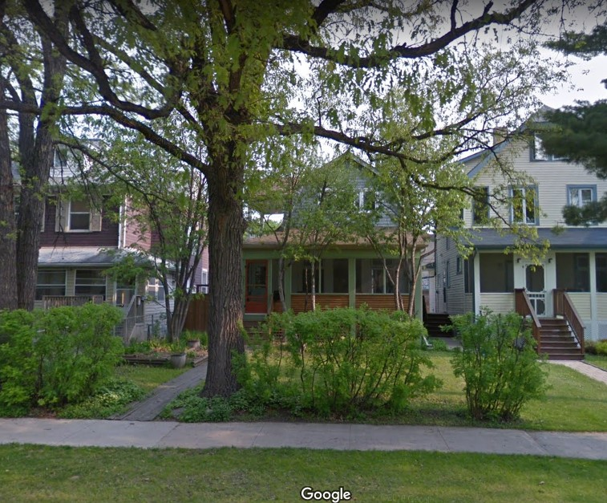
227 Eugenie, today
The house in the middle of the photo is 227 Eugenie

John’s previously owned companies remained the same in 1945 as in 1943, except Mrs. G. Ahlbaum is again proprietor, not listed as manager, of Murray Tent & Awning, still at 269 James Avenue.

In 1945 John’s daughter Gladys, listed as Gladys Murray, is occupied as a typist at WJ Gage & Co. Henderson lists her at a new residence of 8-263 Young Street. This is problematic because 1945 Henderson also indicates that 263 Young was a single-family dwelling. An apartment building, the Alma Apartments, does appear at 269 Young Street but Gladys is not listed among the tenants there. The Alma Apartments contain 28 apartments and was built in 1914. The move from 8-543 Bannatyne, assuming it did occur, was possibly made to accommodate Gladys’s daughter Verna and her husband Arthur returning to Winnipeg (see 1946-Lightfoot, below). LM (no further info). RG DO YOU have any INFO about this?

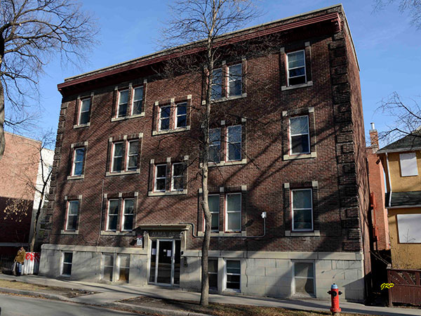

Alma Apartments, today

Vivian and Denny Konchak are not listed in 1945 Henderson. Living at 823 Alverstone Street are Denny’s father, William who is still listed as retired and Denny’s brother Walter who is a yardman for Canadian Pacific Railway (CPR). Walter will remain employed as a yardman (or occasionally a switchman) at CPR until after the 1965 Henderson.

There were no changes in Henderson for Agnes and John Hudson from 1934 to 1945.

In 1945, Margaret’s husband, Hugh Campbell Anderson is now editor of Motor in Canada, a magazine published in Winnipeg and distributed across Western Canada. This magazine first appears in Henderson in 1916 with an advertisement under the name Motor and Sport, published by E.H. Heath Co Ltd and located in the Enderton Building at 334 Portage Avenue. That building no longer exists. Then in 1918 (there is no digitized Henderson for 1917), the company had an advertisement under the name of Motor in Canada which reads “Published monthly by E.H. Heath Co Ltd, Bannatyne corner of Dagmar Street” and gives phone numbers. The Stovel (Printing) Building, constructed around 1918 takes up the whole block on Bannatyne Avenue between Dagmar and Ellen Streets, so it could be the building referred to in the Motor in Canada advertisement. By 1945 when Hugh Anderson becomes editor, Motor in Canada is listed at 365 Bannatyne Street, the Stovel (Printing) Building. By this time, the Stovel company was the largest and oldest commercial printing firm in Winnipeg.

In 1945 Margaret, Hugh and presumably their son Hugh still live at 258 Ash Street.

The year 1946 again saw few changes for the Murrays, so only changes from 1945 will be emphasized here.

By 1946, cars did not need auto top replacements, side curtains, or the other features found in early automobiles. Likely in search of new markets, Murray Auto Top is now called Murray Auto Top and Trimming Co., still located at 280 James where John Murray established it as a department in 1919. H. Batchelor is still the proprietor.

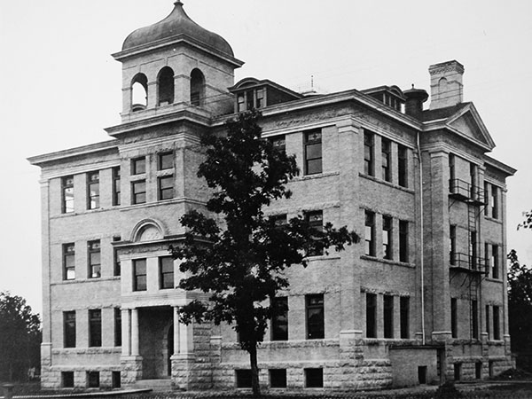
In 1946, John’s son Geordie was living at 227 Eugenie and working as a caretaker at Queen Elizabeth School, at 260 Kenny Street (at right). Named Tache School when constructed in 1907-1908, this school was re-named Norwood Collegiate, then re-named again to Queen Elizabeth School in late 1939 or early 1940.

This building was demolished in 1963.

Gladys is back to being a steno in 1946, from being listed as a typist the previous year. A steno (stenographer) was a higher paying job than a typist. Gladys is still living at 8-263 Young Street in 1946.

Gladys’s daughter Verna is living in the apartment vacated by Gladys, that being 8-543 Bannatyne, in 1946. Arthur might not be listed in 1946, unless he is the person who appears as Art Lightfoot, in active service, whose residence is given as 783 Beverley. More information appears in 1947. Arthur’s father is a pressman with Bulman Bros and still living at 626 Burnell. Arthur’s brother John is in active service, also with the address of 626 Burnell.

Vivian’s father-in-law (Denny’s father) William Konchak died on April 13, 1946. Denny’s brother Walter went from being a yardman to being a switchman at CPR, in 1946.

Elizabeth Hudson, the daughter of Agnes and John Hudson, appeared for the second and last time in digitized Henderson in 1946. The previous time was in 1941. Known to all as Betty, she is listed in Henderson as E.K. Hudson, living with her parents at 120 Bannerman. The middle initial is an error as it should be ‘R’ for Ruth rather than ‘K’. No occupation nor employer is given for Elizabeth. John Alvin Hudson was still a salesman at the Free Press, in 1946.

In 1946 Hugh Campbell Anderson, husband of Margaret (nee Murray) went from being an editor, to being a business manager, for Motor in Canada magazine. Their home was still 258 Ash Street.

These were the only changes for the Murrays in 1946.

In 1947 son George Murray is listed as a tinsmith but with no employer indicated. Previously he had been employed by Reliance Heating Ltd at 45 Arthur Street. Reliance Heating was still listed in 1947 Henderson. George is still living at 701 Banning Street.

John Robertson Murray, still retired, is living at 227 Eugenie in 1947. Also living there would be his wife Julia, and (listed in 1947 Henderson) son Geordie and daughter Ruby. Geordie is listed as John G. Murray, which is his actual name (John George Murray). Geordie is a caretaker at Norwood Collegiate in 1947, the same building as in 1946. Ruby is listed as a receptionist. With no employer given, it is possible that Ruby’s employment with Dr. J.R. Davidson has ended. Dr. Davidson died the next year in 1948.

Murray Auto Top and Trimming continues at 280 James Avenue, with William Batchelor as proprietor. Murray Tent & Awning continues at 269 James Avenue with Mrs. G. Ahlbaum as proprietor.

In 1947 Gladys is listed as a clerk at W.J. Gage & Co., which is another job title change. She is still listed as living at 8-263 Young Street.

Gladys’s daughter Verna is listed as Miss A. Lightfoot living at 8-543 Bannatyne in 1947. Her husband Arthur is listed as Arthur L. Lightfoot, living at 5-543 Bannatyne. Why would these married people have 2 addresses? We will see in the following year that Verna was possibly “saving” apartment #8 for her mother Gladys.

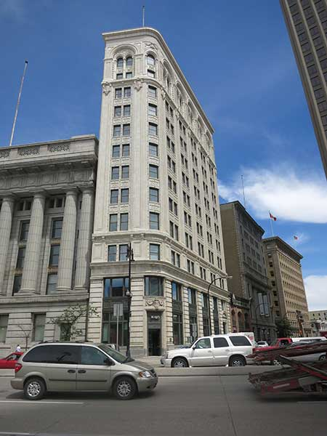
In 1947, Arthur is a salesman for Fred. G Maxwell (F.G Maxwell), who owned a lumber business as manufacturer’s agent in Winnipeg, at 707-191 Lombard. This 13 storey trapezoidal shaped building still stands at the corner of Main Street and Lombard Avenue.

Built by Union Trust (savings and loans) Company, and now known as the Union Tower Building, 191 Lombard was completed in 1913. It is now a municipally-designated historic site.

191 Lombard, today
The Union Tower Building

Arthur’s parents and his older brother also appear in Henderson, living at 626 Burnell. Arthur’s father is Chas G. Lightfoot, a pressman at Bulman Bros. His mother is Charlotte E. Lightfoot, an employee at Hudson Bay Company (HBC). His brother, John G. Lightfoot is an employee at Eatons.

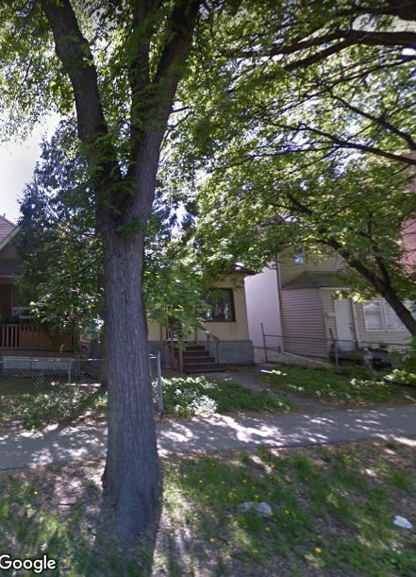
Vivian and Denny Konchak had their second and last child, a son, on May 24, 1947. Likely looking for a home with more space, they moved out of 823 Alverstone and into 253 Young Street. They would continue living there, returning to 823 Alverstone in 1950.

Largely obscured by trees today, 253 Young Street is the yellow home shown in the photo to the left. This 800 square foot bungalow was built in 1905.
Denny’s brother, Walter Konchak is listed in 1947 Henderson as the only person living at 823 Alverstone, still employed as a switchman at CPR. Henderson tended to list only employed people.
253 Young, today

The preceding were the only changes for the Murrays in 1947.

Elizabeth Georgina Barbara Murray was George Murray’s oldest daughter. She married Richard Roden on June 19, 1901, and then moved to Souris, Manitoba around 1907. Elizabeth and Richard had a son, Richard Hendry Roden born on March 26, 1904. (His middle name sometimes appears as “Henry”). In 1948, Henderson lists Richard H. Roden as an employee of Patricia Transportation Co, living at 1251 Strathcona, in Winnipeg. I am taking this Richard H. Roden as being Elizabeth and Richard’s son.

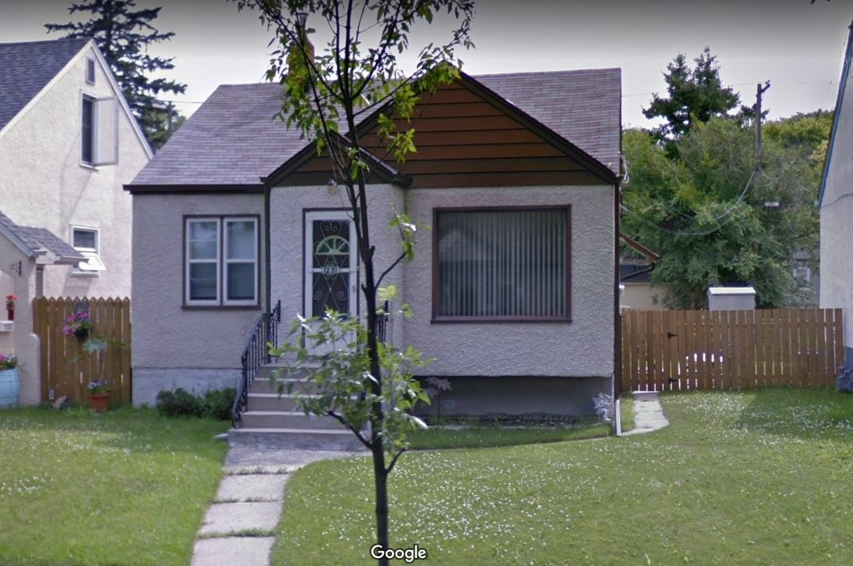
1251 Strathcona, today
This 800 square foot bungalow at 1251 Strathcona was built in 1946

In 1948 son George Murray (the tinsmith) is still living at 701 Banning, but with no occupation and no employer indicated. He was 69 years old in 1948.

On January 27, 1948, John Robertson Murray passed away. He was coming up to 76 years old. He was living at 227 Eugenie with his wife, Julia, his son Geordie, and his daughter Ruby who all remained in that house. John was born on a little farm called Stonehouse in Rathen, Scotland, in 1872. His mother was Anne Fraser. He was the first Murray of our family to come to Winnipeg. He started and operated two companies, one of which continues today (in 2021) called Murray Tent & Awning. John saw a lot of changes in his life which included the obsolescence of his trade of harness maker.

John’s daughter Ruby was listed as a steno but with no employer given in 1948.

The companies John previously owned continued on, in 1948. They were Murray Auto Top and Trimming at 280 James Avenue with W.H. Batchelor as proprietor; and Murray Tent & Awning at 269 James Avenue with Mrs. G. Ahlbaum as proprietor.

In 1948 John’s daughter Gladys has moved from 8-263 Young Street back to 543 Bannatyne Avenue, the building she had vacated in 1945. The apartment number is not given in 1948 but does appear the next year in 1949 as Apartment #8, the same apartment she had vacated in 1945. It is expected that Gladys had left this apartment to make room for her daughter Verna and husband Arthur in 1945-1947. Gladys’s occupation is back to steno at WJ Gage & Co.

Verna and Arthur Lightfoot in 1948 are living in apartment 5-543 Bannatyne. This building is the Bannatyne Apartments where Gladys lives. Arthur’s occupation is now salesman at Boeckh Co Ltd. located at 26-326 Main Street. No longer in existence, the building at 326 Main was across Main Street from the Bank of Montreal building. This company was managed by F.G. Maxwell, who had been Arthur’s employer in 1947.

Arthur’s father Chas G. Lightfoot is still a pressman at Bulman in 1948; and his mother, Charlotte E. Lightfoot, is now a tailoress at Hudson Bay Company. Both are still living at 626 Burnell.

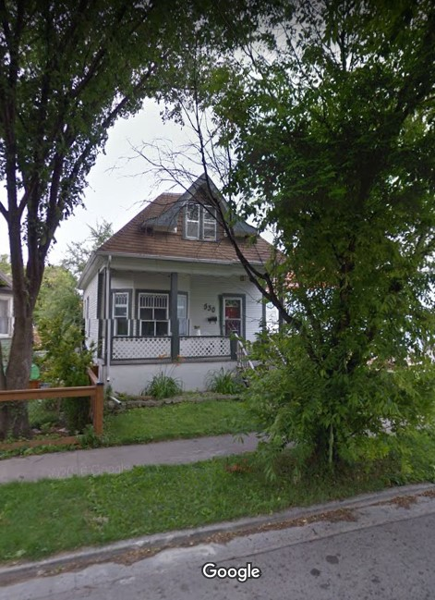

In 1948, Arthur’s brother John G. Lightfoot has moved to 530 Craig a 1 ½ storey home off Portage Avenue in the west end. This house was built in 1911. John is still an employee at Eatons, in 1948.
530 Craig, today

Vivian and Denny Konchak were still living at 253 Young Street in 1948. Listed at the Konchak home of 823 Alverstone were George Konchak, WG Konchak, and Walter Konchak. George, one of Denny’s brothers, was a salesman at Crescent Creamery, WG (William G), son of Pearl and step son of Walter (who was Denny’s brother) was an employee at CPR, and Walter, Denny’s brother, was back to being a yardman at CPR. Denny’s father, William had passed away April 13, 1946.

John Hudson, husband of Agnes (nee Murray) had a job change in 1948. After being a salesman at the Winnipeg Free Press newspaper since 1934, John Alvin Hudson is now a salesman at S.S. Stevenson & Co. This company, founded by Sydney Septimus Stevenson, was a real estate firm established in 1904. John will keep this job until his retirement in 1959. In 1948, John and Agnes were still living at 120 Bannerman Street, their home since 1911.
There was no change for Margaret and Hugh Anderson in 1948 but new in 1948 is the first appearance of their son, Hugh John Anderson, living with them and employed as a lecturer at the University of Manitoba. Hugh John Anderson will go on to become a Phd. chemistry professor at the Memorial University in Newfoundland. He did much research about the Murray family in Scotland, and edited “The Murrays Come to Canada” which was written by his aunt Jessie (nee Murray) Stevenson in 1965.

This is the year 1949. On October 10, 1949, George Murray (the tinsmith) died at his home, 701 Banning. George was the son of George Murray and Elizabeth (nee Thom). He was born in on a farm in Rathen, Scotland and came to Canada with his mother and siblings in 1890. Seemingly a reluctant farmer on his father’s homestead (in what is now Saskatchewan), George moved to Winnipeg when his half-brother John Robertson Murray found work for him. George became a tinsmith and worked in that trade for the rest of his life. He bought a home at 701 Banning in 1920, which also became the home for his parents until their passing. In 1949 Henderson, George is listed as a tinsmith with no employer given. His address, of course, is 701 Banning Street, in Winnipeg, a well-kept house that is still standing today (in 2021).

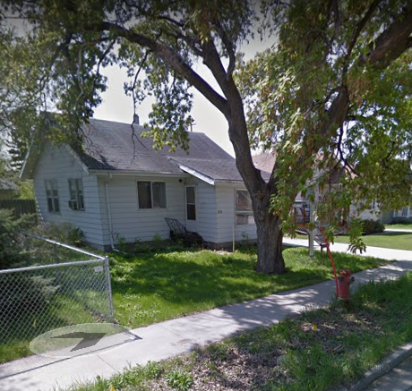

Richard H. Roden, son of Elizabeth Georgina Barbara Murray and Richard Roden has changed jobs to become an employee of the Mining Service Bureau in 1949. The 1949 voters’ list further explains he was employed as an agent.

Having moved from 1251 Strathcona, Richard H. Roden and his wife Anne are on the voters’ list, living at 24 Havelock in 1949.

24 Havelock, today

In 1949, Henderson reported the names of spouses. Julia, the widow of John Robertson Murray, appears in 1949 Henderson, as homeowner of 227 Eugenie. Her daughters Ruby and Hazel are not listed in 1949.

John’s son Geordie, still living with his mother Julia, at 227 Eugenie, is employed by the City of St Boniface in 1949. The job he is doing is not listed, but possibly still a school caretaker. In this same year Hugh A. (Alexander) Cruickshank began employment as a caretaker for the Norwood School Board. Hugh was a first cousin of Charlie Cruickshank, the husband of Gladys’s eldest daughter Isabelle (nee Magee). It seems likely that Geordie Murray and Hugh Cruickshank would have known each other.

John’s two previously owned companies had some changes in 1949. The name of one reverted back to Murray Auto Top (without ‘& Trimming’) for this one year. It is still on 280 James Avenue with Wm. H. Batchelor as manager. The other company, Murray Tent & Awning, is now managed by James O. Seath. It is still located at 269 James Avenue in 1949

John’s daughter Gladys is a typist, working at W.J. Gage & Co, and living at 8-543 Bannatyne, in 1949.

Verna and Arthur Lightfoot now live at 636 Burnell which is 5 houses down the street from Arthur’s mother and father (at 626 Burnell). It is the house with the brown verandah in the photo below, and was built in 1909. In 1949 the names of spouses are given in Henderson and we see John’s wife’s name, Doris.

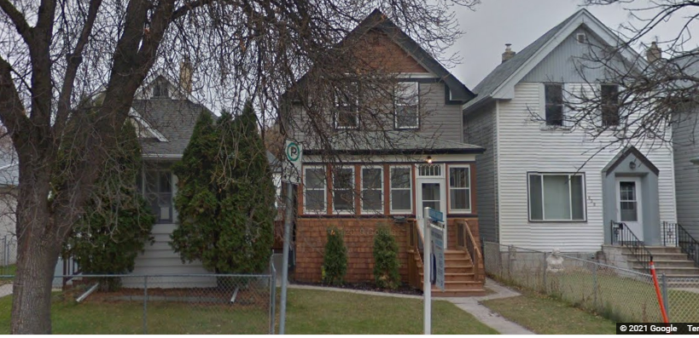
636 Burnell, today

There were no changes for Agnes Hudson and her husband John Alvin Hudson from 1948 to 1949.

There were no changes for Margaret Helenor Anderson (nee Murray), her husband Hugh Campbell Anderson, and their son Hugh John Anderson, from 1948 to 1949.

The 1950’s

With the year 1950, the last 15 years of this study begins. The biggest event in Winnipeg was the 1950 Red River Flood, lasting from mid-April to mid-June. By 1950, many of the original Murrays have either left Winnipeg or have passed away. Census records, a great source of information in earlier years, have only been digitized until 1926, so that information source is not available for the 1950’s. Henderson’s Winnipeg Directory, which has also been a major source of information, is only digitized until 1965. More Murrays will pass away in the next 15 years, between 1950 and 1965. We will focus primarily on changes with the Murray family in Winnipeg, and only occasionally recap the known status of other family members.

The family members of George Murray and Elizabeth (nee Thom) who are remaining in Winnipeg in 1950 are:

- Daughter Agnes (nee Murray) and her husband John (Jack) Alvin Hudson
- Daughter Margaret (nee Murray) and her husband Hugh Campbell Anderson
- Numerous grandchildren, great grandchildren, and great-great grandchildren

George and Elizabeth’s son George (the tinsmith) is reported in 1950 Henderson as retired but this is an anomaly of data collection timing as George had already passed away on October 10, 1949.

In 1950 Henderson, Richard Hendry Roden’s wife is given, as Anne. Anne Roden (nee Derrick) was born in 1913 and died in 1976. [Thanks to S.B., I have their marriage certificate]. Anne Derrick first appears as Annie Derrick in the 1921 Winnipeg census living with her parents and siblings. [ In the 1921 census she was 8 years old, and born in Manitoba. Anne’s parents, Paul and Mary, were born in Ukraine. The family lived at 827 Aberdeen Avenue in 1921. This 1000 square foot home was built in 1910. ] Richard Hendry Roden and Anne had 4 children. Richard has gone back to working for Patricia Transfer Co, with the job listed as ‘agent’ in 1950. Richard and Anne are still living at 24 Havelock. Going forward Richard Hendry Roden is not listed in Henderson again until 1956 or 1957.

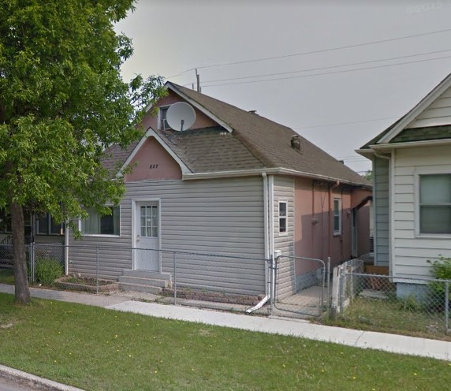
827 Aberdeen, today

John Robertson Murray’s widow, Julia, is living at 227 Eugenie with her son, Geordie,
and her daughter Ruby. Ruby is listed as a receptionist, but with no employer given.
Geordie continues to be a caretaker with the Norwood School Board, in 1950.
The two companies started by son John Robertson Murray continue into the 1950’s. Murray Auto Top & Trimming, managed by Wm. H. Batchelor is located at 280 James Avenue, in 1950. Murray Tent & Awning Co Ltd, managed by J.A. Mabb, is located at 269 James Avenue, in 1950.

John and Julia’s daughter, Gladys, is listed as Gladys Magee (her married name). She is a clerk at WJ Gage & Co. Over the years Gladys has appeared as a steno, a clerk, and a typist. The jobs would seemingly have varying degrees of responsibility and differing pay scales. Gladys is still living at 8-543 Bannatyne.

In 1950, Gladys’s eldest daughter, Isabelle, is living at 1156 Downing with her husband Chas. N. Cruickshank, a salesman at Neuls Spring Service, and their daughter.

Gladys’s middle daughter, Verna and her husband Arthur, live at 636 Burnell in 1950. Arthur has returned to working for FG Maxwell Co., manufacturers agent, where he is a salesman. FG Maxwell as located at 26-325 Main Street. There is no change for Arthur’s parents nor his brother from 1949 to 1950.

In 1950, the youngest daughter of Gladys, Vivian, is living with her husband Denny and their two children at 823 Alverstone, having vacated their home at 253 Young Street, after Walter, Pearl, and George Konchak moved out of 823 Alverstone. Also living at 823 Alverstone in 1950 is one of Denny’s brothers (George) his wife (Mildred) and their two children, and Denny’s mother. Denny’s brother George was a serviceman at Sargent Electric and Radio. Denny’s brother Walter was a yardman at CPR. Denny’s nephew George, sometimes listed as WG Konchak, was the son of Pearl, and a clerk at American Optical. Denny’s mother was Hilda (no occupation). Denny’s father had passed away on April 13, 1946.

In 1950, George and Elizabeth’s daughter Agnes and her husband John Alvin Hudson are living at 120 Bannerman, their home since 1911. John is still a salesman with S.S. Stevenson & Co, his job since 1948.

George and Elizabeth’s daughter Margaret and her husband Hugh Anderson continue to live at 258 Ash Street in 1950. Motor in Canada is listed in 1950 Henderson with Hugh as editor. Under “Anderson”, Hugh is listed as editor of Stovel Press. This is not inconsistent as the magazine Motor in Canada was published by Stovel Press, at 365 Bannatyne. Margaret and Hugh’s son, Hugh John Anderson is not listed in 1950 Henderson.

There is no change in 1951 for the Murrays living at 227 Eugenie except Ruby’s occupation is not listed. This likely means she was unemployed in 1951.

The two companies started by son John Robertson Murray continue in 1951. Murray Auto Top & Trimming, is now owned by M.F. Bailey, proprietor. It is still located at 280 James Avenue. Murray Tent & Awning Co Ltd, with a new manager, D.O. McDonald, has a bold print listing in 1951 Henderson. The location is given as the corner of King Street and James Avenue. This corner of King Street and James Avenue must have been the same location listed as 269 James Avenue, since 1936. This information allows pin-pointing the address as, due to redevelopment, 269 James Street is not an address today. We can now say that the addresses 280 James Avenue and 269 James Avenue were within one block of 180 Princess Street, the location of J. Murray & Co. starting in 1909.

Gladys is listed twice in 1951; once as Gladys Murray (her maiden name); the other listing is Mrs. Gladys Magee. She is a steno at WJ Gage & Co. Gladys is still living at 8-543 Bannatyne.

Isabelle’s father-in-law, Frank Cruickshank, had passed away on August 25, 1950, and the Cruickshank family home at 1040 Garfield was sold. In 1951, 1040 Garfield was owned by Vincent McArthur. On August 5, 1951, Isabelle gave birth to their son.

There was no change of address nor occupation for the Lightfoot families in 1951.

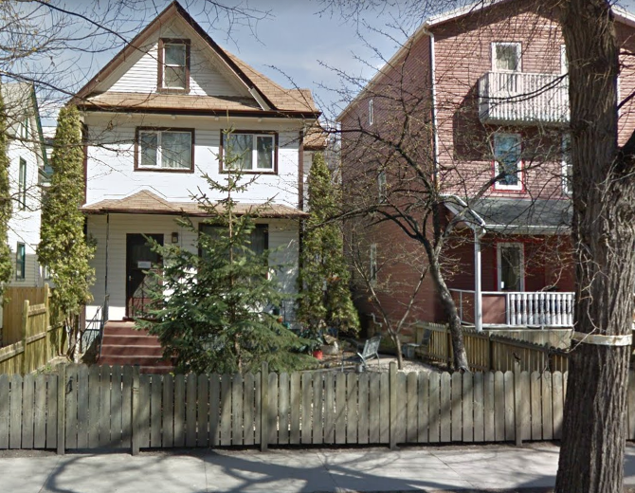
At 823 Alverstone in 1951, all the Konchak family members have the same occupations as in 1950 except Denny’s nephew Wm G Konchak who has become an employee with CPR and moved to
463 Spence (the white house at a left, built in 1903) with his mother Pearl and step-father Walter.

463 Spence, today

The year 1951, saw no change of address or occupation for John and Agnes Hudson at 120 Bannerman from 1948 to 1951. John is still a salesman at S.S. Stevenson & Co.

Likewise, there was no change of address nor occupation for the Anderson family (Margaret and Hugh) from 1950 to 1951.

In 1952, there is no change for the Murrays living at 227 Eugenie. They consist of Geordie, a caretaker for Norwood Collegiate, his mother Julia, and his sister Ruby (no occupation listed).

The two companies started by son John Robertson Murray continue in 1952. Strangely, Murray Auto Top & Trimming, is again owned by Wm. H. Batchelor whereas the proprietor was given as M.F. Bailey in 1951. Murray Auto Top & Trimming has moved from 280 James Avenue and is now located at 180 Princess Street in 1952. Interestingly, this was the original address of J. Murray & Co, beginning in 1909.

In 1952 the address of 180 Princess was still called the McGregor Building with suites on the second storey. Another business still on this block at 172 Princess, is the Elgin Café at the corner of Elgin and Princess. This business, once owned by John Robertson Murray’s friend, Sam Cascisa, continues in 1952, but under the proprietorship of Maxwell Steiman.

Murray Tent & Awning Co Ltd, is still managed by Donald O. McDonald, in 1952, and still located at 269 James Avenue.

There is no change for Gladys in 1952, again listed twice, once as Gladys Murray (her maiden name); the other listing as Mrs. Gladys Magee (her married name). She is still a steno at WJ Gage & Co, and still living at 8-543 Bannatyne.

.

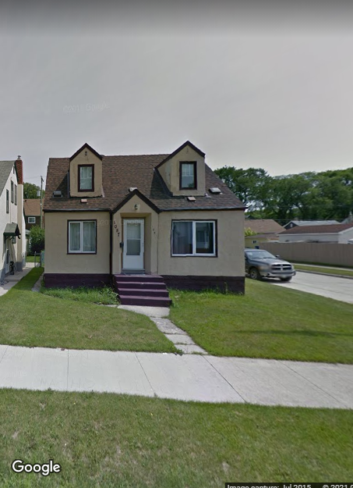
There is no change for Gladys’s daughter Isabelle and her husband Charlie Cruickshank.

Charlie’s brother Hugh was listed in 1952 as an employee at Eatons, having been listed as a carpenter for years. Hugh and Beverley Cruickshank lived at 1087 Garfield Street, a home built by Hugh, his Dad, and two brothers in 1946. This is the last time we will see Hugh and Beverley, as they moved to Vancouver prior to the 1953 Henderson.

1087 Garfield, today

Gladys’s daughter Verna and her husband Arthur, still live at 636 Burnell in 1952, but Arthur has changed jobs to be working for D. Ackland & Son. There are only minor changes for Arthur’s parents and no change for his brother, John.

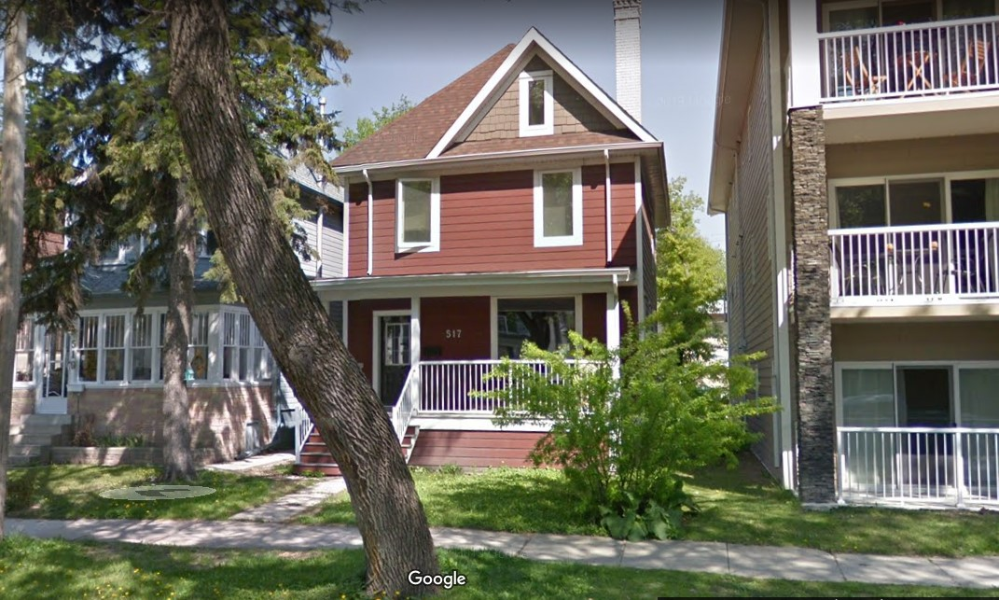
In 1952, only Glady’s daughter Vivian, Denny, their daughter and son, and Denny’s mother, Hilda, remain at 823 Alverstone. Denny’s nephew Wm G Konchak was not found, but his mother Pearl and step-father Walter have moved to 517 McMillan Avenue. This home was built in 1911. Walter is a switchman with CPR. 517 McMillan, today
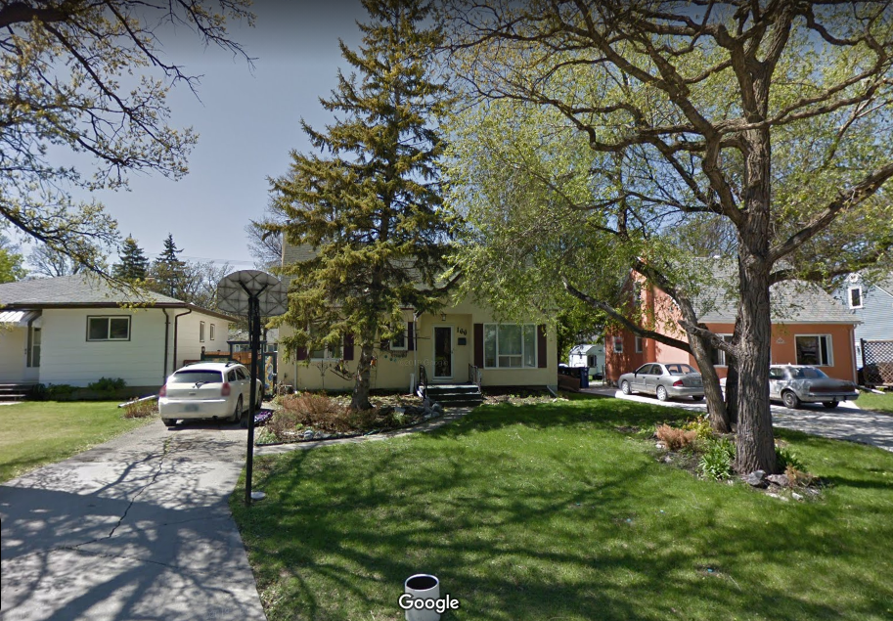
In 1952, Denny’s brother George, a serviceman with Sargent Electric & Radio has moved out of the family home at 823 Alverstone and into a bungalow at 166 Oakdean Blvd, the yellow house in the photo below.

This house was built in 1950.

166 Oakdean, today

In 1952 there were no changes of address or occupation for John and Agnes Hudson at 120 Bannerman from 1948 to 1952. John is still a salesman at S.S. Stevenson & Co.

Hugh and Margaret Anderson’s son, Hugh John Anderson is again living at home, at 258 Ash Street in 1952. He is now a medical student. The occupation for the father Hugh Campbell Anderson continued as editor at Stovel Press.

In 1953, the only change for the Murrays living at 227 Eugenie is Geordie’s name and job title. He is listed as John D. Murray, which should be John G. Murray. His occupation is given as caretaker for Norwood School Board. Julia and Ruby are still living with Geordie.

The two companies started by son John Robertson Murray continue in 1953. Murray Auto Top & Trimming, is still owned by Wm. H. Batchelor, proprietor, but the name has changed to Murray Auto Top. This company was re-located to 180 Princess Street in 1952 and remains there in 1953.

Murray Tent & Awning Co Ltd, still managed by Donald O. McDonald in 1953, has moved from 269 James to 653-655 Sargent Avenue, the same building they still occupy today
(in 2021). The address was simplified to 653 Sargent Avenue, sometime after 1953. It seems like a successful business today (in 2021), with over $1 million in annual sales, and employing 29 people. Their web site is here: https://www.murraytentandawning.com/

653-655 Sargent Avenue, today
Murray Tent & Awning

John and Julia’s daughter, Gladys, is listed twice in 1953. She is listed as Gladys Murray, and as Mrs. Gert McGee. Gladys is still a steno at WJ Gage & Co, living at 8-543 Bannatyne, where she first moved in 1943.

There is no change for Gladys’s daughter Isabelle and husband Charlie in 1953.

Verna’s husband Arthur is now a department manager for Ackland & Son in 1953. Arthur’s parents are still living down the road at 626 Burnell. His father continues to be a pressman at Bulman. It seems Arthur’s mother is not employed. Arthur’s brother John is absent from Henderson and does not reappear so this time could be when they moved to California.

In 1953 Denny Konchak’s brother George is listed for the first time as married to Mildred so they could have been married around this time. George has become a foreman at Sargent Electric. George and Mildred are still living at 166 Oakdean. Denny’s brother Walter, again a yardman at CPR, and his wife Pearl have moved once more; this time to 826 Wolseley Avenue. This is an interesting home built in 1909 as a single-family-dwelling and divided into suites around 1944.

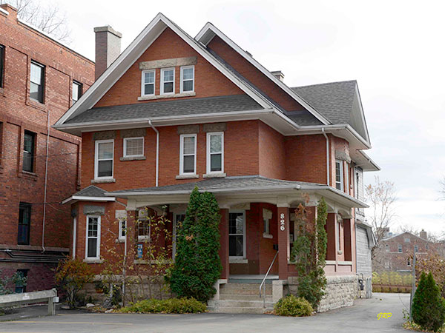
826 Wolseley, today

The year 1953, saw no change for John and Agnes Hudson at 120 Bannerman. John is still a salesman with S.S. Stevenson & Co., the job he started in 1948.

In 1953 Hugh Anderson has changed jobs to become editor at Home Publishing. The president and general manager of Home Publishing was Richard H.G. Bonnycastle. This company was located at 365 Bannatyne Street, the Stovel (Printing) Building. Hugh and Agnes’s son, Hugh John Anderson is still living at home, at 258 Ash Street, with no occupation given. In September 1953 Hugh John Anderson joined the chemistry department of Memorial University in Newfoundland, and stayed for 38 years. He is not found again in Winnipeg Henderson.

The population of Winnipeg in 1954 was 388,000 people. May 31, 1954, television broadcasting arrived in Winnipeg when CBC Winnipeg signed on the air. At first, few families had television sets, perhaps visiting a friend or relative to watch TV.

Another major event in Winnipeg began shortly after 1 a.m. on June 8, 1954, when firefighters were alerted to a fire at the Time Building, on the northwest corner of Portage and Hargrave, downtown. This building had been constructed in 1909. By the time the fire was extinguished days later, the Time Building, Dismorr Block and Edwards Block were completely destroyed, while the Affleck Block and Norlyn Building were severely damaged.

Living at 227 Eugenie, in 1954 are Julia, her son Geordie, and her daughter Ruby. Geordie is the only one employed. Geordie’s name and job title are listed as J. George Murray, caretaker, Norwood School Board.

Murray Auto Top continues under the proprietorship of W.H. Batchelor in 1954, located at 180 Princess. Murray Tent & Awning Co Ltd continues under the management of Donald McDonald, located at 653-655 Sargent, in 1954

John and Julia’s daughter, Gladys, is listed only once in 1954. She is listed as Gladys Murray, steno, WJ Gage & Co. Gladys is still living at 8-543 Bannatyne, where she first moved in 1943.

Gladys’s son-in-law Charlie Cruickshank changed jobs and employer in 1954 to become an employee at Wilson Auto Electric. Charlie and Isabelle are still living at 1156 Downing, with their children. Their third child (their second daughter) was born on November 30, 1954.

There were no changes for Verna and Art Lightfoot from 1953 to1954.

In 1954, Gladys’s daughter Vivian re-entered the workforce. Her daughter was 11 years old and her son was 7 years old in 1954. Vivian worked for Jeannes Bakery as a clerk in 1954. Vivian, Denny, their 2 children, and Denny’s mother Hilda still lived at 823 Alverstone. Denny’ brother, Walter and his wife Pearl moved from 826 Wolseley into 106 Spence. Built in 1900, the house at 106 Spence is a 950 square feet bungalow.

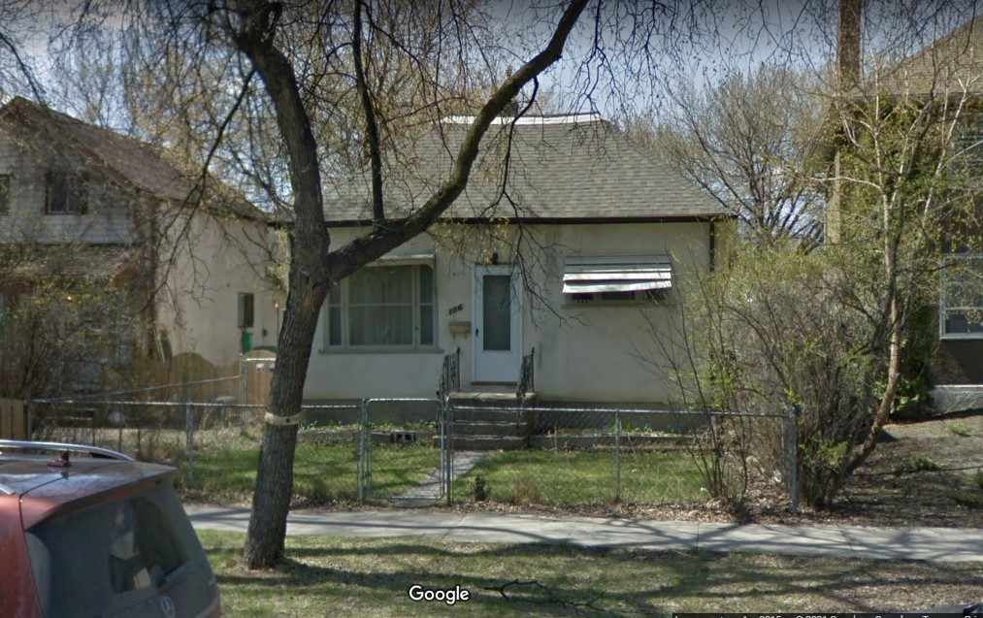
106 Spence, today

In 1954, Henderson has the first appearance of Connie Hudson. Connie is the widow of William Bannerman Hudson, who was the son of John and Agnes. Connie is listed as an employee with Northern Shirt, living at 1922 Ross. That building is no longer standing. Connie will make her second (and last) appearance in 1957 Henderson. John Hudson’s employer’s name is mistakenly given as P.S. Stevenson, but should be S.S. Stevenson & Co. John continues to be a salesman with this company, a job he began in 1948. John and Agnes continue to live at 120 Bannerman.

Hugh Campbell Anderson has changed jobs again in 1954 to become editor at Stovel-Advocate Press, a publishing company in Winnipeg created by the merger of Stovel Press and Advocate Printers Limited in 1952. Stovel-Advocate Press was known for printing a wide range of publications. In addition to its work for wholesalers and manufacturers, and printing and binding books, the firm also published a handful of magazines including Henderson Directories, Harlequin novels, maps, local histories and souvenirs, "Western Home Monthly" and trade publications such as "Canadian Farm Implements", "Nor'-West Farmer" and "Prairie Grocer". Notably, Hugh is still with the Stovel organization, the president and general manager of Stovel-Advocate Press was R H.G. Bonnycastle, and this company was located at 365 Bannatyne Street, the Stovel (Printing) Building. Hugh and Margaret Anderson continue to live at 258 Ash Street in 1954.

There are no changes for Murray Auto Top nor Murray Tent & Awning Co Ltd from 1953 to 1955.

Julia, Geordie, and Ruby are still living at 227 Eugenie, in 1955. Geordie is still the only one employed. Geordie’s name and job title are listed as George Murray, caretaker, Norwood Collegiate.

In 1955 Glady is listed as Mrs. Gertrude McGee, a widow, still living at 8-543 Bannatyne. In reality Gladys was not a widow in 1955 and her last name was spelled Magee

The husband of Isabelle, Charlie Cruickshank, is listed as a salesman in 1955. We know he worked for Wilson Auto Electric at that time. Charlie’s mother appears in 1955 Henderson as the widow of Frank, living at 663 Clifton which is the home of her youngest son, Alexander John Cruickshank, an electrician at City Hydro. This home at 663 Clifton was built in 1947.

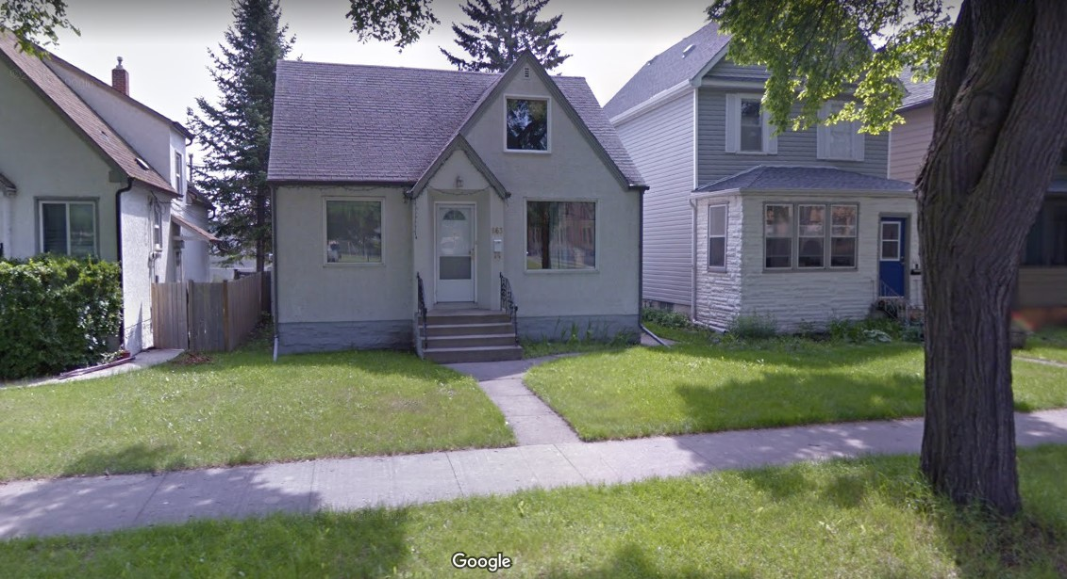
663 Clifton, today

Verna and Arthur Lightfoot, with their two adopted children, moved from 636 Burnell
to 25 Lawndale in 1955, a house built in 1945. This home is where they would remain
for the rest of their lives. While the exterior and front yard have been upgraded since those days, the general appearance of the house is unchanged.

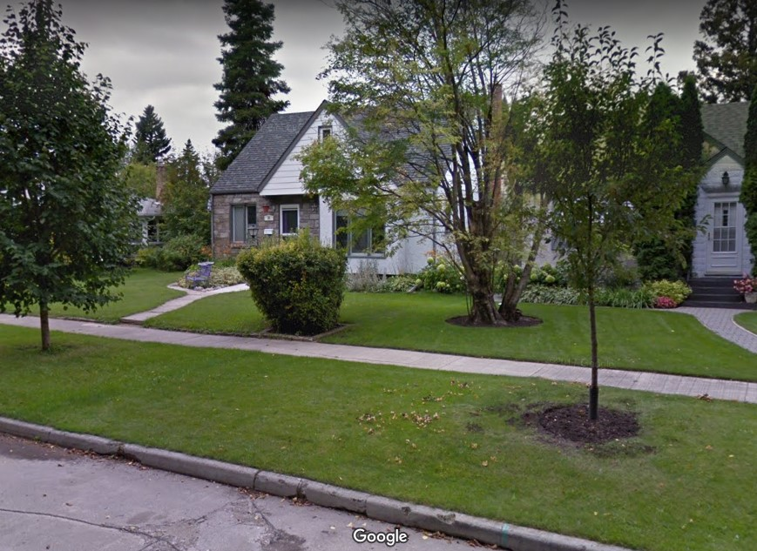
In September of that year Verna gave birth to their third and last child, a daughter.

Arthur is still employed as a department manager at Acklands in 1955. Arthur’s parents are still living at 626 Burnell and Arthur’s father still a pressman at Bulman Bros.
25 Lawndale, today

Vivian Konchak is not listed in the workforce in 1955, so she possibly worked at Jeanne’s Bakery for only a short time. Living at 823 Alverstone are Vivian, Denny, their two children, and Denny’s mother Hilda.

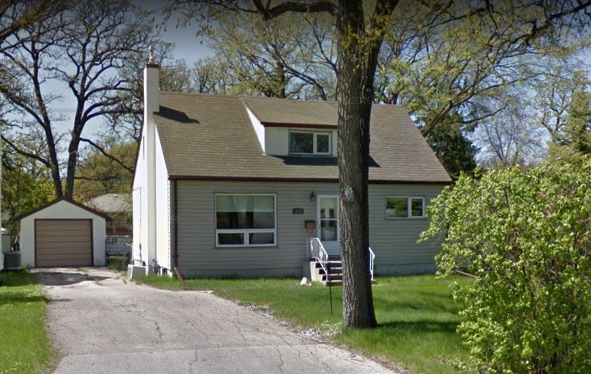

Denny’s brother George is a foreman at Sargent Heating and Equipment. He and Mildred have moved down the street from 166 Oakdean to a brand new house at 172 Oakdean.

172 Oakdean, today
In 1955 Denny’s other brother Walter is still a yardman at CPR. He and Pearl are still living at 106 Spence, where they moved in 1954.

In 1955 there are no changes for John and Agnes Hudson at 120 Bannerman since 1948. Their children (Robert and Elizabeth) are not listed in Winnipeg. Neither is their daughter-in-law Connie listed in Winnipeg in 1955. John is still a salesman with S.S. Stevenson & Co.

John Hudson’s old partner John Crabtree is still president of Honeysuckle Bakeries, a position he obtained in 1932, and would leave in 1955. Henderson indicates that John Crabtree’s wife’s name was Gladys E.

There are no changes in address nor occupation for Hugh and Margaret Anderson from 1954 to 1955.

In February of 1956 a large deposit of nickel was discovered in Manitoba, leading to the creation of the town of Thompson, Manitoba. The year of 1956 was one of few changes for the Murray families.

In 1956, Henderson lists R.D. Roden, a clerk at Patricia Transportation Co., living at 1251 Strathcona. With no spouse’s name listed this is likely a single person, referring to Richard Derrick Roden, the son of Richard Hendry Roden and Anne. The address of 1251 Strathcona is the same house occupied by Richard H. Roden in 1948.

There are no changes for Julia, Geordie, and Ruby, still living at 227 Eugenie, in 1956. Geordie’s employer is listed as Norwood School Board.

There is no change for Murray Auto Top from 1953 to 1956. Murray Tent & Awning Co Ltd is listed with Thomas (last name unclear?) as president in 1956. This could indicate a change of ownership. The address in 1956 for Murray Tent and Awning is 653 Sargent, the same building they occupy today (in 2021).

In 1956 Glady is listed as Gladys E. Murray, a steno, working at WJ Gage & Co, still living at 8-543 Bannatyne.

There were no changes for Gladys’s daughter Isabelle and her husband Charlie Cruickshank in 1956.

In 1956, there were no changes for Verna and Arthur Lightfoot. Arthur’s parents remained living at 626 Burnell and Arthur’s father was still employed as a pressman at Bulman.
There were no changes for Vivian and Denny Konchak in 1956. Walter Konchak’s wife Pearl is listed as a field manager for Avon Products in the year 1956.

There were no changes of address nor occupation for John and Agnes Hudson from 1948 to 1956. John Crabtree, the one-time-partner of John Hudson in the cycle business, is listed as “Harold J. Crabtree, retired” in 1956, living at 308 Dromore.

There were no changes of address nor occupation for Hugh and Margaret Anderson, from 1954 to 1956.

In 1957 Richard H. Roden and his wife Anne (nee Derrick) reappear in Winnipeg Henderson. This Richard is the son of George Murray’s oldest daughter, Elizabeth Georgina Barbara. Elizabeth married Richard Roden on June 19, 1901, and then moved to Souris, Manitoba around 1907. Richard H. Roden is an employee at Motorways (West) Ltd, a transportation company. The 1957 voters’ list further explains that Richard’s job was a ‘clerk’. In 1957 Henderson, Richard H. Roden and Anne are living at 513 Enniskillen, Winnipeg. Also living with them in 1957 is their son, Robert, who is an employee at Imperial Bank. The house at 513 Enniskillen was built in 1922.

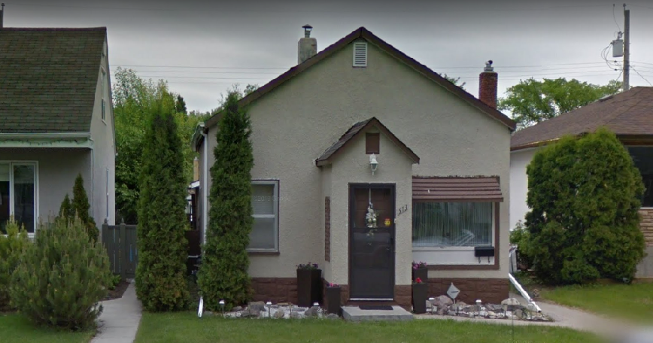
513 Enniskillen, today

Richard H Roden, Anne, and Robert are the only Rodens listed in 1957 Henderson.

There are no changes for Julia, Geordie, and Ruby, still living at 227 Eugenie, from 1956 to 1957. Geordie’s employer is listed as Norwood School Board.

There is no change for Murray Auto Top from 1953 to 1957. Murray Tent & Awning Co Ltd is again listed with D.O. McDonald, this time as general manager in 1957. The address in 1957 for Murray Tent and Awning continues to be 653 Sargent, the building they moved into in 1953, and still occupy today (in 2021).

In 1957 Glady is listed the same as in 1956, that is: Gladys E. Murray, a steno, working at WJ Gage & Co, still living at 8-543 Bannatyne.

There were no changes for Gladys’s daughter Isabelle and her husband Charlie Cruickshank, from 1956 to 1957.

In 1957, there were no changes of occupation nor residence for Verna and Arthur Lightfoot. Arthur’s mother is listed as Charlotte, widow, living at 626 Burnell; so Arthur’s father must have passed away in this time period around 1956 - 1957.

Vivian Konchak is again in the workforce in 1957, this time as a saleslady at Woolworth’s. This is the same job and employer she previously had in 1938. The only other change for the Konchak family is that George is now a mechanic after being a foreman at Sargent Heating and Equipment.
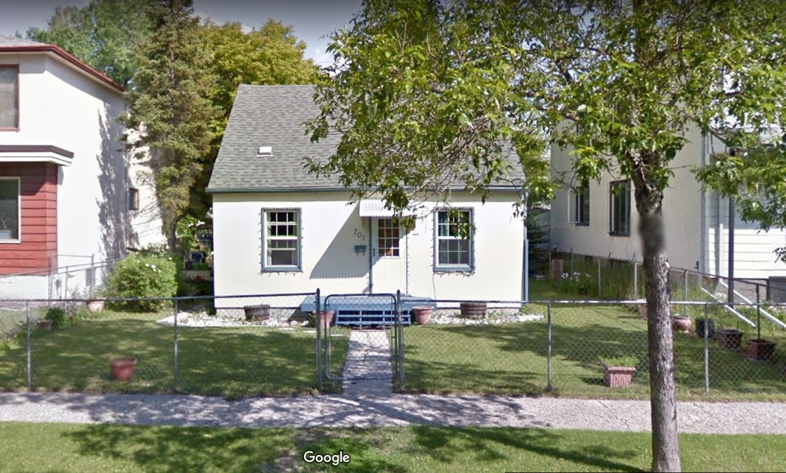
There were no changes of address nor occupation for John and Agnes Hudson, from 1948 to 1957. Connie Hudson, widow of William Bannerman Hudson appears in Henderson for the second and last time in 1957. She is an employee at Eatons living at 701 Carter Avenue (shown above). In the same issue of Henderson, listed at 701 Carter Avenue, is Alec Hudson. This name is not familiar and could be an error in Henderson. The house at 701 Carter Avenue was built in1947.
There were no changes of address nor occupation for Hugh and Margaret Anderson, from 1954 to 1957.

In 1958, Richard and Anne Roden are still living at 513 Enniskillen and Richard is now listed as a clerk with Motorways (West) Ltd. Still living with them is their son, Robert J. Roden who is now a teller at the Imperial Bank, in 1958.

On February 10, 1958, Julia (nee Simmons) Murray passed away. Julia was born April 25, 1874, in Monmouth, Wales, arriving in Winnipeg with her parents and 5 brothers on June 14, 1882 when she was 8 years old. Julia grew up on Syndicate Street in Winnipeg. She married John Robertson Murray on November 26, 1895. Julia had four children: Gladys, Geordie, Ruby, and Hazel.

Julia was living with her son Geordie and daughter Ruby at 227 Eugenie at the time of her passing in 1958. Geordie and Ruby remained at 227 Eugenie. Geordie continued working as a caretaker for the Norwood School Board.

There is no change for Murray Tent & Awning Co Ltd from 1957 to 1958. There is no change for Murray Auto Top from 1953 to 1958 except Wm Batchelor is now listed as a manager not the proprietor.

In 1958 Gladys is listed as Gladys E.L. Murray, a steno, working at WJ Gage & Co, still living at 8-543 Bannatyne. In this year, Gladys’s long-time friend William Hopper Campbell moved from apartment 17 at 435 Qu’Appelle to suite 2-608 Broadway Street. Family lore has it that William followed Gladys from Cardinal to Winnipeg when Gladys moved back. In Cardinal, it is thought, William lived upstairs in one of the Magee houses and was very aware of the difficulties between Gladys and David Magee. [I was unable to find William Campbell in the 1921 census for Cardinal.]

There were no changes for Gladys’s daughter Isabelle and her husband Charlie Cruickshank, from 1956 to 1958.

Arthur Lightfoot became manager for Addison’s Ltd. in 1958. This company was a manufacturer and distributor of home appliances, radios, televisions, records and record players. They were located at 620 St James Street, in a building that is no longer standing, today. Verna and Art remained living at 25 Lawndale. Arthur’s mother Charlotte was still living at 626 Burnell.

In 1958 Henderson, Denny Konchak was promoted from constable to sergeant with the Winnipeg City Police force. Vivian, Denny, their two children, and Denny’s mother Hilda were still living at 823 Alverstone. Denny’s brother George left Sargent Heating and Equipment and opened George’s Heating Service in 1958. The address found for this business in Henderson is George and Mildred’s home address, so it seems that George ran this business out of his home. George and Mildred continued living at 172 Oakdean. Denny’s other brother Walter was still a yardman at CPR, living with his wife Pearl at 106 Spence, in 1958.

On May 8, 1958, John Alvin Hudson passed away at Grace Hospital in Winnipeg. Born August 2, 1882, John was almost 76 years old. Henderson lists John’s employment as real estate salesman at S.S. Stevenson & Co in 1958. His employment had been listed as salesman at S.S. Stevenson & Co since 1948. This was likely not a job change, as S.S. Stevenson was a real estate firm. Agnes continued to live at 120 Bannerman in 1958. [more could be said about Jack Hudson, here … S.B??]

Hugh Anderson’s job title changed in 1958 from “editor at Stovel Advocate” to “with Stovel Press”. There was no change of address for Hugh and Margaret Anderson in 1958.

On Thursday August 20, 1959 Winnipeg’s first shopping centre opened. Named the Polo Park shopping centre, or Polo Park, this shopping complex was adjacent to the Winnipeg Arena (an indoor multi-use building with ice capability for hockey, also used for circuses and concerts), and the Winnipeg Stadium (an outdoor sports field used for football, baseball and other events)

Richard H. Roden, and his wife Anne (nee Derrick) are still living at 513 Enniskillen in 1959. Richard’s occupation is not given, so he could be unemployed. Also living with them, and making her first appearance in Henderson, is their daughter, Elizabeth A. Roden who is employed as a clerk at the Imperial Bank. Elizabeth was commonly known as Betty-Anne.

Geordie and his sister Ruby Murray had no changes from 1956 to 1959.

As for the companies started by John Robertson Murray: Murray Auto Top did not change from 1958 to 1959 except Wm Batchelor is listed as a proprietor not as manager. There is no change for Murray Tent & Awning Co Ltd from 1958 to 1959, except Don O. McDonald is listed as manager not as general manager. The address appears as 655 Sargent not as 653 which looks like a typographical error because the address reverts to 653 Sargent in 1960.

In 1959 Gladys is listed as Gladys Murray, a steno, working at WJ Gage & Co, still living at 8-543 Bannatyne.

There were no changes for Gladys’s daughter Isabelle and her husband Charlie Cruickshank, from 1956 to 1959. Isabelle and Charlie’s older daughter makes her first appearance in Henderson in 1959 as a student at university, living in her parents’ home at 1156 Downing.

Arthur Lightfoot, the husband of Gladys’s daughter Verna, became division manager for Addison’s Ltd. in 1959. Arthur’s mother Charlotte was still living at 626 Burnell, the house she moved into with her husband and two sons in 1918.

Denny Konchak, the husband of Gladys’s daughter Vivian, had a job title change to become patrol sergeant with the Winnipeg City Police in 1959.

John Alvin Hudson is listed as “retired” in 1959 Henderson which is clearly in error as he passed away in 1958.

Hugh Campbell Anderson’s job title changed in 1959 from “with Stovel Press” to “editor, Stovel Advocate Publications”. Hugh and Margaret are still living at 258 Ash, the home they moved into in 1929.

The early 1960’s (1960-1965)

This is the year 1960. By this time some family members of George and Elizabeth Murray have moved away from Winnipeg and others have passed away. From the parents George and Elizabeth Murray there were many grandchildren, great grandchildren, and great great grandchildren by this time. For this study, our focus is on people living in Winnipeg

The son of Elizabeth Georgina Barbara Roden (George Murray’s grandson): Richard Hendry Roden, is now employed as a paymaster for Tallmans Gravel. He is still living at 513 Enniskillen in Winnipeg with his wife Anne (nee Derrick) in 1960. Living with them is their daughter, Elizabeth A. Roden, now a machine operator at the Imperial Bank.

The children of John Robertson Murray (George Murray’s grandchildren): Geordie Murray had no change from 1956 to 1960. His sister, Ruby, was absent from Henderson in 1960, but would reappear in 1961. George and Ruby continued to live at 227 Eugenie.

There is no change for Murray Auto Top from 1959 to 1960, still located at 180 Princess Street. There is no change for Murray Tent & Awning Co Ltd from 1959 to 1960, except Don O. McDonald again is listed as a general manager not as manager. The address is listed as 653 Sargent, where the company moved to in 1953, and the address it still has today (2021).

The daughter of John Robertson Murray (George Murray’s granddaughter): Gladys is listed as Gladys Murray, a secretary, working at WJ Gage & Co, and still living at 8-543 Bannatyne in 1960.

There were no changes for Gladys’s daughter Isabelle and her husband Charlie Cruickshank, from 1956 to 1960. Charlie was still a salesman for Wilson Auto Electric. Their older daughter had moved out of the house. Their son and younger daughter were still living at the family home at 1156 Downing in 1960.

In 1960, Gladys’s daughter Verna and her husband Arthur Lightfoot were still living at 25 Lawndale Drive. Their three children (2 daughters and a son) were still living at this family home. Arthur is listed as prairie division sales manager for Addison’s Ltd. Arthur’s mother Charlotte was not listed in 1960 Henderson nor in the remaining digitized years to 1965, inclusive. This would be when she moved to California to be with her son, John.

There were no changes for Gladys’s daughter Vivian and her husband Denny Konchak from 1959 to 1960. Denny continued as a patrol sergeant with the Winnipeg City Police in 1960. Their daughter, son, and Denny’s mother were still living with them in the family home at 823 Alverstone. Members of the Konchak family appearing for the first time in 1960 Henderson were Dennis and Timothy G. Konchak. Dennis was a student, living with his parents Walter and Pearl at 106 Spence Street. Timothy was living with his parents, George and Mildred, at 172 Oakdean Boulevard, and employed as an apprentice at Manitoba Government Phone. This was an archaic name as the name had changed to Manitoba Telephone System in 1933, the name it retained until 1996 when it was privatized.

Daughter Agnes Hendry (nee Murray) and her husband John Alvin Hudson stayed in Winnipeg. John Hudson had died in 1958. In 1960, Agnes Hudson is not listed in the ‘Last Names’ section of Henderson but she does appear as Mrs. Agnes Hudson at 120 Bannerman under the ‘Streets’ section of Henderson. Agnes is the last member of the Hudson family in Winnipeg. Agnes passed away on October 15, 1960.

Daughter Jessie Ann (nee Murray) moved to Saskatchewan and married William Stevenson. William passed away in Shaunavon, Saskatchewan, in 1937. Jessie would return to Winnipeg and live with her younger sister Margaret Helenor Anderson in the Summer of 1965 before passing away later in 1965.

Margaret Helenor (nee Murray) married Hugh Campbell Anderson and they remained in Winnipeg. Margaret and Hugh were still alive in 1960. Hugh had another job title change in 1960 from “editor, Stovel Advocate Publications” to “editorial consultant, Motor in Canada” which was a Stovel-Advocate publication. Margaret and Hugh continued to live at 258 Ash, the home they moved into in 1929.
There was no change for Richard and Anne Roden from 1960 to 1961. Their daughter Elizabeth A. Roden is still occupied by the Imperial Bank but her job title has changed to ‘clerk’.

The only change for Geordie Murray from 1960 to 1961 was that his listed employer changed from Norwood School Board to Norwood School Division in 1961, where he was still working as a caretaker. His sister, Ruby, reappeared in 1961 Henderson as a housekeeper. They continued to live at 227 Eugenie.

There is no change for Murray Auto Top from 1959 to 1961. There is no change for Murray Tent & Awning Co Ltd from 1960 to 1961.

In 1961 Gladys moved from her home at 8-543 Bannatyne to live with her long-time friend, William Hopper Campbell at Apartment 2-608 Broadway. Gladys had lived at 8-543 Bannatyne since 1943. The house at 608 Broadway was built around 1900, likely as an investment property as it usually had a different family living upstairs from the one on the main floor. Apartment 2 was the upstairs of this 2 storey building. In 1961 Gladys is listed as Gladys E. Murray, a secretary, working at WJ Gage & Co. in 1961. Gladys retired in 1961 after her 65th birthday on September 27th.

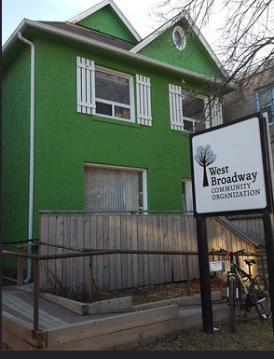
608 Broadway, today
The house colour was white when Gladys lived there, with no fence and no shutters.

There was a big job change in 1961 for Charlie Cruickshank, the husband of Gladys’s daughter, Isabelle. Charlie became a shareholder of a new company called Fort Ignition at 219 Fort Street. This company was a distributorship for the manufacturer Wilson Auto Electric. Charlie was still employed a salesman, now for Fort Ignition, which is how he was listed in 1961 Henderson. Their eldest daughter was married in July of 1961. Their son and younger daughter were still living in the family home at 1156 Downing.

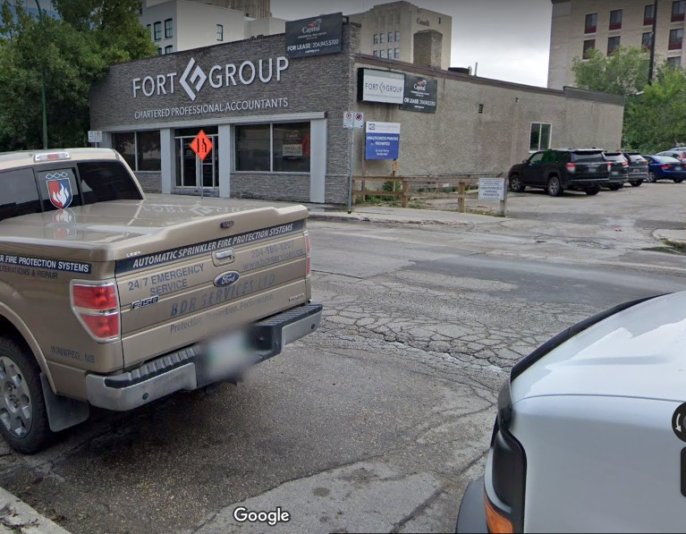
219 Fort Street, today

In 1961, Arthur Lightfoot, the husband of Gladys’s daughter Verna, changed employers to be a salesman for Paul Revere Life Insurance Company. Arthur left Addison’s Ltd, which he had joined in 1958.

Appearing for the first time in 1961 Henderson, is the daughter of Gladys’s daughter Vivian and her husband Denny Konchak. This daughter’s occupation was an employee at CP Freight and she lived with her parents, brother, and grandmother at 823 Alverstone. There were no other changes for Vivian and Denny from 1959 to 1961.

There was no presence of the Hudson family found in Winnipeg in 1961, or onward. By this time Robert Murray Hudson, the son of Agnes and John Alvin Hudson, was living in Quyon, Quebec. Robert and his wife had three children. One son, Stanley born in Ottawa on December, 21, 1937, did not live more than one day. Of their other two children one was a daughter and one was a son.

In 1961, Hugh Campbell Anderson’s job title changed again, this time from “editorial consultant Motor in Canada” to “with Stovel Advocate Publications”.

In 1962, the employer of Richard Hendry Roden changed their name, slightly, to Tallman Gravel and Sand. Richard is still a paymaster there. Richard and Anne are still living at 513 Enniskillen in 1962. Still living with them is their daughter Elizabeth Roden whose employer has changed their name to Canadian Imperial Bank of Commerce. Elizabeth is still a clerk there in 1962.

There was no change for Geordie Murray from 1961 to 1962 His sister, Ruby, appears in 1962 Henderson, but with no occupation listed. They continued to live at 227 Eugenie.

There was no change for Murray Auto Top for 1959 to 1962. The Murray Tent & Awning Co Ltd added a location at 720 Langside in 1962, while retaining their 653 Sargent premises. This Langside address would only last one year. There is no building at 720 Langside, today. Donald O. McDonald was still the general manager in 1962.

In 1962 Gladys, now retired, is listed as Mrs. Gladys Magee, living at Apartment 2-608 Broadway. At the same address is William Campbell, Gladys’s long-time friend, employed as a collector for Peoples Credit Jewelers. Gladys and William would marry the following year on November 16, 1963.

In the Summer of 1962 Gladys’s daughter Isabelle, with her husband Charlie and their two at-home children moved from 1156 Downing Street into 28 Cabot Crescent in St. Vital. This move was not captured in Henderson until 1963 because of the timing of data collection and publication. This was a big move from the 2 bedroom house built by Charlie’s father, brothers, and himself, into a brand new contractor-built 3 bedroom home in a new community.

The house on Downing sold for about $12,000 and the house on Cabot cost about $25,000. Charlie was earning a considerable sum of about $12,000 per year at this time. Charlie’s job remained the same in 1962 as in 1961.

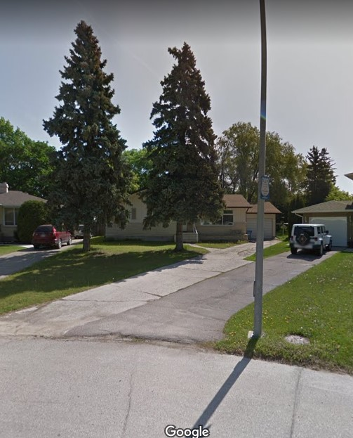

28 Cabot Crescent, today

The two huge blue spruce trees in the front yard of 28 Cabot Crescent were planted about 1962 and were only 3 feet tall when planted.

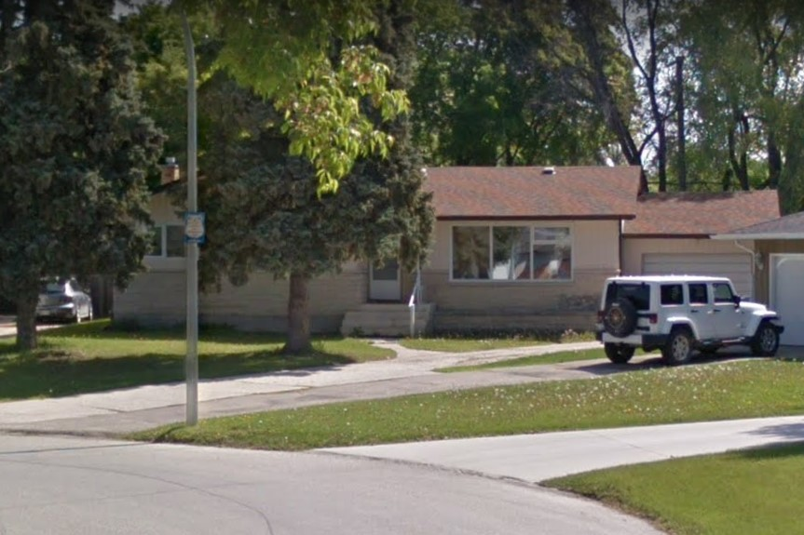
28 Cabot Crescent, today, close up view

From 1961 to 1962 there were no changes for Verna and Art Lightfoot.

In 1962, Vivian and Denny’s daughter is a stenographer at CPR, living in the family home at 823 Alverstone with her parents (Vivian and Denny), her brother, and her grandmother, Hilda. There were no other changes for Vivian and Denny Konchak from 1959 to 1962. Joan Konchak, the daughter of Denny’s brother George and his wife Mildred, makes her first appearance in 1962 Henderson as a student, living with her parents at 172 Oakdean. Timothy Konchak, the son of George and Mildred, is also living with his parents and is an employee with Manitoba Telephone System.

Dennis Konchak is a university student in 1962, living with his parents Walter B. Konchak and Pearl, at 147 West Gate. This Konchak family likely occupied the main floor. At 147 ½ (upstairs or perhaps the 3rd floor) were Joan Paul and Betty Neufeld.

The house at 147 West Gate was built in 1910 for Charles Stewart Tupper, the grandson of Charles Tupper who was one of the Fathers of Confederation and later a Prime Minister of Canada.

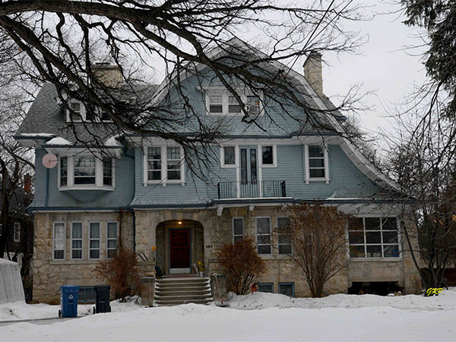
147 Westgate, today

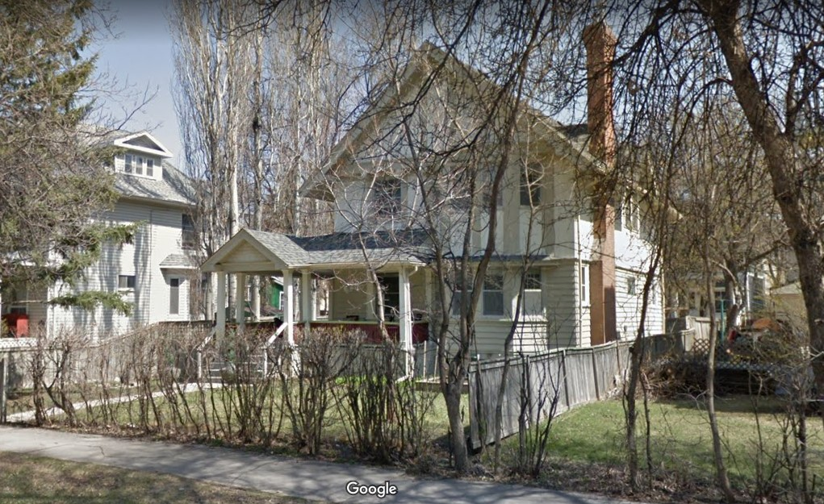
101 Spence, today
W. Konchak (William G Konchak, son of Pearl and step son of Walter) appears in Henderson for the last time in 1962. He is a yardman with CPR living at 101 Spence (photo below). The home at 101 Spence is not listed in the address section of Henderson so it is not possible to say if this was a rooming house situation for William or otherwise. The year-built for 101 Spence was not found.

There were no changes from 1961 to 1962 for Margaret and Hugh Anderson.

In 1963, Richard H. Roden’s employer switched names again, back to Tallman Gravel, where Richard is still a paymaster. Richard and Anne are still living at 513 Enniskillen and for the first time we see another Richard Roden, presumably their son, with no occupation listed. He is also living at 513 Enniskillen. This son is Richard Derrick Roden, born around 1938. Their daughter, Elizabeth Roden who was living with them in 1962, is not listed again in Henderson.

Geordie Murray’s job title changed in 1963 to caretaker Queen Elizabeth School. This school, located at 260 Kenny Street, was the same building he started working at in 1946. Although Geordie had various job title changes from 1946 to 1963, it is quite likely he remained working at the same building, doing the same job, throughout. Though structurally condemned around 1961, this school building continued to see usage until its replacement opened at 363 Enfield Crescent in 1962. The Queen Elizabeth school was demolished in 1963. John George Thornton (Geordie) Murray was 65 years old in 1963. Geordie’s sister, Ruby, appears in 1963 Henderson, but with no occupation listed. Ruby and Geordie continued to live at 227 Eugenie.

Murray Auto Top is listed with Wm. H. Batchelor in brackets in 1963, so it is unclear what his capacity in the company was at that time. The address is still 180 Princess. The Murray Tent & Awning Co Ltd has dropped their 720 Langside address which it had only one year. Donald O. McDonald remained the general manager in 1963, and the address remained as 653 Sargent.

In 1963 Gladys is listed as Mrs. Gladys McGee, living at Apartment 2-608 Broadway. On November 16, 1963, Gladys married William Hopper Campbell in Winnipeg. William continued to be employed as a collector for People’s Credit Jewellers in 1963.

Charlie Cruickshank, husband of Gladys’s eldest daughter Isabelle, had a job title change from salesman to sales manager in 1963. Charlie, Isabelle, and their two at-home children were still living at 28 Cabot Crescent in 1963.

From 1961 to 1963 there were no changes for Verna and Art Lightfoot, other than Arthur’s employer is now listed as Paul Revere Insurance Co., which seems to be an insignificant change.

Glady’s daughter Vivian and her husband Denny remain living at 823 Alverstone. In 1963, Denny Konchak’s job changed from “patrol sergeant” to “sergeant”, police, City of Winnipeg. Their daughter continues as a stenographer at CPR. Dennis W. Konchak, son of Walter and Pearl is now an assistant credit manager at Swifts, living with his parents at 147 West Gate. There are no other changes for the Konchak family in 1963.

In 1963, there is an Elizabeth A Hudson, clerk, at Children’s Hospital, living at 1189 Church, the home of Walter Podalma, in 1963. Could this be Elizabeth Ruth Hudson (with the middle initial wrong) who was the daughter of Agnes Hendry (nee Murray) and John Alvin Hudson? The house at 1189 Church was built in 1955.

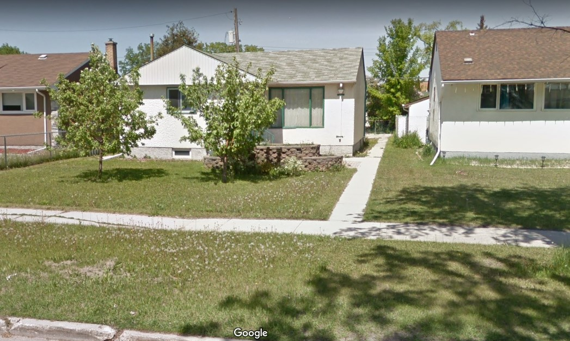
1189 Church, today

Still employed by Stovel-Advocate, High Anderson changed jobs in 1963 from “with Stovel-Advocate Publications” to “editorial consultant Motor In Canada Magazine. This is the job Hugh would have in 1964 and 1965, also. Margaret and Hugh were still living at 258 Ash. (See Appendix note 4 regarding Stovel publishing companies)

In 1964, there is no change for Anne and Richard H. Roden. Their son Richard Derrick Roden is still living with them at 513 Enniskillen and is now a clerk at Rice Sportswear.

In 1964 Henderson, Geordie Murray’s job title is the same as in 1963 which was caretaker Queen Elizabeth School. However, this building was demolished in 1963 so Henderson is using outdated data. Ruby, Geordie’s sister, appears in 1964 Henderson with no occupation listed. Both Ruby and Geordie continued to live at 227 Eugenie.

Regarding the companies started by John Robertson Murray, Murray Auto Top is still operating at 180 Princess in 1964. Wm. H. Batchelor’s name is given but with no job title. The Murray Tent & Awning Co Ltd is still operating at 653 Sargent Avenue in 1964, and Donald O. McDonald remained the general manager.

In 1964 Henderson, just like in 1963, Gladys is listed as Mrs. Gladys McGee, living at Apartment 2-608 Broadway. However, by this time her name is Gladys Campbell as she was married on November 16, 1963. Gladys’s husband, William Campbell continued to be employed as a collector for People’s Credit Jewellers in 1964.

Still employed at Fort Ignition, Charlie Cruickshank, husband of Gladys’s daughter Isabelle, had a job title change from sales manager to president in 1964. This was a bit of hyperbole because as a minor (16.333%) shareholder, Charlie and the other 2 minor shareholders had decided to rotate the role of president of Fort Ignition. Charlie, Isabelle, and their two at-home children continued living at 28 Cabot Crescent in 1964.

From 1963 to 1964 there were no changes for Verna and Art Lightfoot, in Henderson.

There are no changes in Henderson from 1963 to 1964 for Gladys’s daughter Vivian Konchak or that Konchak family. In 1964 Joan Konchak, daughter of George and Mildred re-appears in Henderson as a stenographer working for T S Taylor Machinery. She is living with her parents at 172 Oakdean. T S Taylor company was a distributor of equipment and supplies for the woodworking and metal working industries, located at 1600 Portage Avenue. Also living at 172 Oakdean was George and Mildred’s son, Tim who has advanced to a rackman at Manitoba Telephone System.

There is no evidence of Elizabeth Ruth Hudson in 1964 Winnipeg Henderson.

In 1964, Hugh C. Anderson continued working as “editorial consultant Motor In Canada Magazine. He and Margaret Hendry Anderson are still living at 258 Ash.

The final year, 1965

This is the year 1965. It is the last year for which digitized Henderson Directory exists on the internet. In 1965 the world seems to be a very different place than in 1889 when the Murrays began coming to Canada from Glendaveny, Scotland. They witnessed amazing changes in their lifetime.

In 1965 the world was experiencing the Space Race, the Viet Nam war, Race Riots, Motown music, and the Beatles. Cars were common place and many families had two or more of them. Every home in Winnipeg had indoor running hot and cold water with bathroom facilities (no more back houses), electricity, a refrigerator (not an ice box), automatic clothes washer and dryer, a television (some had colour), and one or more telephones.

Yet even with all these changes many things stayed the same, including most of the buildings that the Murrays lived in and worked in, which still exist; and we can still see them today (2021)

In 1965, the employer of Richard H. Roden has again changed their name back to Tallman Gravel & Sand. Richard continues to be a paymaster there. He and Anne (nee Derrick) are still living at 513 Enniskillen Avenue. In 1965 their son, Richard Derrick Roden is still living with them and is now employed as a clerk at Knitrite Mills. Richard Derrick Roden was a great grandson of George Murray and Elizabeth McRobbie.

John George Thornton (Geordie) Murray is listed as retired in 1965. Geordie’s sister, Ruby, again appears in 1965 Henderson with no occupation listed. Both Ruby and Geordie continued to live at 227 Eugenie. Geordie would pass away on July 13, 1970. Ruby would survive Geordie and passed away on March 27, 1975. Their younger sister Hazel has been difficult to track but outlived all her siblings, passing away on July 11, 2000. These are the siblings of Gladys (nee Murray) Magee (then Campbell).

Murray Auto Top is still operating at 180 Princess in 1965. Wm. H. Batchelor’s name is in brackets but with no job title. Unfortunately, the building at 180 Princess Street was demolished, some time after 1965, and is a parking lot today. As a company, Murray Auto Top no longer exists, today. The Murray Tent & Awning Co Ltd is listed at 649-653 Sargent Avenue (a temporary expansion into the building next door) in 1965, and Donald O. McDonald remained the general manager. The address today (in 2021) is 653 Sargent.

In 1965 Henderson, Gladys was listed next to her husband William (Bill) Campbell who was now retired. Gladys and Bill lived in apartment 2-208 Broadway in 1965. Bill would pass away on May 8, 1966 and Gladys would live until March 13, 1997, reaching an age of 100 ½ years.

Still employed at Fort Ignition, Charlie Cruickshank, husband of Gladys’s daughter Isabelle, is again listed as president in 1965. Charlie, Isabelle, and their two at-home children continued living at 28 Cabot Crescent in 1965. Charlie would pass away on April 7, 1966. Isabelle would live until July 17, 2011.

In 1965 there was a job change for Arthur (Art) Lightfoot as he became a sales manager for Banville Building Supplies. Verna, Art, and their at-home children remained living at 25 Lawndale. Verna would pass away on December 18, 1984, and Art would live until October 16, 2008.

Denny Konchak’s job title in 1965 Henderson was “policeman Winnipeg” but this may not be a significant change, as he retained the rank of sergeant until retirement. Vivian is listed as Vivian R. Konchak in 1965 Henderson. Her second name was Rhonda. Vivian and Denny’s daughter continues as a stenographer for CNR, living with her parents, brother, and grandmother Hilda Konchak, at 823 Alverstone, in 1965. A complete list of those people with the last name Konchak listed in 1965 Winnipeg Henderson is:

- George (Denny’s brother) and his wife Mildred living at 172 Oakdean. George was owner of George’s Heating Service.
- Sandra Konchak, wife of George and Mildred’s son Tim. Sandra was a stenographer at CBC, living at 453 Sherbrook
- Joan Konchak, daughter of George and Mildred. Joan was a stenographer at T S Taylor Machinery, and lived with her parents.
- Laurel J. Konchak, daughter of Vivian and Denny. She was a stenographer at CPR, and lived with her parents at 823 Alverstone.
- Walter B. Konchak (Denny’s brother) and his wife Pearl living at 147 West Gate. Walter was a yardman at CPR.

William Daniel Konchak (Denny) would pass away on July 1, 1970. Vivian Rhonda (nee Magee) Konchak would live until October 7, 2015.

There were no family members or descendants Agnes Hendry (nee Murray) Hudson found remaining in Winnipeg in 1965.

Margaret Helenor (nee Murray) Anderson and her husband Hugh Campbell Anderson continued living at 258 Ash Street in 1965. Hugh was still employed as editorial consultant for Motor In Canada Magazine, the job he took in 1963.

Margaret Anderson’s older sister Jessie Ann was living in Shaunavon, Saskatchewan, in 1965 when she became ill. That summer Jessie came to stay with Margaret and Hugh until later in the year when she entered hospital and subsequently died [Exact date unknown] While she was living with Margaret and Hugh, Jessie wrote her recollections called, ‘The Murray’s Come to Canada’. This is a priceless and precious piece of writing.

Hugh Anderson would pass away on November 21, 1973 and Margaret would pass away on June 11, 1988.

In Conclusion

By 1965 there are few original Murray family members remaining in Winnipeg. Here is a recap of this Murray family (last name of Murray is omitted). George and Elizabeth (the parents) died in Winnipeg on April 23,1939 and September 12, 1938, respectively. George and Elizabeth are buried at Brookside Cemetery, Winnipeg.

Son John Robertson married Julia Simmons, stayed in Winnipeg, and died on January 27, 1948. Julia died February 10, 1958. John and Julia are buried at Elmwood Cemetery, Winnipeg.

Daughter Elizabeth Georgina Barbara married Richard Roden, moved to Souris and would live until April 1, 1973. Elizabeth is buried at Glenwood Souris cemetery, in Souris, Manitoba. Richard died in 1952. Their son, Richard Hendry Roden married Anne Derrick and then moved to Winnipeg in 1948. A daughter and 2 sons lived with Richard and Anne at various times in Winnipeg. On the 1974 voters’ list are Richard (retired), Anne, and their son Richard Derrick Roden a salesman, all living at 513 Enniskillen. Richard Hendry Roden and his wife Anne are buried at Elmwood Cemetery in Winnipeg.

Son George (the tinsmith) did not marry, stayed in Winnipeg and died on October 10, 1949. His parents lived with him until their passing. George (the tinsmith) is buried at Brookside Cemetery, Winnipeg.

Son James died at 2 years old in 1881 in Glendaveny, Scotland, before the family immigrated to Canada.

Daughter Agnes Hendry married John Alvin Hudson and stayed in Winnipeg. John died on May 8, 1958 but Agnes lived in Winnipeg until October 15, 1960. Elizabeth Ruth Hudson remained unmarried it seems. She attained her master of Arts degree when she was 75 years old. Elizabeth Ruth Hudson worked all over Canada and in London, England as a legal secretary. and died in Winnipeg on January 17, 2003. Agnes, John, their son William Bannerman, and their daughter Elizabeth Ruth are buried at Elmwood Cemetery in Winnipeg.

Daughter Jessie Ann moved to Saskatchewan and married William Stevenson. William died in 1937. Jessie is on the voters’ list in 1962 for Shaunavon, Saskatchewan, with the occupation ‘retired’. She would return to Winnipeg and live with her sister Margaret before passing away in 1965.

Daughter Robertson (Robin) moved to Saskatchewan and married Arthur Ernest Pearce. Robin died in 1941. She is buried at Brookside Cemetery, in Winnipeg. Ernest died in 1970.

Son Alexander died on September 7, 1890, at 22 months old, just after the family arrived in Saltcoats, Saskatchewan. His grave could not be found.

Margaret Helenor married Hugh Campbell Anderson and remained in Winnipeg. She was still alive in 1965, passing away June 11, 1988. Hugh predeceased Margaret, passing away on November 21, 1973. Margaret and Hugh are buried at Brookside Cemetery, in Winnipeg.

Mary Ur(e)y married Charles Nicholson Hendry and moved to Chicago then to the village of Lena in Stephenson County, Illinois, USA. Mary was still alive in 1965, passing away on June 13, 1996 in Lena.

APPENDIX:

- CHILDREN of ROBIN from S.B’s Ancestry:.
- Leona Margaret Pearce (B1912 in Wallace Sask-D2000 in Richmond BC), married John Kennedy Blaylock (B1902-D1978)

- Evelyn Mary Pearce (B July 23,1917-D Oct 1, 2006). Married [first name unknown] Rowbottom. Buried in Mountain View Lethbridge Cemetery, Alberta.

To Do for a future article: RAY: LOOK IN the SASK CENSUS records, for
these children

- RODEN FAMILY: I do have them on some links on Ancestry.com, where a child seems to have moved to Kenora and so explains how Elizabeth Georgina Barbara could have died there

- MARY MURRAY in Chicago. I have a link to a site for searching the 1940 Chicago Census. Of course, this is not part of the Murrays in Winnipeg

- Stovel-Advocate Press, in its various forms, was a long-time employer of Murray family members, beginning in 1901 with Agnes. Stovel seems to have ceased operations in the mid 1970's, according to the Manitoba Government Archives website

